**ICECAPS-ACE Weekly Report**

October 22 – 28, 2018

Gus Allen

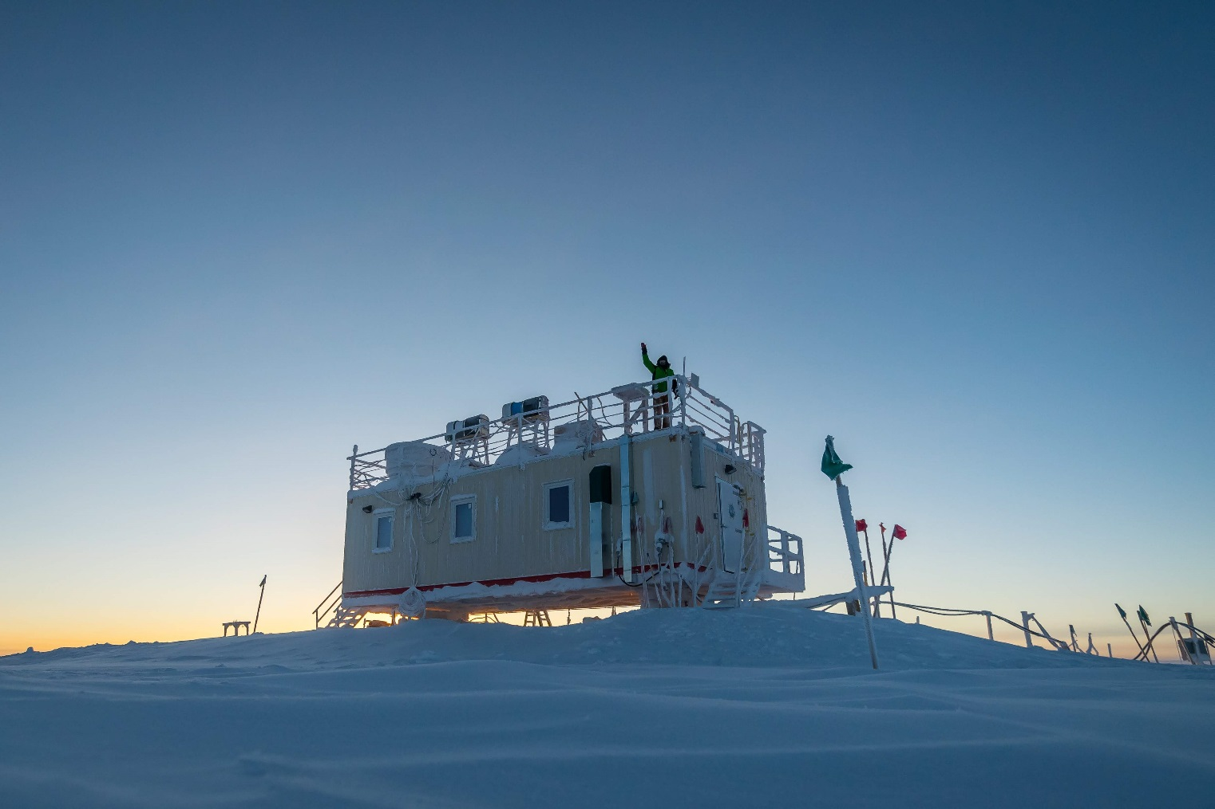

*Hello everyone! I spent the week familiarizing myself with the MSF instruments and facilities. -Gus*

**General:**

Hannah departed on 10-23, after two days of flight delays. This allowed some extra time to turnover on more instruments and procedures. A wind event on the morning of 10-27 blew in some snow and required a small amount of cleanup on the MSF roof.

**Significant Weather Observations:**

* 10-22: bkn low cirrostratus. -45C, 13kts from 093, fzfg
* 10-23: bkn low cirrostratus, -38C, 12kts from 122, no present weather
* 10-24: sct cirrocu, -40C, 12kts from 141, vicinity fog
* 10-26: few cirrostratus on horizon, -52C, 11kts from 164, rime icing
* 10-27: NOTE high wind and blowing snow overnight, observed 40kts from 200. 1630Z: bkn000(BLSN), -20C, 13kts from 198, blowing snow
* 10-28: bkn032 cirrostratus, -36C, 8kts from 342, no resent weather

**ICECAPS-ACE Data Management:**

* 10-22: Data transfer did not start as scheduled at 02Z because the diskpath file was not updated to reflect the USB harddrive that was switched out the previous day. Diskpath file was updated by Sam and transfer was started manually at 1305Z.
* 10-23: Data transfer complete at 1011Z.
* 10-24: Data transfer complete at 0954Z.
* 10-25: Data transfer complete at 0840Z.
* 10-26: Data transfer complete at 0858Z.
* 10-27: Data transfer complete at 0852Z.
* 10-28: Data transfer complete at 0917Z.

**MWR:**

* 10-24: 150-90 ambient temperature sensor fan not turning.
* 10-25 1110Z: Cleared rime from amb temp sensor fan. It still isn’t turning. I will continue to monitor and log, with no further actions requested, per Dave Turner.
* 10-28: During daily check, observed 150-90 amb temp sensor fan to be “bouncing”. I gave it a nudge and it started spinning.
* Operating normally.

**SODAR:**

* 10-27: All JPG images recorded prior to daily check on this day are black. The data look good, per Matt Shupe. Reason for bad JPGs remains undetermined. I suspect user error.
* Operating normally.

**POSS:**

* Operating normally.

**MMCR:**

* Operating normally.

**CAPABL:**

* 10-24: Instrument taken offline remotely on the evening of 10-23-2018. Instrument is out of alignment, requiring attention of PIs, who are in the field and unavailable.

**MPL:**

* Operating normally.

**VCEIL:**

* Operating normally.

**IceCAM:**

* Operating normally.

**PAERI:**

* 2018-10-27: At record 539, the PAERI threw red condition flags for LWresponsivity & SWresponsivity. The LW_HBB_NEN and SW_HBB_NEN flags went red shortly after. This is correlated with a high wind event Summit experienced overnight, which presumably blew snow onto the scene mirror. I was not able to immediately go to the MSF to address this issue because of high wind and poor visibility. Conditions improved around 1330Z, and I was able to get out and clean the scene mirror. All four of the flags in question returned to green at record 2006, around 1345Z.
* Operating normally.

**TSI:**

* Offline for winter season.

**IcePIC:**

* No images captured this week.

**Radiosonde:**

* Twice daily launches.
* 2018-10-27 12Z launch not performed due to high wind.

**MASC:**

* Instrument offsite for repair, will not return until summer 2019.

**OPC:**

* Operating normally.

**CLASP:**

* Instrument offline and being shipped offsite for repair.

**CPC:**

* Instrument offline and being shipped offsite for repair.