**ICECAPS-ACE Weekly Report**

October 29 – November 4, 2018

Gus Allen

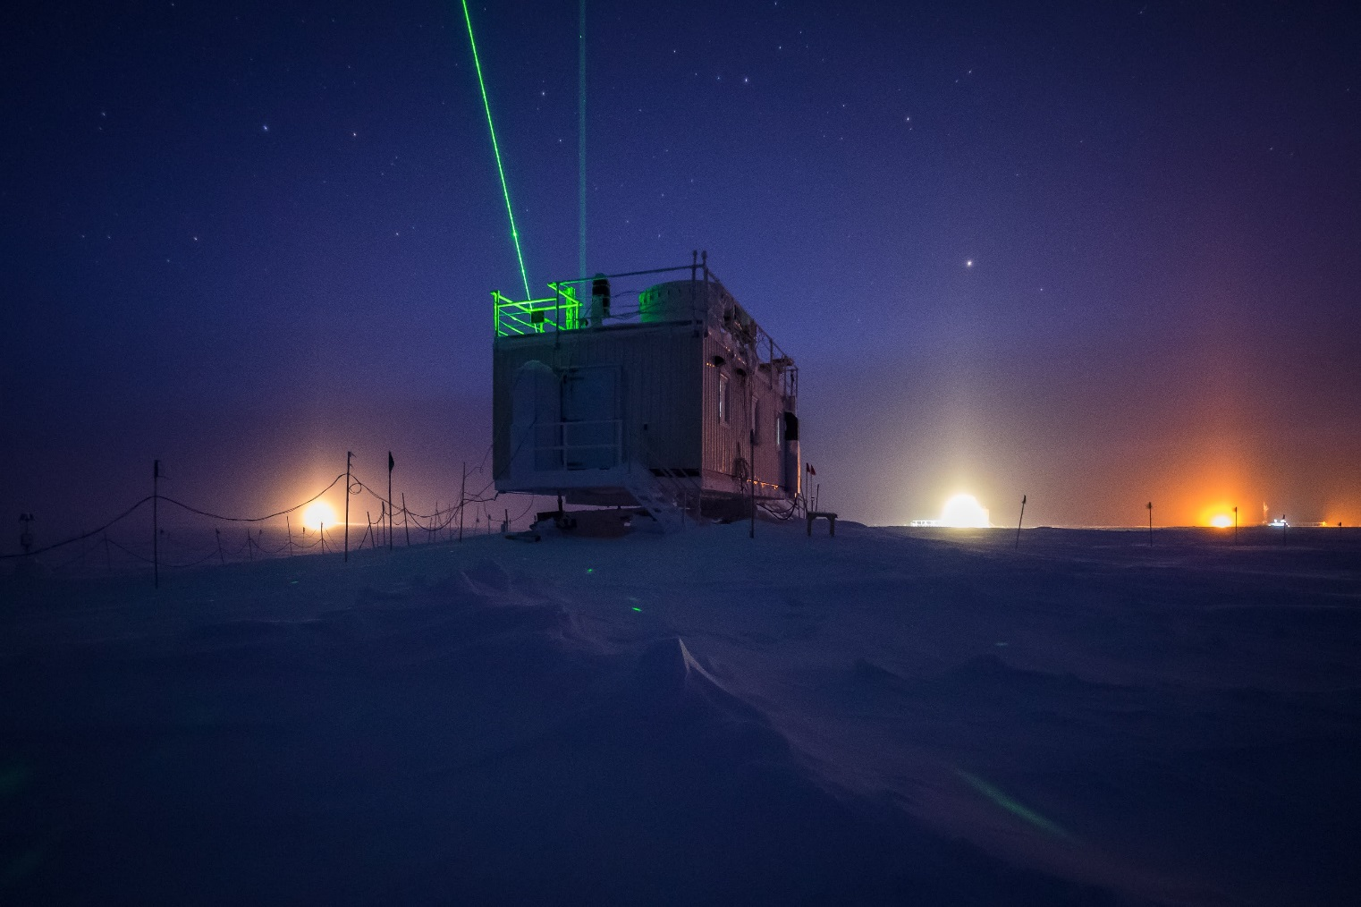

*CAPABL and MPL lasers adding color to a late evening at the MSF, with a little rave ice visible*

**General:**

Troubleshooting CAPABL occupied the most tech time this week. It was a quiet week for ICECAPS aside from a little snow on the PAERI scene mirror.

**Significant Weather Observations:**

|  |  |  |  |  |  |  |
| --- | --- | --- | --- | --- | --- | --- |
| **Date** | **Time (Z)** | **Wind** | **Weather** | **Sky** | **Temp(C)** | **Notes** |
| 10-29 | 1200 | 13 from 087 | BR | SCT CIRROCU | -33 |  |
| 10-30 | 1210 | 13 from 102 | DRSN BR | BKN CIRRUS | -45 |  |
| 10-31 | 1311 | 11 from 092 | DRSN FZFG | BKN CIRRUS | -35 |  |
| 11-01 | 12 | 14 from 098 | FZFG SN | OVC | -33 | Low vis SN |
| 11-02 | 1225 | 10 from 168 | BR | BKN CIRROCU | -40 |  |
| 11-03 | 1700 | 17 from 089 | BR | SCT CIRRUS | -37 | Late ob |
| 11-04 | 1205 | 14 from 095 | BR | SCT CIRROCU | -42 |  |

**ICECAPS-ACE Data Management:**

* 10-29: Data transfer complete at 0855Z.
* 10-30: Data transfer complete at 0852Z.
* 10-31: Data transfer complete at 0934Z
* 11-1: Data transfer complete at 0910Z
* 11-2: Data transfer complete at 0943Z
* 11-3: Data transfer complete at 0910Z
* 11-4: Data transfer complete at 1010Z.

**MWR:**

* Operating normally.

**SODAR:**

* Operating normally.

**POSS:**

* Operating normally.

**MMCR:**

* Operating normally.

**CAPABL:**

* Instrument taken offline remotely on the evening of 10-23-2018.
* 10-30 1800Z: Attempted manual alignment with laser 1 with marginal success.
* 10-31: I spent several hours troubleshooting with Dr. Neely via Skype. The conclusion appears to be that recently-reinstalled laser 1 is producing a distorted beam. CAPABL was left active and recording data using laser 2, which Neely reports is reasonably well-aligned.
* 11-1: CAPABL operating normally using Laser 2
* 11-2: With Neely’s guidance, I removed cover of combiner box to diagnose laser 1 beam shape. We concluded that it 1 is misshapen coming out of the head. Instrument was then returned to normal operation using laser 2.
* Instrument currently operating normally using laser 2

**MPL:**

* Operating normally.

**VCEIL:**

* Operating normally.

**IceCAM:**

* 10-31: Lens covered in snow until 1300Z
* 11-2: Moon transits between 0315 and 0445Z
* Operating normally.

**PAERI:**

* 10-29: At approximately 2100Z the PAERI threw red flags for LW_Responsivity and SW_responsivity, associated with increased wind with blowing snow deposited on the scene mirror. I was able to clean the mirror from the roof around 1230Z, and the flags returned to green shortly after.
* 11-3: Around 22Z, the PAERI threw the same for LW_Responsivity and SW_responsivity flags. I cleared snow from the mirror at approximately 11-4 0005Z, and the flags returned to green right after.
* Operating normally.

**TSI:**

* Offline for winter season.

**IcePIC:**

* No images captured this week.

**Radiosonde:**

* Twice daily launches.

**MASC:**

* Instrument offsite for repair, will not return until summer 2019.

**OPC:**

* Operating normally.

**CLASP:**

* Instrument offline and being shipped offsite for repair.

**CPC:**

* Instrument offline and being shipped offsite for repair.