**ICECAPS-ACE Weekly Report**

September 10 – 16, 2018

Hannah James

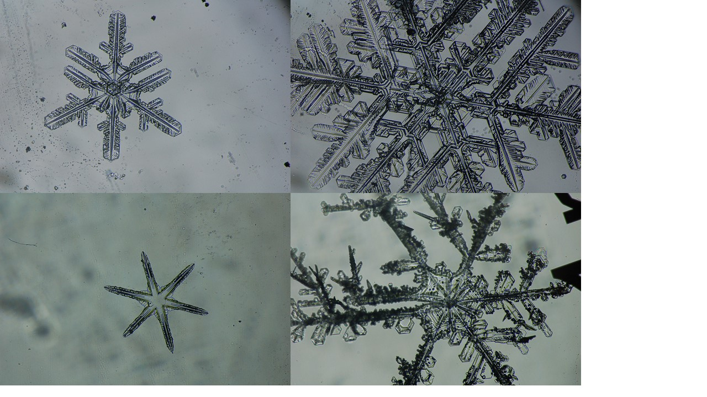

Some of Thursday’s IcePICs. -HJ

**General:**

None to report.

**Significant Weather Observations:**

* 09-10: Few stratus, sct altocumulus. -16C, 13 kts. Br, IC.
* 09-11: Bkn stratocumulus. -14C, 11 kts. Drsn, -sn.
* 09-12: Ovc stratocumulus. -12C, 16 kts.
* 09-13: Ovc stratocumulus. -13C, 10 kts. -Sn.
* 09-14: VV001. Fzfg. -20C, 6 kts.
* 09-15: VV001. Fzfg. -28C, 8 kts.
* 09-16: Ovc stratus. -19C, 14kts.

**ICECAPS-ACE Data Management:**

* 09-10: Data transfer complete 06:19Z.
* 09-11: Data transfer complete 06:08Z.
* 09-12: Data transfer complete 06:14Z.
* 09-13: Data transfer complete 06:13Z.
* 09-14: Data transfer complete 05:39Z. Matt Shupe cleared up space on the MMCR mount (previously 92%, currently 41%).
* 09-15: Data transfer complete 06:24Z.
* 09-16: Data transfer complete 05:38Z.

**MWR:**

* Operating normally.
* 09-13: Installed insulation blanket on HATPRO.

**SODAR:**

* Operating normally.

**POSS:**

* Operating normally.

**MMCR:**

* Operating normally.
* Pitch wavering between 0.00 and -0.10, Roll 0.32.

**CAPABL:**

* Operating normally in Configure Ops Laser 2.
* 09-16: CAPABL laser off for window/roof cleaning 13:43-14:58Z.

**MPL:**

* Operating normally.

**VCEIL:**

* Operating normally.

**IceCAM:**

* Operating normally.

**PAERI:**

* Operating normally.

**TSI:**

* Operating normally.

**IcePIC:**

* 09-13: Slides placed for collection 21:27-22:03Z. Images captured include split plate stellar dendrites, simple stars, stellar plates, stellar dendrites, trigonal stellar dendrites, some rimed ice, few radiating dendrites. One plate of just a simple rectangular form- looks like a broken branch, but seems so evenly cut. Small bits of rave ice seen, though it was too light out for good imaging. Later in the night, rave ice was visible at an average of 1 every 2 seconds, with each burst of light covering a pretty large area (up to 2 square feet, potentially).

**Radiosonde:**

* Twice daily soundings.
* New payoff weight calculated for lighter sondes throughout the week. Weights are not finalized yet, and will be reported the following week.

**MASC:**

* Instrument offsite for repair, will not return until summer 2019.

**OPC:**

* Operating normally.

**CLASP:**

* Operating normally.

**CPC:**

* Instrument currently powered down due to “Air Pump Problem, High Current” error. Awaiting instruction from PI.
* 09-12: Added butanol to bottle.
* 09-13: Alarm stating “Error Liquid” present. After loosening the cap at 12:07, liquid was able to flow and the error ceased.
* 09-16: Filter changed. Around 22:30Z, the CPC stopped collecting data. Error found during Monday rounds. Instrument powered down.