**ICECAPS-ACE Weekly Report**

September 17 – 23, 2018

Hannah James

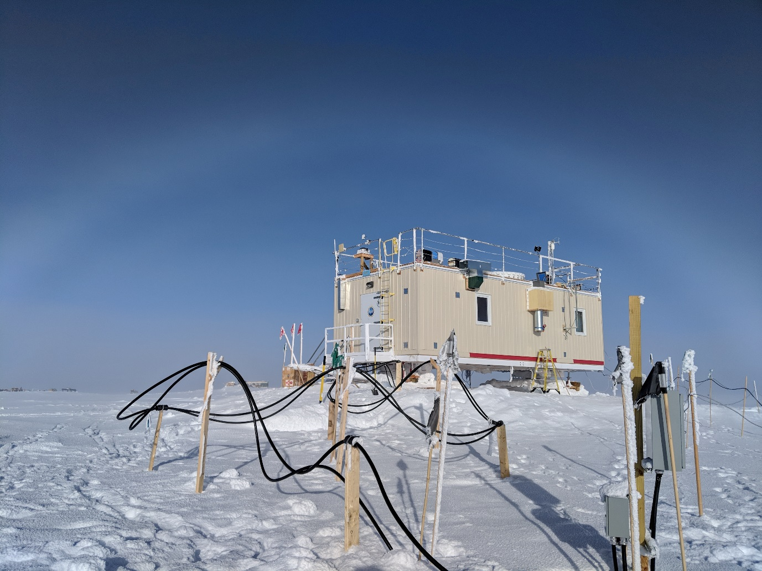

One of the many fogbows of the week. -HJ

**General:**

The MSF has settled at a pitch/roll of 0.00/0.32, with occasional swings to a roll of 0.43. After receiving information about the pin holding the two plates together, a re-leveling will occur this week.

**Significant Weather Observations:**

* 09-17: Bkn cumulus. -20C, 14kts. 18:39Z- 22 degree halo, parhelia, parhelic circle, circumzenithal arc, 120 degree parhelion.
* 09-18: Bkn altocumulus. -26C, 6 kts. 09:30-10:30Z, 16:00-19:00- Fogbow.
* 09-19: Ovc stratus. -20C, 12 kts.
* 09-20: VV002. -29C, 6 kts. Fzfg. 12:00-13:00Z fogbow.
* 09-21: VV005. -36C, 7 kts. Fzfg. 10:00-11:00Z, 12:00-13:00 fogbow.
* 09-22: Few cirrostratus. -28C, 4 kts.
* 09-23: Few cirrostratus. -32C, 12kts. 14:00Z- Fatamorgana.

**ICECAPS-ACE Data Management:**

* 09-17: Data transfer complete 06:11Z
* 09-18: Data transfer complete 05:38Z.
* 09-19: Data transfer complete 05:31Z.
* 09-20: Data transfer complete 05:34Z.
* 09-21: Data transfer complete 05:29Z.
* 09-22: Data transfer complete 05:41Z.
* 09-23: Data transfer complete 05:35Z.

**MWR:**

* Operating normally.
* 09-21: 150 channel reading 0.00 during scans. Peaks are visible during calibrations. Emailed Dave and Erik to make sure things were normal.

**SODAR:**

* Operating normally.
* Some strange noise values occurred on 09-21 and 09-22. Matt Shupe and Bill Neff are looking into things. Temperatures were quite low, so it could be the popping/settling of the SODAR.

**POSS:**

* Operating normally.

**MMCR:**

* Operating normally.
* Pitch wavering between 0.00 and -0.10, Roll 0.32.
* 09-17: Error 7 found. “Continue” selected at 12:58Z, all daily checks passed afterwards.
* 09-18: Error 7 found. “Continue” selected at 12:14Z, all daily checks passed afterwards.

**CAPABL:**

* Operating normally in Configure Ops Laser 2.

**MPL:**

* Operating normally.
* 09-17: Afterpulse calibration performed 19:04-19:27Z. 30m, 30s CopolBkdAvg: 0.000326, CopolBkdStd: 0.000205. 15m, 30s CopolBkdAvg: 0.000321, CopolBkdStd: 0.000299.

**VCEIL:**

* Operating normally.

**IceCAM:**

* Operating normally.

**PAERI:**

* Operating normally.

**TSI:**

* Operating normally.

**IcePIC:**

* No images captured this week.

**Radiosonde:**

* Twice daily soundings.
* New payoff weight calculated, but one more box of the heavier sondes were found. The weight was brought back to the original value, but will be adjusted again when the heavier sondes are totally used up.

**MASC:**

* Instrument offsite for repair, will not return until summer 2019.

**OPC:**

* Operating normally.
* 09-20: No opc or opc.png files sent over Dataman.

**CLASP:**

* Operating normally.

**CPC:**

* Operating normally.
* 09-17: “Air pump problem, current too high” error found during Monday rounds. After restarting, changing the filter, and unplugging a few lines, it was found that the exhaust line leading outside to the north of the MSF was clogged with frost/snow. It was pulled inside, thawed out, and cleared of snow. Normal operation resumed at 13:53Z.
* 09-18: Same error as previous day. Pulled exhaust line in, emptied frost, dried out with a cotton swab, and returned outside. Instrument back online at 10:48Z.
* 09-20: Ran the script to ensure that data logging had started. I missed this step on the previous days, but the plots were updating. Awaiting Neely’s reply to ensure that data collection looks good from his end.