**ICECAPS-ACE Weekly Report**

September 24 – 30, 2018

Hannah James

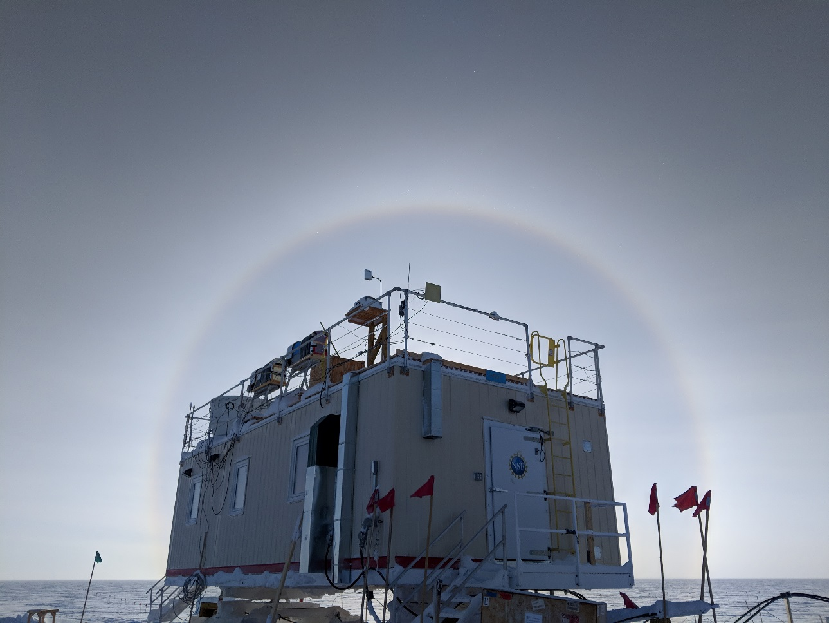

The MSF surrounded by one of the many 22 degree halos of the week. -HJ

**General:**

None to report.

**Significant Weather Observations:**

* 09-24: Bkn cirrocumulus. -25C, 10 kts. Drsn, br. 09:30-10:30Z- 22 degree halo.
* 09-25: Sct stratocumulus, bkn cirrocumulus. -28C, 8 kts.
* 09-26: Few cirrocumulus. -39C, 10 kts. Br.
* 09-27: Bkn altostratus, bkn cirrostratus. -35C, 13 kts. Br, IC. 12:00-19:00Z- 22 degree halo.
* 09-28: Bkn altocumulus, bkn cirrocumulus. -22C, 17 kts. Drsn. 19:50Z- 22 degree & 46 degree halo, upper tangent arc, circumzenithal arc, start of parhelic circle.
* 09-29: Bkn altocumulus, bkn cirrostratus. -34C, 11 kts. Br, IC. 10:00-16:00Z- 22 degree halo.
* 09-30: Bkn altocumulus. -28C, 14 kts. Drsn, br.

**ICECAPS-ACE Data Management:**

* 09-24: Data transfer complete 05:28Z.
* 09-25: Data transfer complete 05:49Z.
* 09-26: Data transfer complete 05:28Z.
* 09-27: Data transfer complete 05:44Z.
* 09-28: Data transfer complete 05:37Z.
* 09-29: Data transfer complete 05:46Z.
* 09-30: Data transfer complete 05:45Z.

**MWR:**

* Operating normally.

**SODAR:**

* Operating normally.

**POSS:**

* Operating normally.
* 09-27: Plugged lightbulb in at 18:53Z.

**MMCR:**

* Operating normally.
* Pitch wavering between 0.00 and -0.10, Roll 0.32.
* 09-24: Error 7 found. “Continue” selected at 13:14Z, all daily checks passed afterwards.

**CAPABL:**

* Operating normally in Configure Ops Laser 2.

**MPL:**

* Operating normally.

**VCEIL:**

* Operating normally.

**IceCAM:**

* Operating normally.
* 09-24: Broken link to 04:00Z photo.
* 09-29: Broken link to 09:15Z photo.

**PAERI:**

* Operating normally.

**TSI:**

* Operating normally.
* 09-27: 12:36Z- removed frost from camera lens.
* 09-29: 11:09Z- TSI shut down and removed from the roof for the winter season.

**IcePIC:**

* No images captured this week.

**Radiosonde:**

* Twice daily soundings.
* 09-30: Lighter sondes cycled into sonde launches.
* New payoff weight calculated for lighter improved sonde covers. The previous weight of 610.7g was reduced to 510.4g to achieve an average ascent rate of 4.75 meters per second.

**MASC:**

* Instrument offsite for repair, will not return until summer 2019.

**OPC:**

* Operating normally.
* 09-26: No opc files or opc.png files sent over Dataman.

**CLASP:**

* Operating normally.
* 09-30: 15:15Z- Powered down and brought inside to thaw out per Neely’s request. After 24-48 hours inside, and no fog is present, it will be reinstalled on the ACE tower.

**CPC:**

* Temperature and status lights alternating between orange and green throughout the day since 09-28. Data plots continue to update.
* 09-30: 14:37-14:39Z: Refilled butanol bottle