**ICECAPS-ACE Weekly Report**

September 3 – 9, 2018

Hannah James

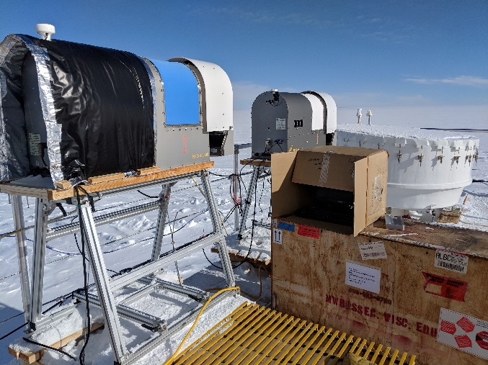 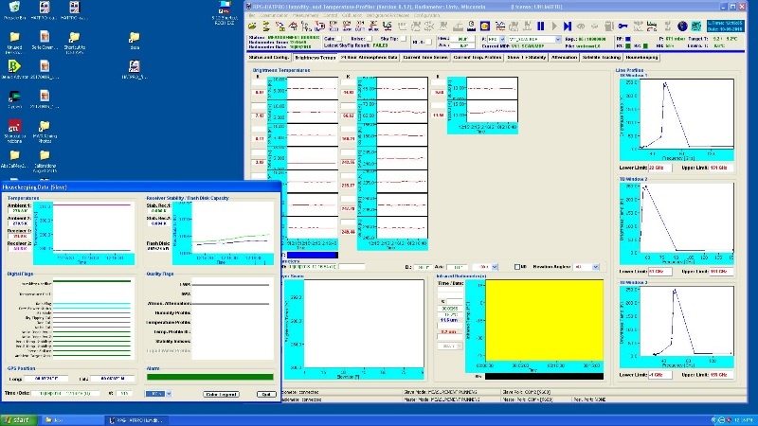

A successful day at the office on the MSF roof! The HATPRO and 150-90 MWRs are

back in buisness collection data together in the Master/Slave configuration. -HJ

**General:**

On Friday, September 7, an attempt to bring the MSF to 0.00/0.00 leveling occurred. In order to get the pitch (front to back) level, the rear of the building needed to be jacked up quite a bit, so the pivot plates between the skis and MSF are separated by a large gap (the pin is still securely in place). We are awaiting FEMCO’s recommendation on how to proceed. As of Monday morning, the MSF sits at -0.10 Pitch, 0.22 Roll.

**Significant Weather Observations:**

* 09-03: Few altocumulus, sct cirrus, sct cirrus spissatus. -25C, 14 kts. Br, IC.
* 09-04: Bkn cumulus, bkn cirrus. -23C, 6 kts. IC. 11:00-11:30Z- Parhelic circle, 22-degree halo, circumzenithal arc. 11:07Z- 120° parhelion.
* 09-05: Sct altostratus, bkn cirrus. -23C, 17 kts. Br, drsn.
* 09-06: Ovc stratus. -14C, 14 kts.
* 09-07: Bkn cirrus. -12C, 17 kts. Drsn.
* 09-08: Ovc stratus. -13C, 9 kts. -Sn, br.
* 09-09: Ovc stratus. -14C, 13 kts. -Sn.

**ICECAPS-ACE Data Management:**

* 09-03: Data transfer complete 05:17Z.
* 09-04: Data transfer complete 05:21Z.
* 09-05: Data transfer complete 05:15Z.
* 09-06: Data transfer complete 05:17Z. MWR mounts down. Unable to remount drives.
* 09-07: Data transfer complete 06:04. ArchiveBoulder log reported that there were no cpc png, opc files, or opc png files to send.
* 09-08: Data transfer complete 06:02Z.
* 09-09: Data transfer complete 06:02Z.

**MWR:**

* **Both** radiometers operating normally!
* 09-04: 150-90 started up at 16:33Z. Comms cable needed to be re-seated, version 8.12 opened after “190” files were moved out of R2CH folder.
* 09-05: Successfully connected to the HATPRO! On the roof, a monitor and keyboard connection were made directly to the back of the radiometer. Thomas from RPG was on the line with Dave, and Hannah, Dave, and Erik were all on a skype call during the entire process. A reboot was performed, and on the monitor showed that the radiometer was operating in Version 8.12. The copper comms cable was connected, and connection was established with a baudrate of 19200 to the HATPRO. After a few minutes however, the connection was lost. The cables were swapped both on the roof and inside to the host computer, the radiometers were rebooted, and a successful connection was established with a baudrate of 9600. Data collection started around 15:00Z.

**SODAR:**

* Operating normally.
* 09-07: SODAR moved to its new location further behind the MSF. After it was placed, the instrument and then dishes were cleared of snow and leveled. Data collection paused 11:50-14:28Z.

**POSS:**

* Operating normally.
* 09-03: DC offset error at 11:50Z.

**MMCR:**

* Operating normally.
* Pitch -0.10, Roll wavering between 0.22 and 0.32.
* 09-07: MSF leveling attempted. The southeast corner needed to be raised a fair amount, which increased a gap between the pivot plates. We are awaiting FEMCO’s suggestion on how to proceed.

**CAPABL:**

* Operating normally in Configure Ops Laser 2.
* 09-07: Data collection paused during MSF leveling from 12:51-14:16Z.

**MPL:**

* Operating normally.

**VCEIL:**

* Operating normally.

**IceCAM:**

* Operating normally.

**PAERI:**

* Operating normally.

**TSI:**

* Operating normally.

**IcePIC:**

* 09-09: Slides placed for collection 14:00-14:27Z. Images captured include Bullet rosettes, sheaths, isolated bullets, hollow columns, broken arms of stellar dendrites, one trigonal ice plate.

**Radiosonde:**

* Twice daily soundings.
* 09-08: New sondes with “improved covers” made of lighter Styrofoam (as opposed to the hard plastic previously used) cycled into launches. These sondes are 29 grams lighter than the old plastic covers, so a new payoff weight to obtain an ascension rate of 4.75 meters per second will be calculated over the coming days.

**MASC:**

* Instrument offsite for repair, will not return until summer 2019.

**OPC:**

* Operating normally.
* 09-07:ArchiveBoulder log reported that there were no opc files or opc .png files to send.

**CLASP:**

* Operating normally.

**CPC:**

* Operating normally.
* 09-07: ArchiveBoulder log reported that there were no cpc .png files to send.