**ICECAPS Weekly Report**

April 16 – 22, 2018

Rex Nelson

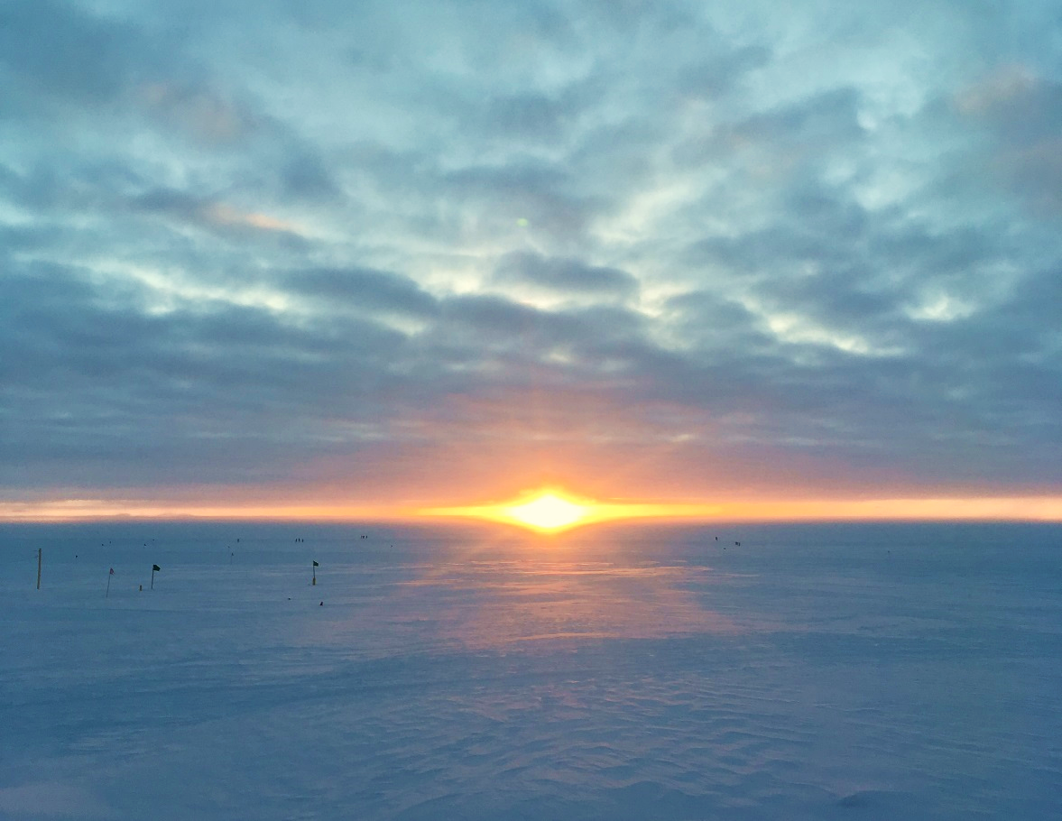

A nice sunset on 04-17.

**General:**

* The MSF time server GPS antenna is being borrowed by the Radiosonde base station.

**Significant Weather Observations:**

* 04-16: Few altostratus. -24C, 7kts. A period of freezing fog in the morning.
* 04-17: Ovc fzfg. -20C, 14kts. Turning clear after the sundog. 12:50-13:10Z: 22deg halo, parhelia, faint upper tangent arc, faint 46deg halo, circumzenithal arc, partial parhelic circle, 120deg parhelia.
* 04-18: Sct fzfg. -25C, 10kts. 10:30-11:30Z: fogbow.
* 04-19: Few stratus. Fzfg. Sn. -22C, 12kts. Intermittent 22deg halo throughout the day.
* 04-20: Ovc stratocumulus. Br. Sn. -19C, 12kts.
* 04-21: Bkn altostratus. -25C, 6kts.
* 04-22: Br. -33C, 14kts.

**ICECAPS Data Management:**

* 04-16: Data transfer complete 06:48Z
* 04-17: Data transfer complete 06:28Z
* 04-18: Data transfer complete 07:04Z
* 04-19: Data transfer complete 06:38Z
* 04-20: Data transfer complete 06:43Z
* 04-21: Data transfer complete 06:51Z
* 04-22: Data transfer complete 06:52Z

**MWR:**

* As of 10-28, 150-90 operating in V11_SCAN_HF.MBF.

**SODAR:**

* Operating normally.
* 04-16: 16:46-16:58Z, SODAR off while cleaning snow from dishes.

**POSS:**

* Operating normally in old software.

**MMCR:**

* Operating normally.

**CAPABL:**

* Operating normally.
* 04-17: 05:45Z. PMT voltage increased to 1000.
* 04-22: 12:36Z. Cleared snow from window after sweeping roof.

**MPL:**

* Operating normally.
* 04-22: 12:36Z. Cleared snow from window after sweeping roof.

**VCEIL:**

* The ceilometer was removed from the roof on 2018-03-28 due to laser failure. It is awaiting parts.

**Hotplate:**

* Offline since 2018-01-11 due to Error 1073807339 (timeout expired before operation completed).

**IceCAM:**

* Operating normally.

**PAERI:**

* Operating normally.
* 04-17: 1630-1730Z. Fan removed and thermistors unplugged from IPSD while replacing Outside Temp thermistor.

**TSI:**

* In the MSF for winter storage.

**IcePIC:**

* No images collected this week

**Radiosonde:**

* Twice daily soundings.
* Radiosonde GPS antenna is temporarily located on SE Green House roof railing.

**MASC:**

* The MASC has been packaged for shipment to Vanderbuilt for repairs.