**ICECAPS Weekly Report**

April 2 – 8, 2018

Rex Nelson

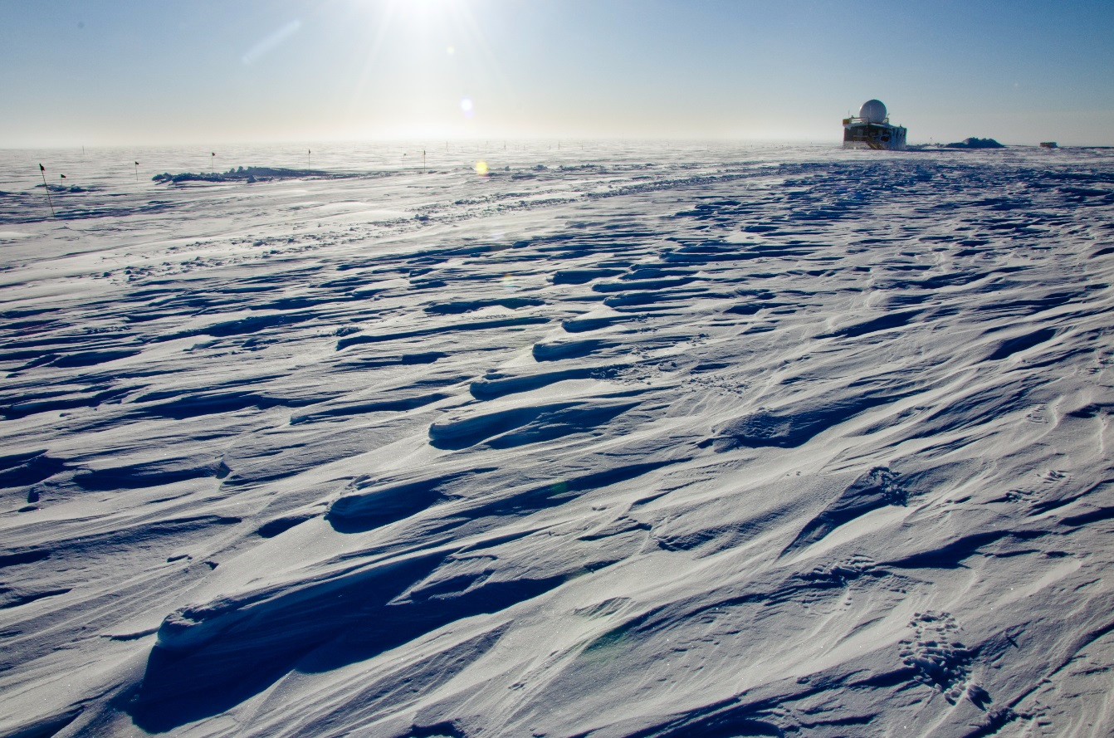

Old footsteps wind-carved into new sastrugi on the path from MSF to the Big House.

**General:**

* Heavy equipment operations around station all week.

**Significant Weather Observations:**

* 04-02: Ovc altostratus. -28C, 12kts. Fzfg. ~11:15 to ~18:30Z: 22deg halo.
* 04-03: Few stratocumulus. -36C, 20kts. Br, Drsn.
* 04-04: Skc. -44C, 11kts.
* 04-05: Few altostratus. -44, 9kts.
* 04-06: Few stratus. -44C, 11kts. Br.
* 04-07: Few cirrus. -38C, 12kts. Br.
* 04-08: Few altostratus. -32C, 9kts. ~10:00 to ~12:30Z: faint 22deg halo

**ICECAPS Data Management:**

* 04-02: Data transfer complete 14:38Z
* 04-03: Data transfer complete 14:09Z
* 04-04: Data transfer complete 17:45Z
* 04-05: Data transfer complete 15:06Z
* 04-06: Data transfer complete 16:21Z
* 04-07: Data transfer complete 17:29Z
* 04-08: Data transfer complete 13:37Z

**MWR:**

* As of 10-28, 150-90 operating in V11_SCAN_HF.MBF.

**SODAR:**

* Operating normally.
* 04-04 through 04-07: Heavy equipment operations caught on SODAR.

**POSS:**

* Operating normally in old software.

**MMCR:**

* Operating normally.

**CAPABL:**

* Operating normally.
* 04-02: 17:00Z. Wiped snow from window after sweeping roof.

**MPL:**

* Operating normally.

**VCEIL:**

* The ceilometer was removed from the roof on 2018-03-28 due to laser failure. It is awaiting parts.

**Hotplate:**

* Offline since 2018-01-11 due to Error 1073807339 (timeout expired before operation completed).

**IceCAM:**

* Operating normally.

**PAERI:**

* Operating normally.
* 04-04: Multiple yellow flags due to low temps outside and inside.
* 04-05: Some yellow flags due to low outside temps.
* 04-06: Some yellow flags due to low outside temps.
* 04-07: Some yellow flags due to low outside temps.

**TSI:**

* In the MSF for winter storage.

**IcePIC:**

* 04-02: Slides placed for collection 1830-1835Z. Particles photographed include isolated bullets, bullet rosettes, radiating plates, and irregulars.

**Radiosonde:**

* Twice daily soundings.
* Radiosonde GPS antenna is temporarily located on SE Green House roof railing.

**MASC:**

* The MASC has been packaged for shipment to Vanderbuilt for repairs.