**ICECAPS Weekly Report**

April 23 – 29, 2018

Rex Nelson

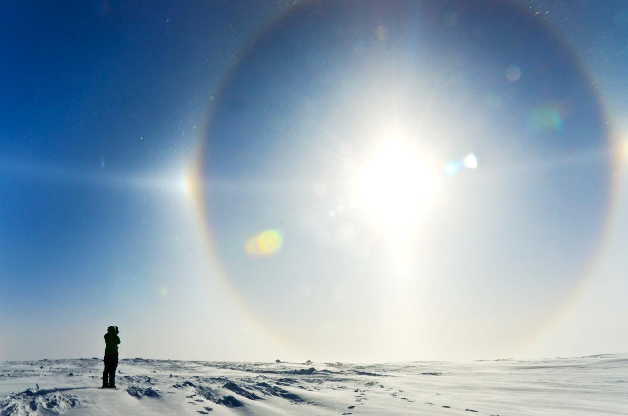

Admiring a nice sundog on 04-28.

**General:**

* The MSF time server GPS antenna is being borrowed by the Radiosonde base station.

**Significant Weather Observations:**

* 04-23: Sct altostratus. -32C, 6kts. Freezing fog in the morning.
* 04-24: Few altostratus. -33C, 5kts. Freezing fog in the morning.
* 04-25: Br. -35C, 4kts.
* 04-26: Few stratus. -36C, 12kts. Intermittent 22deg halo, parhelia, upper & lower tangent arc throughout the day.
* 04-27: Br. -38C, 8kts.
* 04-28: Low vis in Blsn. -23C, 25kts. 18:30Z & 20:30Z: 22 & 46deg halos, parhelia, upper tangent arc, circumzenithal arc, partial parhelic circle.
* 04-29: Sct altocumulus. Br. -34C, 19kts.

**ICECAPS Data Management:**

* 04-23: Data transfer complete 05:32Z
* 04-24: Dataman found unresponsive at 12:42Z. Rebooted at 15:40Z. Data transfer complete 21:32Z
* 04-25: Data transfer complete 06:58Z
* 04-26: Data transfer complete 06:59Z
* 04-27: Data transfer complete 11:16Z
* 04-28: Data transfer complete 06:19Z
* 04-29: Data transfer complete 05:52Z

**MWR:**

* As of 10-28, 150-90 operating in V11_SCAN_HF.MBF.

**SODAR:**

* Operating normally.

**POSS:**

* Operating normally in old software.

**MMCR:**

* Operating normally.
* 04-26: NetCDF errors present. Initiated system reboot at 12:18Z. Additional reboots at 12:31Z, 12:46Z, 13:03Z, 13:19Z. System collecting data again at 13:32Z.
* 04-27: NetCDF errors present.

**CAPABL:**

* Operating normally.
* 04-24: Cleaned snow from window at 12:48Z

**MPL:**

* Operating normally.
* 04-24: Cleaned snow from window at 12:49Z

**VCEIL:**

* The ceilometer was removed from the roof on 2018-03-28 due to laser failure. Parts arrived this week.
* 04-27: Replaced heater and laser assemblies. Ceilometer returned to normal operation at 18:30Z.

**Hotplate:**

* Offline since 2018-01-11 due to Error 1073807339 (timeout expired before operation completed).

**IceCAM:**

* Operating normally.

**PAERI:**

* Operating normally.
* 04-23: 13:37-13:55Z. Removed fan to defrost.
* 04-25: 11:53-12:21Z. Removed fan to defrost.
* 04-28: Red LW & SW Responsivity flags. Did not clean due to foul weather.
* 04-29: LW & SW Responsivity flags cleared overnight.

**TSI:**

* In the MSF for winter storage.

**IcePIC:**

* No images collected this week

**Radiosonde:**

* Twice daily soundings.
* Radiosonde GPS antenna is temporarily located on SE Green House roof railing.
* 04-28: Due to the NOAA met being down, the evening sonde’s surface ob for RH was obtained from the sonde itself.

**MASC:**

* The MASC has been packaged for shipment to Vanderbuilt for repairs.