**ICECAPS Weekly Report**

April 30 – May 6, 2018

Rex Nelson

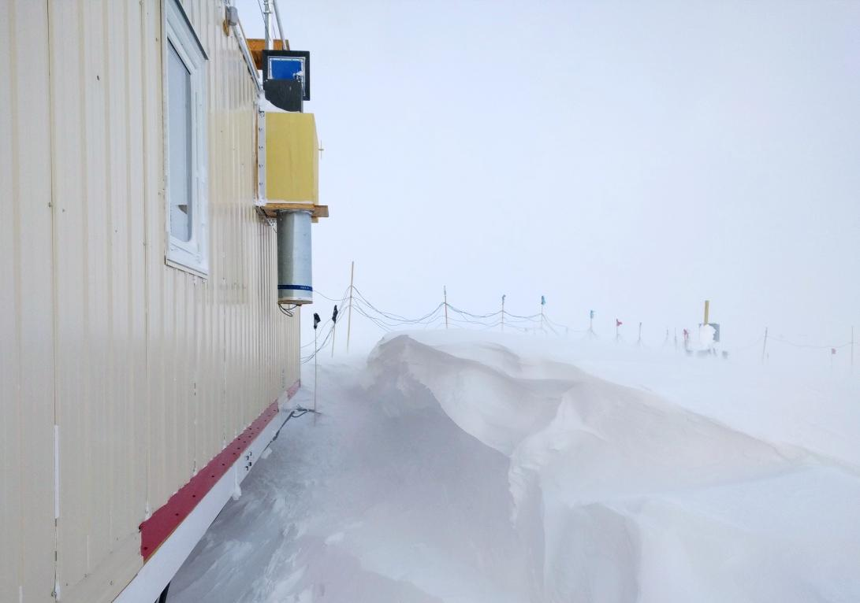

The growing drift south of MSF.

**General:**

* The MSF time server GPS antenna is being borrowed by the Radiosonde base station.

**Significant Weather Observations:**

* 04-30: Br. -36C, 10kts.
* 05-01: Sct altostratus. -33C, 12kts.
* 05-02: Blsn. Very low vis. -24C, 32kts.
* 05-03: Bkn stratus. -30C, 12kts. 11:00Z to 22:00Z: 22deg halo
* 05-04: Few stratocumulus. Drsn. Ic. -26C, 15kts. 07:00Z to 12:00Z: 22deg halo
* 05-05: Few stratocumulus. -30C, 5kts.
* 05-06: Bkn altocumulus. Drsn. Br. -33C, 22kts. 18:00Z: 22deg halo, parhelia

**ICECAPS Data Management:**

* 04-30: Data transfer complete 05:47Z
* 05-01: Data transfer complete 07:42Z
* 05-02: Data transfer complete 07:30Z
* 05-03: Data transfer complete 05:50Z
* 05-04: Data transfer complete 06:40Z
* 05-05: Data transfer complete 08:23Z
* 05-06: Data transfer complete 05:45Z

**MWR:**

* As of 10-28, 150-90 operating in V11_SCAN_HF.MBF.

**SODAR:**

* Operating normally.
* 04-30: 12:39-12:46Z: SODAR off while cleaning snow from dishes.
* 05-03: 12:30-12:55Z: SODAR off while cleaning snow from dishes and leveling.

**POSS:**

* Operating normally in old software.

**MMCR:**

* Operating normally.

**CAPABL:**

* Operating normally.
* 05-03: CAPABL was found with a disk boot error at 12:00Z, caused by motor controller comms failure. After power cycling everything, a basic alignment was required.

**MPL:**

* Operating normally.

**VCEIL:**

* Operating normally.

**Hotplate:**

* Offline since 2018-01-11 due to Error 1073807339 (timeout expired before operation completed).
* The hotplate was shipped out for repair.

**IceCAM:**

* Operating normally.

**PAERI:**

* Operating normally.
* 04-30: Red LW & SW Responsivity flags. Cleaned mirror at 11:57Z.
* 05-02: Red LW & SW Responsivity flags. Flags cleared after a few hours.
* 05-03: 1535Z. Cleared snow from around roof box.

**TSI:**

* In the MSF for winter storage.

**IcePIC:**

* 05-06: Slides placed for collection 12:45-12:55Z. Particles photographed include isolated bullets, needles, simple prisms, and irregulars.

**Radiosonde:**

* Twice daily soundings.
* Radiosonde GPS antenna is temporarily located on SE Green House roof railing.

**MASC:**

* The MASC was shipped out for repair.