**ICECAPS Weekly Report**

April 9 – 15, 2018

Rex Nelson

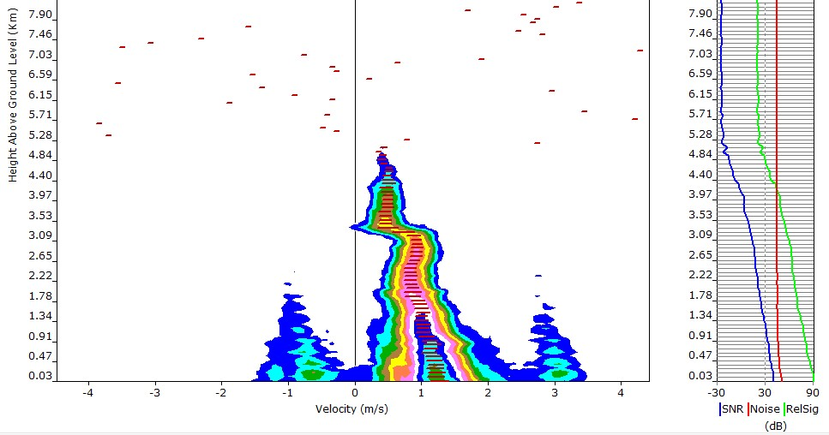

Interesting plot on the MMCR. 04-14: 11:50Z

**General:**

* Heavy equipment operations around station all week.

**Significant Weather Observations:**

* 04-09: Few altostratus. -29C, 10kts. ~13:30 to ~21:00Z: 22deg halo with occasional parhelia.
* 04-10: Sct stratocumulus. -24C, 17kts. Blsn. Ic. ~11:30 to ~1700Z: 22deg halo with occasional parhelia and 46deg halo. 14:00Z: upper tangent arc, circumzenithal arc.
* 04-11: Ovc stratus. -24C, 16kts. Drsn. Ic. Fzfg. ~07:00 to ~16:00Z: intermittent 22deg halo with occasional parhelia.
* 04-12: Skc. -29C, 11kts. Fzfg. 12:00Z: fogbow.
* 04-13: Few stratocumulus, Sct altostratus. -31C, 11kts. Br.
* 04-14: Ovc. -22C, 17kts. Fzfg.
* 04-15: Few stratus. -23C, 11kts.

**ICECAPS Data Management:**

* 04-09: Data transfer complete 13:52Z
* 04-10: Data transfer complete 14:56Z
* 04-11: Data transfer complete 13:56Z
* 04-12: Data transfer complete 05:49Z
* 04-13: Data transfer complete 06:47Z
* 04-14: Data transfer complete 07:09Z
* 04-15: Data transfer complete 06:56Z

**MWR:**

* As of 10-28, 150-90 operating in V11_SCAN_HF.MBF.

**SODAR:**

* Operating normally.
* 04-09: 15:34-15:42Z. SODAR off while cleaning snow from dishes.

**POSS:**

* Operating normally in old software.

**MMCR:**

* Operating normally.

**CAPABL:**

* Operating normally.

**MPL:**

* Operating normally.
* 04-13: 12:25-12:46Z. Afterpulse calibration performed.

**VCEIL:**

* The ceilometer was removed from the roof on 2018-03-28 due to laser failure. It is awaiting parts.

**Hotplate:**

* Offline since 2018-01-11 due to Error 1073807339 (timeout expired before operation completed).

**IceCAM:**

* Operating normally.

**PAERI:**

* Operating normally.
* 04-10: 21:15-21:30Z: Removed fan enclosure and cleared snow. 22:25-22:30Z: Removed fan enclosure to troubleshoot red Outside Air Temp flag.
* 04-11: 12:40-12:45Z: Removed fan enclosure to check thermistor. 12:55Z: Cleaned mirror.
* 04-13: 16:35-16:47Z: Fan enclosure removed and J28 (thermistors) disconnected from IPSD, to assess thermistor wiring.

**TSI:**

* In the MSF for winter storage.

**IcePIC:**

* 04-09: Slides placed for collection 16:50-17:00Z. Particles photographed include isolated bullets, bullet rosettes, hollow columns, and irregulars.
* 04-14: Slides placed for collection 12:10-12:15Z. Particles photographed include isolated bullets, hollow columns, hexagonal plates, radiating plates, and irregulars.

**Radiosonde:**

* Twice daily soundings.
* Radiosonde GPS antenna is temporarily located on SE Green House roof railing.
* 4-10: The GPS antenna connector was damaged while replacing the antenna cable. As a result, the evening radiosonde terminated itself.
* 4-11: The GPS antenna was replaced with the MSF time server antenna.

**MASC:**

* The MASC has been packaged for shipment to Vanderbuilt for repairs.