**ICECAPS Weekly Report**

February 5 – February 11, 2018

Hannah James & Rex Nelson

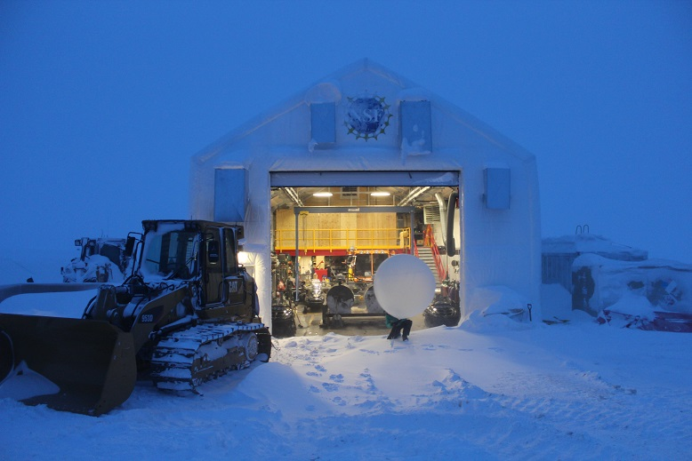

Tech Holly Abercrombie connects the radiosonde to a morning balloon. -HJ

**General:**

* NOAA 10m sonic anemometer was reporting incorrect wind speed and direction on 2018-02-05. Andy Clarke at NOAA noted that this seems to happen at temperatures below -50C. Due to the server transmitting a high amount of data mid-week, ICECAPS data delivery was delayed at times.

**Significant Weather Observations:**

* 02-05: Sct stratus, ovc altostratus. -49C, 6 kts. Fzfg. 13:00Z- Yukimarimos accumulated in surface depressions (formed previous night). Balls measured up to 3cm in diameter.
* 02-06: Skc, -58C, 15 kts. Vcfzfg, 12:00Z- fatamorgana. In afternoon, ovc cirrostratus. -48C, 25kts. Drsn.
* 02-07: Sct stratus, bkn altocumulus, bkn cirrostratus. Many different cloud layers moving in throughout the morning. -36C, 20 kts, calming to 12 knots by 14:30Z. Blsn, drsn.
* 02-08: Bkn altostratus, bkn cirrostratus. -42C, 12 kts. Br.
* 02-09: Bkn stratus, clearing to few stratus. -46C, 16 kts. Drsn, fzfg.
* 02-10: Ovc altostratus. -43C, 19 kts. Drsn, fzfg.
* 02-11: VV 100 meters. -36C, 28 knots, gusts up to 52kts. Blsn.

**ICECAPS Data Management:**

* 02-05: Data transfer complete 13:03Z.
* 02-06: Data transfer complete 13:01Z.
* 02-07: Data transfer complete 20:22Z. Large changes to server caused Dataman transfers to be delayed.
* 02-08: Data transfer complete 21:15Z.
* 02-09: Data transfer complete 18:52Z
* 02-10: Data transfer complete 12:22Z.
* 02-11: Data transfer complete 20:25Z. Network outage mid-morning, data transfer stopped for unknown reasons. Manual data transfer started at 13:52Z, lost connection at other points throughout the day due to high winds.

**MWR:**

* As of 10-28, 150-90 operating in V11_SCAN_HF.MBF.
* HATPRO and faulty comms cable sent off station for repairs at RPG in Germany 2018-02-09.
* 02-07: 150-90 found with no comms during daily check. Upon first reconnection attempt, “Baudrate programming failed” error appeared. Cables on the roof looked good, so a power cycle of the radiometer occurred. Connection was established and data collection resumed at 14:14Z.
* 02-11: 14:06Z- MWR lost communications due to high winds. Cables on roof looked good, after power cycle of instrument the connection was reset at 14:37Z. After loading batch file, comms were immediately lost, reconnection established at 14:41Z, data collection resumed.

**SODAR:**

* Operating normally.
* Due to high winds at the end of the week, SODAR data was filled with noise.

**POSS:**

* Operating normally in old software.

**MMCR:**

* Operating normally.
* 02-06: Error 7 found, occurring around 04:00Z. Hit “continue” at 12:28, data collection resumed and daily 12:30Z calibration passed. Error 7 found again in the evening; hit “continue” at 17:35Z.
* 02-09: Error 7 found during rounds, occurring around 10:00Z. Hit “continue” at 12:49Z, data collection resumed.
* 02-10: Error 7 found during rounds, occurring around 04:00Z. Hit “continue” at 12:35Z, data collection resumed.

**CAPABL:**

* Operating normally.

**MPL:**

* Operating normally.

**VCEIL:**

* Operating normally.

**Hotplate:**

* Offline since 2018-01-11 due to Error 1073807339 (timeout expired before operation completed).

**IceCAM:**

* Operating normally.

**PAERI:**

* Operating normally.
* 02-06: Sterling cooler louder than usual. A constant, whining sound was audible upon entering the MSF at 17:30Z. Von was contacted, and reported that it may be dying. We will be keeping a special eye (and ear) on it.
* 02-07: Sterling cooler noise level returned to normal.
* 02-11: 19:15Z- cleaned snow off mirror.

**TSI:**

* In the MSF for winter storage.

**IcePIC:**

* No images collected this week.

**Radiosonde:**

* Twice daily soundings

**MASC:**

* Per Ralf’s request, the MASC will be shipped off station and return to Vanderbuilt for repairs. Shipment date has not been determined, but it will be ready to leave on the incoming Twin Otter if DHL shipment through Iceland can be arranged.02-05: Found power supply unplugged on Monday morning rounds. After restarting software and power cycling instrument, the instrument remained unresponsive and interior LED lights were off. The MASC was brought inside for inspection, where LED lights turned back on and paper dropped through the decagon was captured. John requested that it remain inside while he discusses options with Ralf.
* 02-07: Brought electronics box inside.