**ICECAPS Weekly Report**

February 12 – February 18, 2018

Rex Nelson

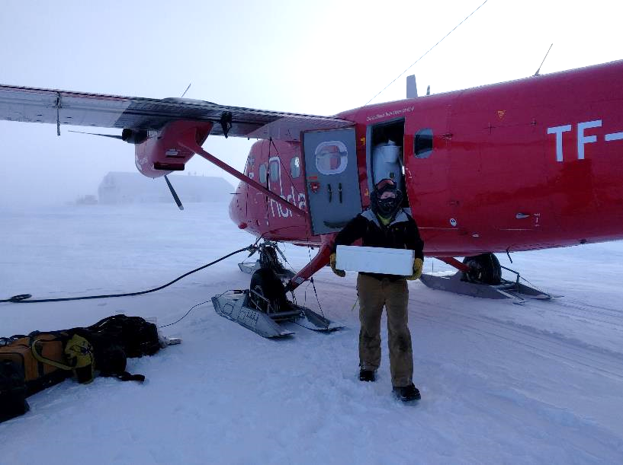

Tech Hannah James unloading freshies for the spring phase.

**General:**

* The ICECAPS tech position was successfully turned over this week. Hannah and the remaining winter crew finally departed station on the 18th after several days of weather delay.

**Significant Weather Observations:**

* 02-12: Ovc altostratus. -38C, 27kts. Blsn.
* 02-13: Ovc stratus. -35C. 29kts. Blsn.
* 02-14: Ovc stratus. -36C. 23kts. Drsn.
* 02-15: Ovc altostratus. -34C. 26kts. Blsn.
* 02-16: Bkn altostratus. -28C. 26kts. Blsn.
* 02-17: Ovc altostratus. -26C. 21kts. Blsn.
* 02-18: Ovc altocumulus. -33C. 21kts. Drsn.

**ICECAPS Data Management:**

* 02-12: Data transfer complete 14:51Z. Rebooted 1820-1828Z for turnover purposes.
* 02-13: Data transfer complete 12:59Z
* 02-14: Data transfer complete 14:35Z
* 02-15: Data transfer complete 13:31Z
* 02-16: Data transfer complete 15:03Z
* 02-17: Data transfer complete 15:46Z
* 02-18: Data transfer complete 12:45Z

**MWR:**

* As of 10-28, 150-90 operating in V11_SCAN_HF.MBF.
* 02-14: The 150-90 was found disconnected during daily check at ~13:15Z. Upon initial reconnection attempts, “Baudrate” errors appeared due to user error inputting comms settings. Cables on the roof looked good. A power cycle of the radiometer occurred. Connection was established and data collection resumed at 13:30Z.
* 02-17: Software found blank/frozen at 12:45Z. Restarted software but could not connect. Power cycled instrument and regained connection at 12:51Z.

**SODAR:**

* Operating normally.
* 02-12: Very low signal due to heavy snowpack. Cleaned dishes and rebooted 1854-1913Z.
* 02-16: Very low signal due to heavy snowpack. Cleaned dishes 1418-1431Z.

**POSS:**

* Operating normally in old software.
* 02-12: Rebooted 1818-1828Z for turnover purposes.

**MMCR:**

* Operating normally.
* 02-12: Rebooted to clear “NetCDF” errors. First reboot at 1737Z. Second reboot at 1751Z. System collecting data at 1759Z.

**CAPABL:**

* Operating normally.
* 02-13: System shutdown at 1808Z for training purposes.

**MPL:**

* Operating normally.
* 02-13: 14:08-14:31Z: Afterpulse calibration performed. 14:12-14:20Z- 30m, 30s. CoPolBkdAvg: 0.000258, CoPolBkdStd: 0.000176. 14:22-14:30Z- 15m, 30s. CoPolBkdAvg: 0.000292, CoPolBkdStd: 0.000257.

**VCEIL:**

* Operating normally.
* 02-13: Cleared snow at ~12:40Z.

**Hotplate:**

* Offline since 2018-01-11 due to Error 1073807339 (timeout expired before operation completed).

**IceCAM:**

* Operating normally.

**PAERI:**

* Operating normally.
* 02-12: Cleaned mirror at ~1300Z due to LW&SW HBB NEN and LW&SW Responsivity flags. Time Series Graph window disappeared after cleaning.
* 02-13: Encoder Scene Confirm flag turned yellow sometime before 0000Z.
* 02-14: Encoder Scene Confirm flag green.
* 02-15: Cleaned fan enclosure which triggered red LW&SW Responsivity flags. Cleaned mirror.
* 02-16: Cleaned fan enclosure and mirror.

**TSI:**

* In the MSF for winter storage.

**IcePIC:**

* No images collected this week.

**Radiosonde:**

* Twice daily soundings, excepting a couple missed soundings due to high winds.

**MASC:**

* The MASC has been packaged for shipment to Vanderbuilt for repairs.