**ICECAPS Weekly Report**

February 19 – February 25, 2018

Rex Nelson

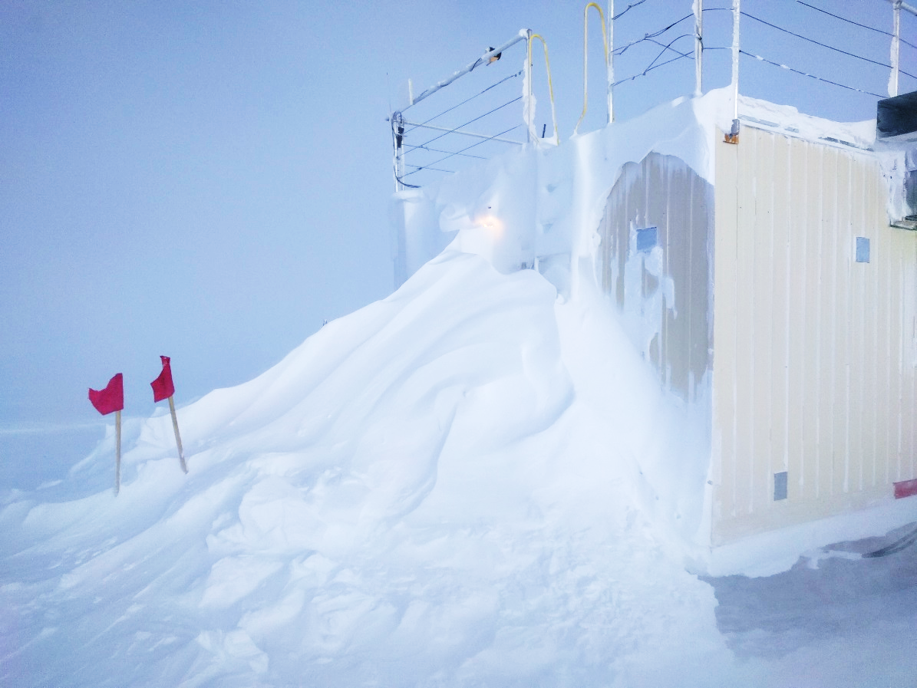

The MSF front door after a storm with record-breaking wind speeds.

**General:**

* It’s been a very stormy week, with certain impact to science. The MSF suffered from snow in the ventilation system and also snow blowing in through the east door jamb, wetting a square meter of carpet. It is suspected that these caused a rise in humidity in the building which in turn caused frost on the inside of the CAPABL and MPL windows. Other instrument problems also occurred due to snow build-up and static from high winds.

**Significant Weather Observations:**

* 02-19: Visibility zero. -25C, 49kts. Blsn.
* 02-20: Visibility zero. -25C, 42kts. Blsn.
* 02-21: Skc. -48C, 7kts. Beautiful morning! Ovc altostratus in afternoon. By evening visibility zero in Blsn.
* 02-22: Ovc altostratus. -35C, 9kts. Drsn. Br.
* 02-23: Skc. -37C, 23kts. Blsn.
* 02-24: Visibility zero. -23C, 45kts. Blsn.
* 02-25: Low visibility. -32C, 26kts. Blsn.

**ICECAPS Data Management:**

* 02-19: Data transfer complete 12:23Z
* 02-20: Data transfer complete 11:57Z
* 02-21: Data transfer complete 17:28Z
* 02-22: Data transfer complete 11:15Z
* 02-23: Data transfer complete 13:21Z
* 02-24: Data transfer complete 11:18Z
* 02-25: Data transfer complete 10:09Z

**MWR:**

* As of 10-28, 150-90 operating in V11_SCAN_HF.MBF.
* 02-21: The 150-90was found disconnected at ~14:20Z. The radiometer was power cycled, successfully re-establishing connection at 14:28Z.
* 02-22: The 150-90was found disconnected at 14:16Z. The radiometer was power cycled, successfully re-establishing connection at 14:18Z.
* 02-25: The 150-90was found disconnected at ~14:40Z. The radiometer was power cycled, successfully re-establishing connection at 14:47Z.

**SODAR:**

* Operating normally.
* 02-21: Cleaned snow from dishes 18:24-18:42Z.
* 02-25: Poor signal, most likely from snow in the dishes. Did not clean due to bad weather.

**POSS:**

* Operating normally in old software.

**MMCR:**

* Operating normally.
* 02-24: Roll is out of level. MSF leveling will occur at first opportunity.

**CAPABL:**

* Operating normally.
* 02-21: Low signal due to frost on the inside of the window. A heat gun was used to slowly melt the frost. Data collection resumed at 17:48Z.
* 02-25: Rebooted computer due to communications outage ~18:40Z. Considerable frost on the inside of the window. Cleaning did not occur due to degradation of weather.

**MPL:**

* Operating normally.
* 2-25: Considerable frost on the inside of the window. Cleaning did not occur due to degradation of weather.

**VCEIL:**

* Operating normally.
* 02-21: Window cleared of snow at 15:15Z, but partially covered in ice. Warning in status message: “Receiver optical cross-talk compensation poor.”
* 02-22: Window cleared of snow at 14:32Z, but still partially covered in ice.
* 02-23: Window partially covered in ice, but improving.
* 02-25: Window almost fully covered in ice. Cleared of snow at ~16:40Z. Warnings in status message: “Receiver failure (A)Window contaminated (W)Battery low (W)Laser power low (W)Receiver optical cross-talk compensation poor”

**Hotplate:**

* Offline since 2018-01-11 due to Error 1073807339 (timeout expired before operation completed).

**IceCAM:**

* Operating normally.
* 02-21: Rebooted at 15:30Z to clean up image.
* 02-22: Rebooted at 14:13Z to clean up image.
* 02-25: Camera not communicating. Power cycle and transfer to known-good switch port were unsuccessful.

**PAERI:**

* Operating normally.
* 02-25: Cleaned mirror at ~16:30Z and again at 16:35Z due to LW&SW Responsivity flags. The flags returned promptly in foul weather.

**TSI:**

* In the MSF for winter storage.

**IcePIC:**

* No images collected this week.

**Radiosonde:**

* Several soundings were missed due to foul weather.
* 02-20: Evening sonde received no GPS signal. This caused automatic launch start to fail.
* 02-21: GPS issue continues.
* 02-22: The GPS cable was found to be faulty. A spare cable and antenna were used for the evening sonde. This antenna is temporarily located on the SE corner of the Green House roof. Height adjustment was made in the Vaisala sonde software.
* 02-23 through 02-25: Continuing to use spare antenna.

**MASC:**

* The MASC has been packaged for shipment to Vanderbuilt for repairs.