**ICECAPS Weekly Report**

February 26 – March 4, 2018

Rex Nelson

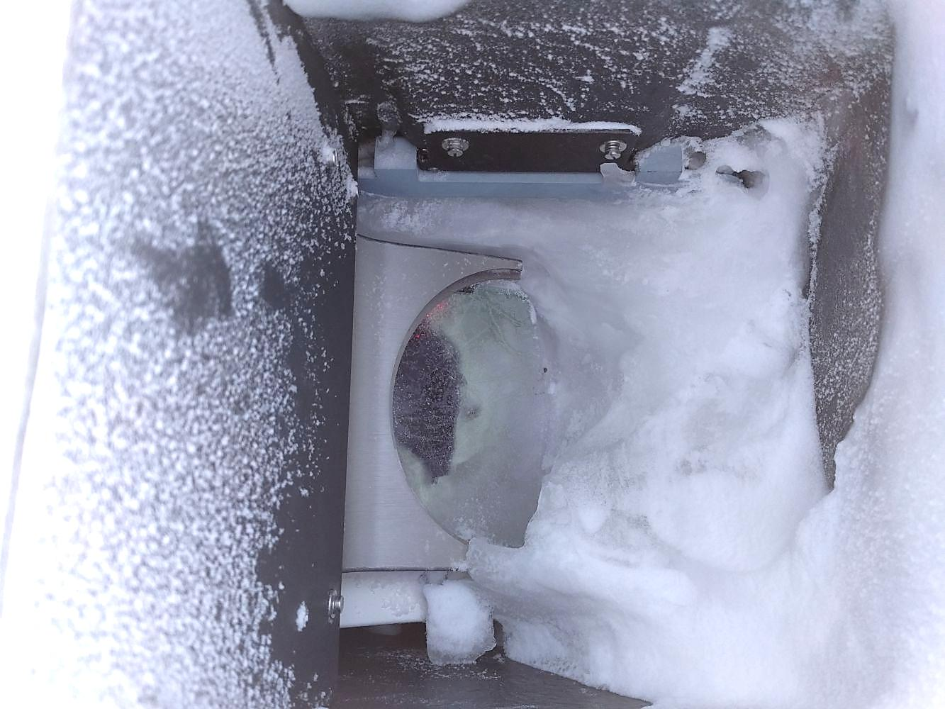

The Ceilometer window after intense storms last week.

**General:**

* 03-01: 14:15-15:15Z Heavy equipment clearing snow drift on west side of MSF.
* 03-01: ~14:00-14:30Z Cleared snow accumulation from MSF roof.
* 03-02: 19:15-2015Z Heavy equipment used to lower ceilometer from roof and clear more snow on west side of MSF.

**Significant Weather Observations:**

* 02-26: Ovc stratus. -24C, 11kts. Br.
* 02-27: Sun! Sct stratus. -32C, 13kts. Br. Diamond dust.
* 02-28: Few stratus. -40C, 10kts.
* 03-01: Bkn stratus. -28C, 12kts. Br.
* 03-02: Ovc stratus. -22C, 15kts. Br. Diamond dust.
* 03-03: Bkn stratocumulus. -30C, 10kts. Diamond dust.
* 03-04: Skc. -46C, 1kt. Br.

**ICECAPS Data Management:**

* 02-26: Data transfer complete 09:56Z
* 02-27: Data transfer complete 12:03Z
* 02-28: Data transfer complete 11:20Z
* 03-01: Data transfer complete 12:12Z
* 03-02: Data transfer complete 12:43Z
* 03-03: Data transfer complete 11:58Z
* 03-04: Data transfer complete 11:09Z

**MWR:**

* As of 10-28, 150-90 operating in V11_SCAN_HF.MBF.
* 02-26: The 150-90 was found disconnected. The radiometer was power cycled, successfully re-establishing connection at 17:03Z.

**SODAR:**

* Operating normally.
* 02-26: Cleaned snow from dishes 17:59-18:14Z.

**POSS:**

* Operating normally in old software.

**MMCR:**

* Operating normally.
* 02-27: Error 7 found and cleared at ~14:50Z.

**CAPABL:**

* Operating normally.
* 02-26: Low signal due to frost on the inside of the window. A heat gun was used to slowly melt the frost. Data collection resumed at ~19:25Z.
* 03-03: Cleared snow from window at 13:20Z.

**MPL:**

* Operating normally.
* 02-26: Frost from 02-25 cleared itself overnight.

**VCEIL:**

* 02-26: Window mostly covered in ice. Warnings in status message: “Receiver failure (A)Window contaminated (W)Battery low (W)Laser power low (W)Receiver optical cross-talk compensation poor”
* 02-27 through 03-02: Window mostly covered in ice. Blower not working. Warnings in status message: “Receiver failure (A)Voltage failure (A)Window contaminated (W)Battery low (W)Laser power low (W)Laser temperature high or low (W)Voltage high or low”
* 03-01: Blanket wrap removed from instrument. Access panel found frozen shut and bulging from ice.
* 03-02: Ceilometer disconnected at ~1530Z and moved indoors to thaw.

**Hotplate:**

* Offline since 2018-01-11 due to Error 1073807339 (timeout expired before operation completed).

**IceCAM:**

* 02-26 through 03-04: Camera inoperable.
* 02-27: Camera brought inside for troubleshooting.
* 03-02: Regained connection to camera, but there is no image.

**PAERI:**

* Operating normally.
* 02-26: LW&SW Responsivity flags from 02-25 cleared without a mirror cleaning.

**TSI:**

* In the MSF for winter storage.

**IcePIC:**

* No images collected this week.

**Radiosonde:**

* Twice daily soundings.
* 02-26: Radiosonde GPS antenna was removed from Green House tower and relocated to SE roof railing. Height adjustment was made in the Vaisala sonde software.

**MASC:**

* The MASC has been packaged for shipment to Vanderbuilt for repairs.