**ICECAPS Weekly Report**

January 1 – January 7, 2018

Hannah James

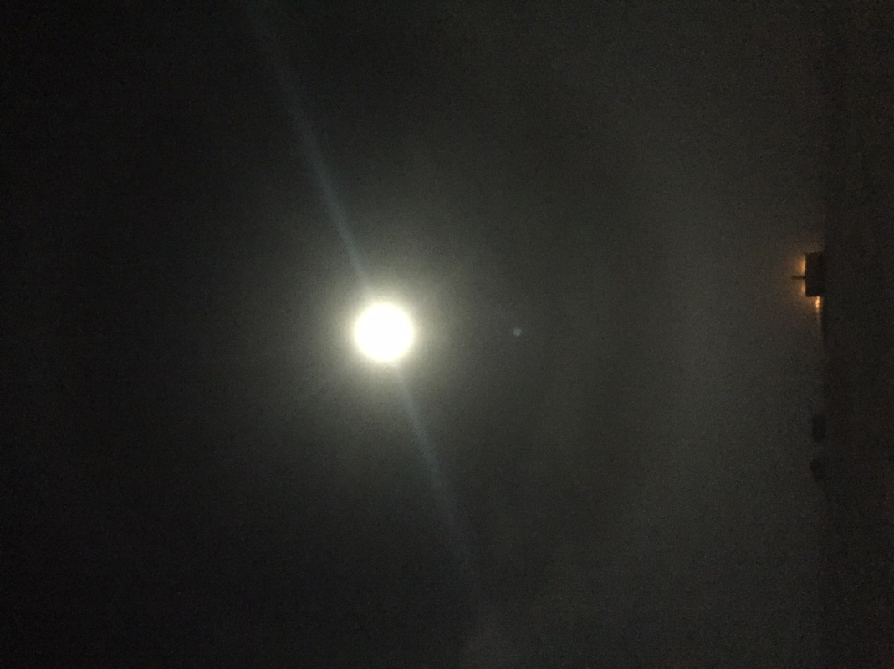

A halo around the full moon shines brightly over the MSF. -HJ

**General:**

* Internet issues at the MSF are being monitored by SRI. The insulation on the wireless bridge was improved, but at the time it is difficult to say if this solved the issues we were having. Improving the stability of this connection is on their 2018 summer tasking list.

**Significant Weather Observations:**

* 01-01: Sct stratus, bkn cirrostratus. -47C, 16 kts. Br, drsn.
* 01-02: Few stratocumulus. -52C, 12 kts. Br. 13:20Z- verga in distance.
* 01-03: Few altostratus, few cirrostratus. -56C, 11 kts. Vcfzfg, drsn.
* 01-04: Few altocumulus, few cirrostratus. -58C, 12 kts.
* 01-05: Sct altostratus, bkn cirrostratus. -52C, 6 kts. Br. –Sn 13:10-13:30Z.
* 01-06: Few stratus, few altostratus, sct cirrostratus. -59C, 13 kts. Fzfg in morning. 12:00-13:00Z: Exhaust from SMG generators passing over MSF.
* 01-07: Bkn stratus, bkn stratocumulus. -40C, 12 kts. Blsn.

**ICECAPS Data Management:**

* 01-01: Data transfer complete 09:43Z. MMCR mount down.
* 01-02: Data transfer complete 14:09Z. MMCR files from previous day successfully transferred.
* 01-03: Data transfer interrupted with MSF network issues. Manual push started at 14:06Z, data transfer complete 19:03Z.
* 01-04: Data transfer interrupted with MSF network issues. Manual push started at 13:10Z. Connection lost again, manual start at 15:05Z. Data transfer did not complete by end of the day. Radiosonde mount reported that “host is down.”
* 01-05: Data transfer complete 14:38Z. CAPABL and Ceilometer mounts down.
* 01-06: Data transfer complete 13:11Z. CAPABL and Ceilometer data from previous day successfully transferred.
* 01-07: Data transfer complete 11:48Z.

**MWR:**

* As of 10-28, 150-90 operating in V11_SCAN_HF.MBF. HATPRO remains on and heated until weather conditions allow it to come off the MSF roof.

**SODAR:**

* Operating normally.
* 01-06: Exhaust from SMG generators passing over MSF approximately 12:00-13:00Z.

**POSS:**

* Operating normally in old software.

**MMCR:**

* Operating normally.
* 01-01: Mount down overnight.

**CAPABL:**

* Operating normally.
* 01-01: 14:30Z- Beam visible, no rave ice observed.
* 01-03: Block diagram open with error line flashing, due to internet interruption at MSF. Robert remotely looked things over and restarted, data collection resumed at 13:28Z.
* 01-04: Block diagram open with error line flashing, due to internet interruption at MSF. Robert remotely looked things over and restarted, data collection resumed at 13:15Z.
* 01-05: Mount down overnight.
* 01-06: 13:10Z- Beam visible, no rave ice observed.

**MPL:**

* Operating normally.

**VCEIL:**

* Operating normally.
* 01-05: Mount down overnight.

**Hotplate:**

* Operating normally.
* 01-03: Error 1073807339 found (timeout expired before operation completed). Data collection resumed at 14:02Z.
* 01-05: Same error as above found. Restarted data collection at 13:10Z.

**IceCAM:**

* Operating normally.

**PAERI:**

* Operating normally.
* 01-03: Fan brought inside to remove frost 13:45-16:35Z.

**TSI:**

* In the MSF for winter storage.

**IcePIC:**

* 01-05: Slides placed for collection 13:10-13:35Z. Particles photographed include needles, graupel, solid columns, and irregulars. Some riming was present. Frost from the railing was also photographed. Crystals included bullet rosettes, needles, and rimed crystals.

**Radiosonde:**

* Twice daily soundings.

**MASC:**

* Operating normally.
* 01-04: Found MASC logged out of remote windows desktop. Logged in again, programs were running as they should be.