**ICECAPS Weekly Report**

January 8 – January 14, 2018

Hannah James

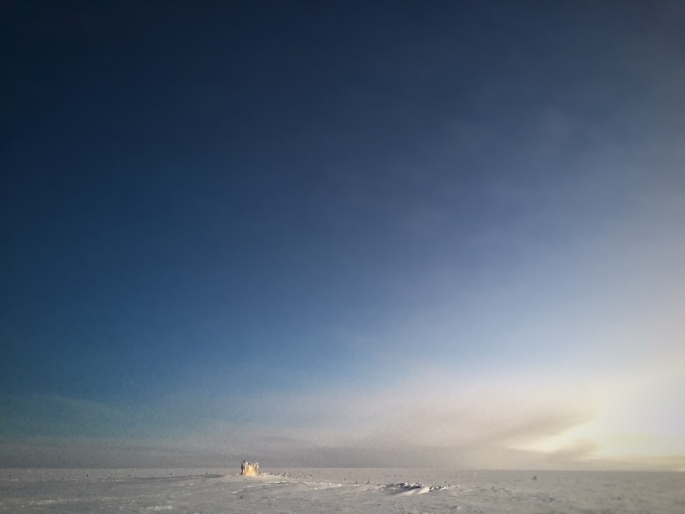

Summit’s first blue skies of 2018. -MM

**General:**

* The shipping crate for the HATPRO was dug out from the berms this week. The Hotplate is currently offline due to the same error seen earlier in the season. As weather allows, it will be brought inside for troubleshooting.

**Significant Weather Observations:**

* 01-08: Ovc stratus. -30C, 17 kts. Drsn, -sn.
* 01-09: Sct stratus, bkn cirrostratus. -38C, 17 kts. Br, drsn, -sn.
* 01-10: Ovc stratus. -25C, 23 kts. Blsn, -sn.
* 01-11: Ovc stratus, clearing later in the day to sct stratus, bkn cirrus. -29C, 9 kts. –Sn.
* 01-12: Sct stratus, bkn cirrostratus, later in the day ovc stratus. -36C, 21 kts. Drsn, -sn, br.
* 01-13: Bkn stratus, ovc cirrostratus. -32C, 16 kts. Br.
* 01-14: Sct stratus, ovc cirrostratus. -41C, 17 kts, increasing in the evening. Br, ic.

**ICECAPS Data Management:**

* 01-08: Data transfer complete 12:04Z.
* 01-09: Data transfer complete 12:11Z.
* 01-10: Data transfer complete 12:16Z.
* 01-11: Data transfer complete 11:19Z.
* 01-12: Data transfer complete 11:06Z.
* 01-13: Data transfer complete 11:30Z.
* 01-14: Data transfer complete 11:37Z.

**MWR:**

* As of 10-28, 150-90 operating in V11_SCAN_HF.MBF. HATPRO remains on and heated until weather conditions allow it to come off the MSF roof.

**SODAR:**

* Operating normally.
* 01-09: 14:04-14:21Z- SODAR off while cleaning dishes.
* 01-13: 13:06-13:15Z- SODAR off while cleaning dishes.

**POSS:**

* Operating normally in old software.

**MMCR:**

* Operating normally.

**CAPABL:**

* Operating normally.
* 01-08: 13:00Z- Beam visible, small amounts of rave ice observed (1 every 10 seconds). 20:00Z- Beam visible, 3-5 images every second.
* 01-10: 13:00Z- Beam visible, no rave ice.
* 01-11: 12:30Z- Beam ‘sparkling,’ small amounts of rave ice observed (2 every 5 seconds).

**MPL:**

* Operating normally.

**VCEIL:**

* Operating normally.
* 01-12: 13:36-13:38Z- Temporarily off during computer restart for Hotplate troubleshooting.

**Hotplate:**

* Offline due to below errors.
* 01-10: Error 85 (Input string does not contain data in the expected format). Restarted at 12:55Z, RH and dew point unstable, all other daily checks pass.
* 01-11: Error 1073807339 found (timeout expired before operation completed). Unable to connect again, power cycled, connection not established.
* 01-12: Continued troubleshooting. Power cycled instrument, computer, switched indoor network port. Connection not established. Lights on instrument are normal (solid blue and yellow indicating power, flashing green indicating things are good).

**IceCAM:**

* Operating normally.

**PAERI:**

* Operating normally.
* 01-08: Scene mirror cleaned at 13:10Z.

**TSI:**

* In the MSF for winter storage.

**IcePIC:**

* No images captured this week.

**Radiosonde:**

* Twice daily soundings.

**MASC:**

* Operating normally.