**ICECAPS Weekly Report**

January 15 – January 21, 2018

Hannah James

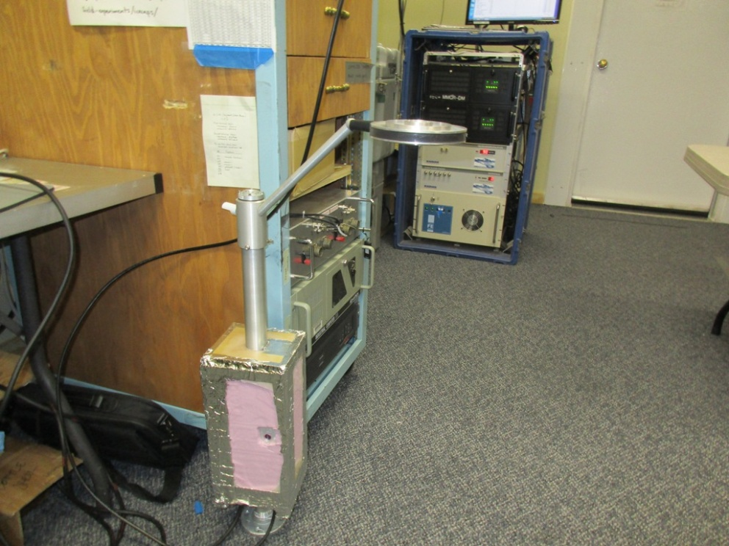

The Hotplate has returned to the interior of the MSF to troubleshoot miscellaneous errors. -HJ

**General:**

* Due to a pump failure on Generator #1, station experienced two unexpected power outages on 01-20, lasting from 18:21-18:22Z and 19:00-19:04Z. The Hotplate was brought back inside. High winds throughout the week prevented the HATPRO from coming off the roof.

**Significant Weather Observations:**

* 01-15: VV 100m. -36C, 24 kts. Blsn.
* 01-16: VV 200m. -32C, 19-30 kts. Blsn.
* 01-17: Ovc stratus. Bkn alto- and cirrostratus later in the day. -29C, 24 kts. Blsn.
* 01-18: Sct altocumulus, bkn cirrostratus. -30C, 20 kts. Drsn, br.
* 01-19: Sct cirrostratus, bkn cirrus, becoming ovc stratus with –sn in the afternoon. -46C, 18 kts, winds dying down in the afternoon.
* 01-20: Ovc stratus, clearing to bkn cirrostratus later in the day. -38C, 12 kts. –Sn.
* 01-21: Few stratus, ovc cirrostratus. -50C, 12 kts. Br.

**ICECAPS Data Management:**

* 01-15: Data transfer complete 11:45Z.
* 01-16: Link to “To Boulder” down due to missing “data” folder. Matt Shupe diagnosed, made a new folder, and started a manual transfer around 16:00Z. Data transfer not complete.
* 01-17: Data transfer from previous day continues; data transfer complete 23:45Z.
* 01-18: Data transfer complete 11:53Z.
* 01-19: Data transfer complete 11:46Z.
* 01-20: Data transfer complete 12:54Z.
* 01-21: Data transfer complete 11:47Z.

**MWR:**

* As of 10-28, 150-90 operating in V11_SCAN_HF.MBF. HATPRO remains on and heated until weather conditions allow it to come off the MSF roof.

**SODAR:**

* Operating normally.
* 01-15: Heavy noise due to blowing snow. Restarted SODAR for training purposes.
* 01-16: Heavy noise due to blowing snow.
* 01-17: Heavy noise due to blowing snow.

**POSS:**

* Operating normally in old software.

**MMCR:**

* Operating normally.

**CAPABL:**

* Operating normally.

**MPL:**

* Operating normally.
* 01-19: Afterpulse calibration performed 14:32-14:57Z. 14:36-14:44Z: 30m, 30s. CoPolBkdAvg: 0.000230, CoPolBkdStd: 0.000199. 14:44-14:53Z: 15m, 30s. ColPolBkdAvg: 0.000257, CoPolBkdStd: 0.000277.

**VCEIL:**

* Operating normally.
* 01-17: 13:23Z- Removed accumulated snow from lens.

**Hotplate:**

* Offline since 2018-01-11 due to Error 1073807339 (timeout expired before operation completed).
* 01-19: Disconnected and brought inside.

**IceCAM:**

* Operating normally.

**PAERI:**

* Operating normally.
* 01-15: Scene mirror cleaned at 15:27, 15:33, and 16:40Z.
* 01-16: Scene mirror cleaned at 12:50 and 14:28Z.
* 01-17: Scene mirror cleaned 13:05, 15:04, and 16:38Z.
* 01-20: Cleaned frost from fan blades 12:40Z.

**TSI:**

* In the MSF for winter storage.

**IcePIC:**

* No images collected this week.

**Radiosonde:**

* RH exceeded 100% during 01-18 evening sonde, but did not quit out! New software seems to be preventing self-termination.
* Twice daily soundings, other than:
* 01-15: No morning sonde due to high winds and low visibility.
* 01-16: No evening sonde due to high winds and low visibility.

**MASC:**

* Operating normally.
* 01-16: Many blank images captured.
* 01-21: “Waiting for status” flag.