**ICECAPS Weekly Report**

January 29 – February 4, 2018

Hannah James

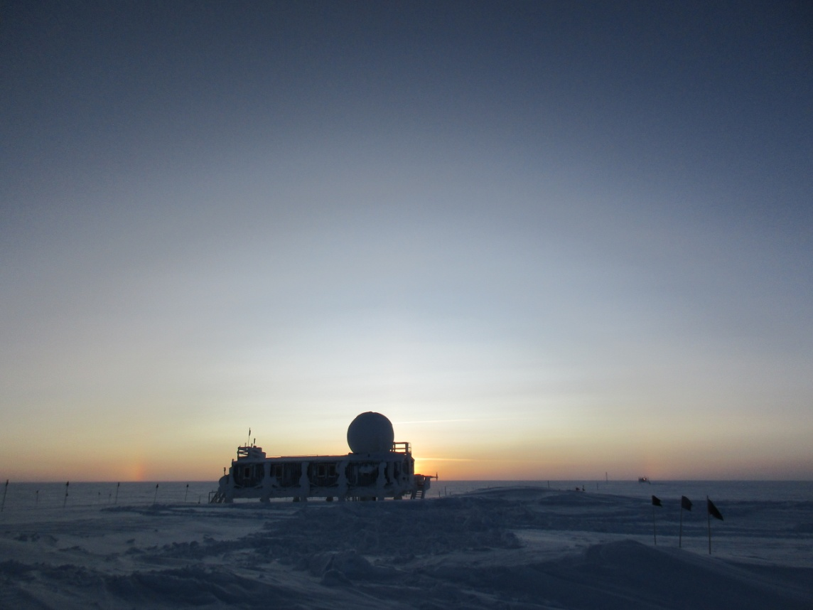

The first solar optics of the year were visible mid-day of January 31. The sun has returned! -HJ

**General:**

* None to report.

**Significant Weather Observations:**

* 01-29: Sct stratus, sct cirrus. -37C, 20 kts. Drsn, br.
* 01-30: Bkn altostratus, bkn cirrus. -41C, 15 kts. Drsn, fzfg.
* 01-31: Few stratus, bkn cirrostratus. -47C, 11 kts. Br. 12:50-15:00Z sun column, parhelia at times.
* 02-01: VV 100m. -32C, 28 kts. Blsn.
* 02-02: Bkn stratocumulus, bkn altostratus. -35C, 17 kts. Br, drsn.
* 02-03: Sct altostratus, sct cirrostratus. -47C, 11kts. Br. Nacreous clouds above sun during sunrise, 13:30Z, remained through the day. Winds picked up in evening, reaching 35+ knots.
* 02-04: Sct stratus, bkn altostratus. -36C, 12 kts. Drsn, fzfg. 23:15Z- Yukimarimos forming and accumulating in surface depressions. Balls measured up to 3cm in diameter.

**ICECAPS Data Management:**

* 01-29: Data transfer complete 11:23Z.
* 01-30: Data transfer complete 13:20Z.
* 01-31: Data transfer complete 12:45Z.
* 02-01: Data transfer complete 12:48Z.
* 02-02: Data transfer complete 12:44Z.
* 02-03: Data transfer complete 12:03Z.
* 02-04: Data transfer complete 12:00Z.

**MWR:**

* As of 10-28, 150-90 operating in V11_SCAN_HF.MBF.

**SODAR:**

* Operating normally.
* 01-29: 13:08-13:28Z- SODAR off while snow was removed from dishes. Heavy snow pack prevented signal to be read prior to cleaning.
* 02-02: 15:37-15:48Z- SODAR off while snow was removed from dishes.

**POSS:**

* Operating normally in old software.

**MMCR:**

* Operating normally.

**CAPABL:**

* Operating normally.
* 02-02: CAPABL not collecting data 13:12-13:24Z to clean snow off window. Water added to Laser 2.

**MPL:**

* Operating normally.

**VCEIL:**

* Operating normally.
* 02-02: Cleared snow off of lens at approximately 13:00Z.

**Hotplate:**

* Offline since 2018-01-11 due to Error 1073807339 (timeout expired before operation completed).

**IceCAM:**

* Operating normally.

**PAERI:**

* Operating normally.
* 02-02: 13:15 and 23:30Z- cleaned snow off scene mirror.

**TSI:**

* In the MSF for winter storage.

**IcePIC:**

* No images collected this week.

**Radiosonde:**

* Twice daily soundings

**MASC:**

* Found unplugged on Monday morning rounds. After restarting software and power cycling instrument, the instrument remained unresponsive. Awaiting instructions from PIs.
* 02-02: Power cable found unplugged after high wind event. Power returned 12:59Z, images captured. “Waiting for status” flag found during daily indoor rounds.