**ICECAPS Weekly Report**

March 12 – 18, 2018

Rex Nelson

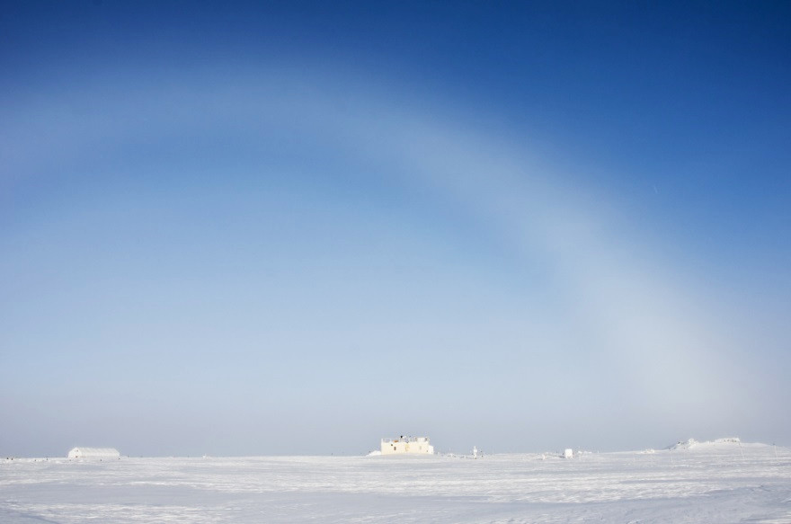

A fogbow over the MSF

**General:**

* 03-15: Five degree F temperature increase in MSF overnight with no significant weather change. Cause unknown.

**Significant Weather Observations:**

* 03-12: Few altostratus. -46C, 7kts.
* 03-13: Skc. -52C, 5kts.
* 03-14: Sct altostratus. -47C, 11kts.
* 03-15: Few altostratus. -49C, 12kts.
* 03-16: Few altostratus. -46C, 12kts.
* 03-17: Few altostratus. -34C, 17kts. Br. Drsn. Faint sundog.
* 03-18: Skc. -30C, 12kts. Fzfg.

**ICECAPS Data Management:**

* 03-12: Data transfer complete 12:41Z
* 03-13: Data transfer complete 11:27Z
* 03-14: Data transfer complete 12:39Z
* 03-15: Data transfer complete 12:38Z
* 03-16: Data transfer complete 11:56Z
* 03-17: Data transfer complete 12:23Z
* 03-18: Data transfer complete 12:16Z

**MWR:**

* As of 10-28, 150-90 operating in V11_SCAN_HF.MBF.

**SODAR:**

* Operating normally.
* 03-12: 14:50-15:00Z. SODAR off while cleaning snow from dishes.

**POSS:**

* Operating normally in old software.

**MMCR:**

* Operating normally.

**CAPABL:**

* Operating normally.
* 03-12: 18:52Z-20:15Z. Laser 1 flashlamp changed.

**MPL:**

* Operating normally.
* 03-14: 14:10-14:34Z. Afterpulse calibration performed.

**VCEIL:**

* 03-12 through 03-14: Errors in status message: “Laser failure (A) Laser power low (W)”
* 03-17 through 03-18: Errors in status message: “Laser failure (A) Laser power low (W)”

**Hotplate:**

* Offline since 2018-01-11 due to Error 1073807339 (timeout expired before operation completed).

**IceCAM:**

* Operating normally.

**PAERI:**

* Operating normally.
* 03-14: 13:45-14:46Z. Fan enclosure brought inside to thaw. Cleaned mirror at 15:52Z.
* 03-15: Multiple flags present.

**TSI:**

* In the MSF for winter storage.

**IcePIC:**

* 03-14: Slides placed for collection 1450-1530Z. Particles photographed include isolated bullets, bullet rosettes, and hollow columns.

**Radiosonde:**

* Twice daily soundings.
* Radiosonde GPS antenna is temporarily located on SE Green House roof railing.

**MASC:**

* The MASC has been packaged for shipment to Vanderbuilt for repairs.