**ICECAPS Weekly Report**

March 19 – 25, 2018

Rex Nelson

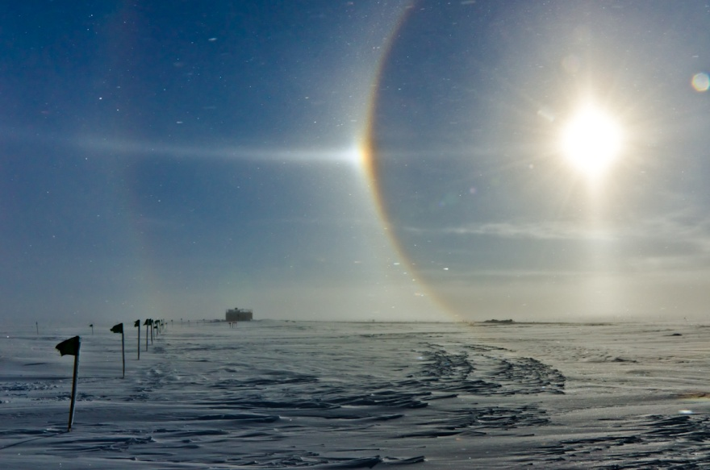

Sundog over the MSF on 03-20

**General:**

* 03-24: Some snow penetration under the emergency door.

**Significant Weather Observations:**

* 03-19: Ovc cumulus. -21C, 16kts. Drsn. Fzfg.
* 03-20: Ovc cumulus. -20C, 21kts. Blsn. ~13:15 to ~14:30Z: 22deg halo, 46deg halo, parhelia, full parhelic circle, circumzenithal arc.
* 03-21: Ovc altocumulus, clearing to Few by evening. -27C, 7kts.
* 03-22: Ovc cumulus. -27C, 10kts.
* 03-23: Bkn stratus. -33C, 20kts. Drsn. Fzfg. ~07:30 to 14:30Z: Faint 22deg halo.
* 03-24: Ovc altostratus. -30C, 30kts. Blsn.
* 03-25: Ovc stratus. -31C, 24kts. Blsn.

**ICECAPS Data Management:**

* 03-19: Data transfer complete 12:20Z
* 03-20: Data transfer complete 12:45Z
* 03-21: Data transfer complete 12:45Z
* 03-22: Data transfer complete 11:54Z
* 03-23: Data transfer complete 12:36Z
* 03-24: Data transfer complete 13:31Z
* 03-25: Data transfer complete 13:40Z

**MWR:**

* As of 10-28, 150-90 operating in V11_SCAN_HF.MBF.
* 03-25: The 150-90was found disconnected. The radiometer was power cycled, successfully re-establishing connection at 12:47Z.

**SODAR:**

* Operating normally.
* 03-20: 17:32-17:38Z. SODAR off while cleaning snow from dishes.
* 03-24 and 03-25: Data looks like the SODAR dishes are snow-packed. Did not clean due to foul weather.

**POSS:**

* Operating normally in old software.
* 03-19: 17:10Z. Cleared frost.
* 03-20: Several “Gunn current low” errors present.

**MMCR:**

* Operating normally.
* 03-25: 13:09-13:14Z. Desiccant replaced.

**CAPABL:**

* Operating normally.
* 03-20: 17:55Z. Cleaned window after sweeping roof.

**MPL:**

* Operating normally.

**VCEIL:**

* 03-19 through 03-25: Errors in status message: “Laser failure (A) Laser power low (W)” Clouds not appearing in data.
* 03-22: 13:17Z. Power cycled instrument and computer.

**Hotplate:**

* Offline since 2018-01-11 due to Error 1073807339 (timeout expired before operation completed).

**IceCAM:**

* Operating normally.

**PAERI:**

* Operating normally.
* 03-21: 13:12-13:54Z. Fan enclosure brought inside to thaw.
* 03-24 and 03-25: Flags: LW & SW Responsivity, LW & SW HBB NEN. Did not clean mirror due to foul weather.

**TSI:**

* In the MSF for winter storage.

**IcePIC:**

* 03-19: Slides placed for collection 1745-1750Z. Particles photographed include simple prisms, triangular crystals, split plates, rimed, and irregulars.
* 03-21: Slides placed for collection 1400-1420Z. Particles photographed include isolated bullets, bullet rosettes, simple prisms, hollow columns, capped columns, and irregulars.

**Radiosonde:**

* Twice daily soundings.
* 03-18: Morning sounding unexpectedly closed by software. Data was incomplete.
* 03-19: Evening sounding data did not transfer.
* Radiosonde GPS antenna is temporarily located on SE Green House roof railing.

**MASC:**

* The MASC has been packaged for shipment to Vanderbuilt for repairs.