**ICECAPS Weekly Report**

March 26 – April 1, 2018

Rex Nelson

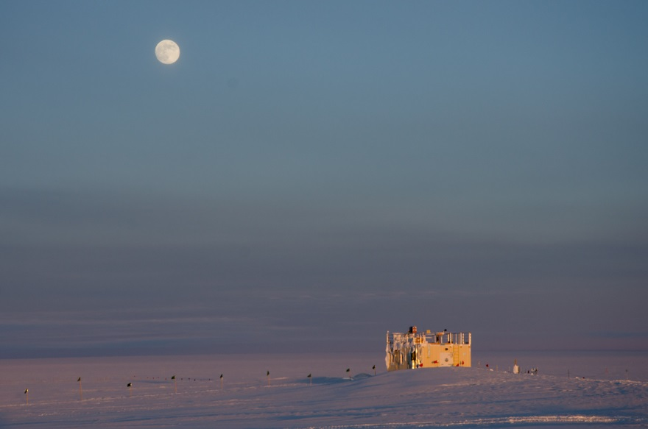

The MSF under a full moon on the last day of March.

**General:**

* 03-28 to 03-30: Heavy equipment operations clearing drifts around station.

**Significant Weather Observations:**

* 03-26: Ovc altostratus. -31C, 19kts. Drsn. Fzfg. ~13:00 to ~19:00Z: 22deg halo and parhelia.
* 03-27: Ovc stratus, altostratus. -30C, 14kts. Br. ~11:00 to ~18:00Z: 22deg halo.
* 03-28: Sct stratus. -34C, 8kts. Br. ~1930 to ~2030Z: 22deg halo and parhelia.
* 03-29: Ovc stratus. -31C, 13kts. Br. ~0930 to ~1200Z: 22deg halo and parhelia.
* 03-30: Few altostratus. -34C, 10kts.
* 03-31: Sct altostratus. -39C, 10kts. ~0930 to ~2000Z: 22deg halo and occasional parhelia. 1850Z: 46deg halo, upper tangent arc.
* 04-01: Sct altostratus. -39C, 2kts. Br.

**ICECAPS Data Management:**

* 03-26: Data transfer complete 12:37Z
* 03-27: Data transfer complete 15:44Z
* 03-28: Data transfer complete 13:55Z
* 03-29: Data transfer complete 14:23Z
* 03-30: Data transfer complete 13:50Z
* 03-31: Data transfer complete 12:50Z
* 04-01: Data transfer complete 14:01Z

**MWR:**

* As of 10-28, 150-90 operating in V11_SCAN_HF.MBF.

**SODAR:**

* Operating normally.
* 03-26: 1232-1245Z. SODAR off while cleaning dishes.
* 03-28 to 03-30: Heavy equipment ops caught on SODAR.

**POSS:**

* Operating normally in old software.

**MMCR:**

* Operating normally.
* 03-27: Initiated system reboot at 12:52Z to clear NetCDF errors. System collecting data again at 13:57Z.

**CAPABL:**

* Operating normally.

**MPL:**

* Operating normally.

**VCEIL:**

* 03-26: The window is completely iced over. Errors in status message: “Laser failure (A) Laser power low (W)” Clouds not appearing in data.
* 03-27: 12:55Z. Shut down software.
* 03-28: Removed ceilometer from roof.

**Hotplate:**

* Offline since 2018-01-11 due to Error 1073807339 (timeout expired before operation completed).

**IceCAM:**

* Operating normally.

**PAERI:**

* Operating normally.
* 03-26: Flags: LW & SW Responsivity, LW & SW HBB NEN. 12:50-12:56Z: Cleaned roof box and mirror. Snow can be seen in the mirror reflection.
* 03-27: Flags: LW & SW Responsivity. Took photos of obstructing snow at 1315Z. Cleared snow from mirror area at 1725Z.

**TSI:**

* In the MSF for winter storage.

**IcePIC:**

* 03-28: Slides placed for collection 1930-1945Z. Particles photographed include radiating plates, bullet rosettes, simple prisms, and hollow columns.

**Radiosonde:**

* Twice daily soundings.
* Radiosonde GPS antenna is temporarily located on SE Green House roof railing.

**MASC:**

* The MASC has been packaged for shipment to Vanderbuilt for repairs.