**ICECAPS Weekly Report**

May 14 – May 20, 2018

Rex Nelson

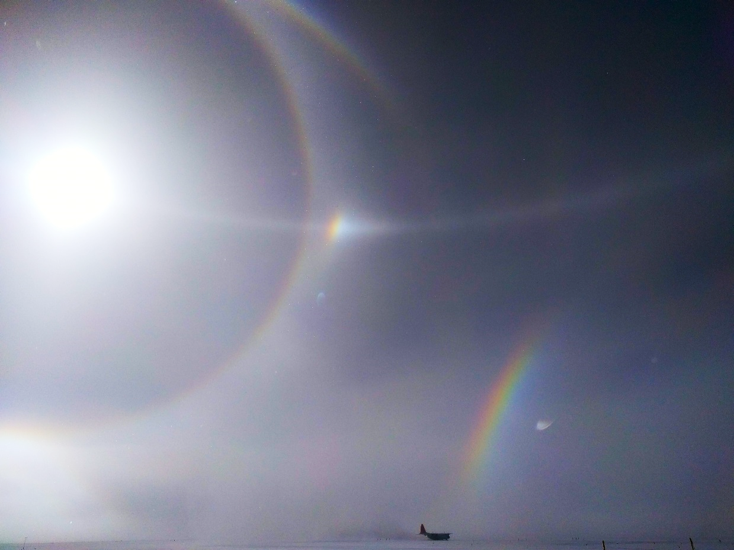

Solar optics during flight ops on 05-16.

**General:**

* The MSF time server GPS antenna is being borrowed by the Radiosonde base station.

**Significant Weather Observations:**

* 05-14: Ovc stratus, altocumulus, cirrus. -Sn. -20C, 8kts.
* 05-15: Ovc stratus. Br. Sn. -23C, 9kts. 12:00Z-00:00Z: occasional faint 22deg halo with parhelia and upper/lower arcs
* 05-16: Ovc stratus. Br. -23C, 2kts. 09:00Z-22:00Z: 22deg halo. 17:45-18:45Z: 22deg halo, partial 46deg halo, parhelia, upper & lower tangent arcs, partial parhelic circle.
* 05-17: Ovc stratus. Br. -15C, 15kts.
* 05-18: Bkn altocumulus. Ic. -17C, 15kts. 18:00Z: 22deg halo, upper tangent arc, partial parhelic circle.
* 05-19: Ovc stratus. Br. -19C, 17kts. 12:00Z: 22deg halo.
* 05-20: Sct cirrus. -23C, 7kts. 09:00-10:00Z: 22deg halo, parhelia, lower tangent arc, partial parhelic circle, partial 46deg halo.

**ICECAPS Data Management:**

* 05-14: Data transfer complete 05:51Z
* 05-15: Data transfer complete 06:01Z
* 05-16: Data transfer complete 06:13Z
* 05-17: Data transfer complete 05:55Z
* 05-18: Data transfer complete 06:03Z
* 05-19: Data transfer complete 06:05Z
* 05-20: Data transfer complete 05:58Z

**MWR:**

* As of 10-28, 150-90 operating in V11_SCAN_HF.MBF.

**SODAR:**

* Operating normally.

**POSS:**

* Operating normally in old software.

**MMCR:**

* Operating normally.

**CAPABL:**

* Operating normally.

**MPL:**

* Operating normally.
* 05-14: 13:13-13:34Z: Afterpulse calibration performed.
  + 13:13-13:24Z- 30m, 30s. CoPolBkdAvg: 0.000257, CoPolBkdStd: 0.000169.
  + 13:26-13:34Z- 15m, 30s. CoPolBkdAvg: 0.000260, CoPolBkdStd: 0.000276.

**VCEIL:**

* Operating normally.

**Hotplate:**

* Offline since 2018-01-11.
* The hotplate has been shipped out for repair.

**IceCAM:**

* Operating normally.

**PAERI:**

* Operating normally.
* 05-20: 13:41-13:49Z: Fan enclosure removed to thaw rime.

**TSI:**

* In the MSF for winter storage.

**IcePIC:**

* 05-15: Slides placed for collection 16:18-16:45Z. Particles photographed include hollow columns, radiating plates, and irregulars.

**Radiosonde:**

* Twice daily soundings.
* Radiosonde GPS antenna is temporarily located on SE Green House roof railing.

**MASC:**

* The MASC has been shipped out for repair.