**ICECAPS Weekly Report**

May 21 – May 27, 2018

Rex Nelson

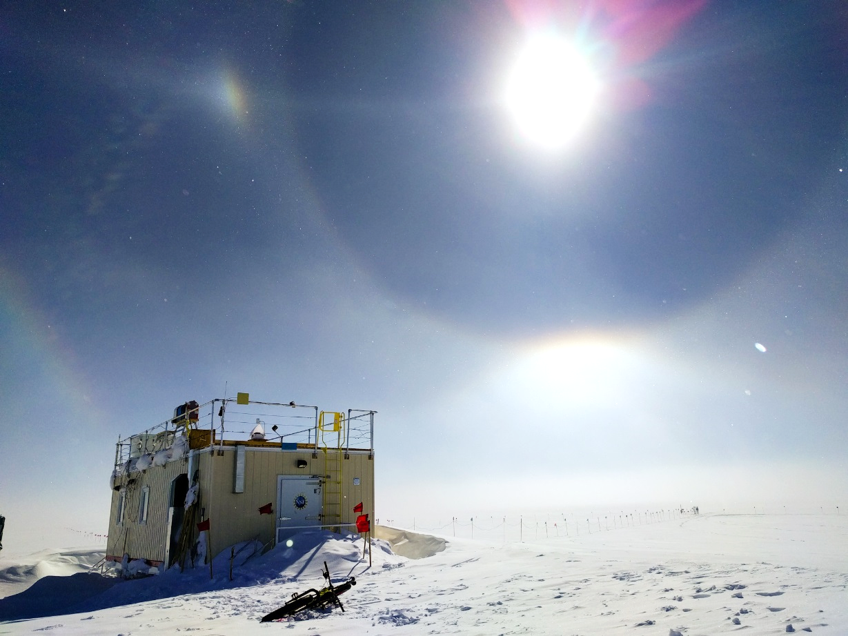

Optics over the MSF on 05-22.

**General:**

* The MSF time server GPS antenna is being borrowed by the Radiosonde base station.

**Significant Weather Observations:**

* 05-21: Few altostratus. -24C, 7kts.
* 05-22: Sct altostratus. Br, Ic. -27C, 10kts. 12:30-13:30Z: 22deg halo, parhelia, parhelic circle, upper & lower tangent arcs, partial 46deg halo.
* 05-23: Sct cirrus. -23C, 12kts.
* 05-24: Ovc stratocumulus, altostratus. Br, -Sn. -20C, 8kts.
* 05-25: Ovc altocumulus. -20C, 10kts.
* 05-26: Ovc altostratus. Blsn. -18C, 24kts.
* 05-27: Sct cirrus. -20C, 8kts.

**ICECAPS Data Management:**

* 05-21: Data transfer complete 05:45Z
* 05-22: Data transfer complete 07:35Z
* 05-23: Data transfer complete 05:52Z
* 05-24: Data transfer complete 05:49Z
* 05-25: Data transfer complete 06:49Z
* 05-26: Data transfer complete 06:10Z
* 05-26: Data transfer complete 05:59Z

**MWR:**

* As of 10-28, 150-90 operating in V11_SCAN_HF.MBF.

**SODAR:**

* Operating normally.

**POSS:**

* Operating normally in old software.

**MMCR:**

* Operating normally.

**CAPABL:**

* Operating normally.

**MPL:**

* Operating normally.

**VCEIL:**

* Operating normally.

**Hotplate:**

* Offline since 2018-01-11.
* The hotplate has been shipped out for repair.

**IceCAM:**

* Operating normally.

**PAERI:**

* Operating normally.

**TSI:**

* 05-22: TSI installed and collecting data.

**IcePIC:**

* 05-24: Slides placed for collection 11:45-11:50Z. Particles photographed include isolated bullets, bullet rosettes, hollow columns, hexagonal plates, radiating plates, and irregulars.

**Radiosonde:**

* Twice daily soundings.
* 05-24: New GPS antenna and cable were installed on the Green House tower, but do not work. Reverted back to temporary antenna with borrowed UNAVCO cable, located on SE Green House roof railing.

**MASC:**

* The MASC has been shipped out for repair.