**ICECAPS Weekly Report**

May 28 – Jun 3, 2018

Rex Nelson

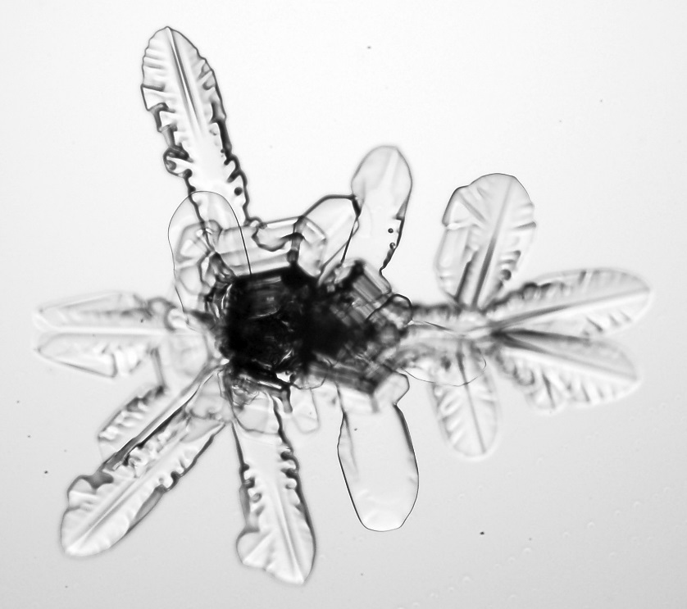

IcePIC from 06-04.

**General:**

* The MSF time server GPS antenna is being borrowed by the Radiosonde base station.

**Significant Weather Observations:**

* 05-28: Few distant cirrus? Br, Ic. -22C, 11kts. 12:00-13:00Z: faint 22deg halo, partial 46deg halo, parhelia, upper & lower tangent arcs, parhelic circle.
* 05-29: Few distant altocumulus? -21C, 13kts.
* 05-30: Bkn stratocumulus. -13C, 14kts.
* 05-31: Sct stratocumulus. Br, Ic. -14C, 17kts. 10:00-11:30Z: snow.
* 06-01: Ovc stratus. Blsn. -15C, 19kts.
* 06-02: Ovc stratocumulus. -15C, 11kts.
* 06-03: Bkn stratocumulus. Br. 17C, 11kts.

**ICECAPS Data Management:**

* 05-28: Data transfer complete 05:55Z
* 05-29: Data transfer complete 06:11Z
* 05-30: Data transfer complete 05:59Z
* 05-31: Data transfer complete 05:59Z
* 06-01: Data transfer complete 06:03Z
* 06-02: Data transfer complete 06:33Z
* 06-03: Data transfer complete 07:31Z

**MWR:**

* As of 10-28, 150-90 operating in V11_SCAN_HF.MBF.

**SODAR:**

* Operating normally.
* 05-28: 13:12-13:20Z: SODAR off while cleaning dishes.

**POSS:**

* Operating normally in old software.

**MMCR:**

* Operating normally.

**CAPABL:**

* Operating normally.

**MPL:**

* Operating normally.

**VCEIL:**

* Operating normally.

**Hotplate:**

* Offline since 2018-01-11.
* The hotplate has been shipped out for repair.

**IceCAM:**

* Operating normally.

**PAERI:**

* Operating normally.
* 05-31: 22:06-22:12Z: Removed fan to defrost, but no frost was apparent. Temperature difference persists between outside air and blackbody.

**TSI:**

* Operating normally.

**IcePIC:**

* 05-30: Slides placed for collection 16:50-16:55Z. Particles photographed include broken sectored plates and irregulars.
* 06-03: Slides placed for collection 11:48-11:52Z. Particles photographed include hexagonal plates, isolated bullets, bullet rosettes, and irregulars.

**Radiosonde:**

* Twice daily soundings.
* Radiosonde GPS antenna is temporarily located on SW Green House roof railing.

**MASC:**

* The MASC has been shipped out for repair.