**ICECAPS Weekly Report**

May 7 – May 13, 2018

Rex Nelson

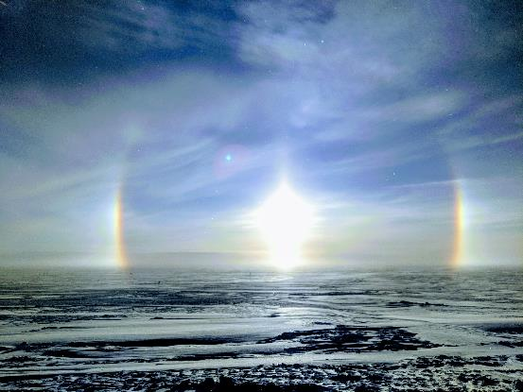

Sun halo in thick diamond dust on the evening of 05-12. Photo by Marci Beitch.

**General:**

* The MSF time server GPS antenna is being borrowed by the Radiosonde base station.

**Significant Weather Observations:**

* 05-07: Few altocumulus. -35C, 9kts.
* 05-08: Skc. -36C, 7kts.
* 05-09: Skc. -34C, 11kts. 18:00Z: faint 22deg halo.
* 05-10: Sct altocumulus. -27C, 10kts.
* 05-11: Low visibility in Blsn. -22C, 21kts. 18:00Z: 22deg halo, parhelia, upper tangent arc, faint circumzenithal arc
* 05-12: Bkn altocumulus. Blsn. -17C, 20kts. Skc in afternoon. Thick diamond dust in evening. 12:00Z: 22deg halo. 19:00-00:00Z: partial 22deg halo, parhelia, solar pillar
* 05-13: Sct altocumulus. -19C, 5kts.

**ICECAPS Data Management:**

* 05-07: Data transfer complete 05:49Z
* 05-08: Data transfer complete 06:02Z
* 05-09: Data transfer complete 07:36Z
* 05-10: Data transfer complete 07:02Z
* 05-11: Data transfer complete 05:49Z
* 05-12: Data transfer complete 06:08Z
* 05-13: Data transfer complete 06:07Z

**MWR:**

* As of 10-28, 150-90 operating in V11_SCAN_HF.MBF.

**SODAR:**

* Operating normally.
* 05-12: 18:21-18:27Z: SODAR off while cleaning dishes.

**POSS:**

* Operating normally in old software.

**MMCR:**

* Operating normally.

**CAPABL:**

* Operating normally.

**MPL:**

* Operating normally.

**VCEIL:**

* Operating normally.

**Hotplate:**

* Offline since 2018-01-11.
* The hotplate has been shipped out for repair.

**IceCAM:**

* Operating normally.

**PAERI:**

* Operating normally.
* 05-12: LW & SW Responsivity flags intermittent and self-clearing in blowing snow.

**TSI:**

* In the MSF for winter storage.
* 05-12: Confirmed functionality in preparation for redeployment.

**IcePIC:**

* 05-12: Slides placed for collection 17:45-17:50Z. Particles photographed include simple prisms, hexagonal plates, and irregulars.
* 05-13: Slides placed for collection 18:30-18:50Z. Particles photographed include hollow columns, radiating plates, and irregulars.

**Radiosonde:**

* Twice daily soundings.
* Radiosonde GPS antenna is temporarily located on SE Green House roof railing.

**MASC:**

* The MASC has been shipped out for repair.