**ICECAPS-ACE Weekly Report**

December 31, 2018 – January 6, 2019

Gus Allen

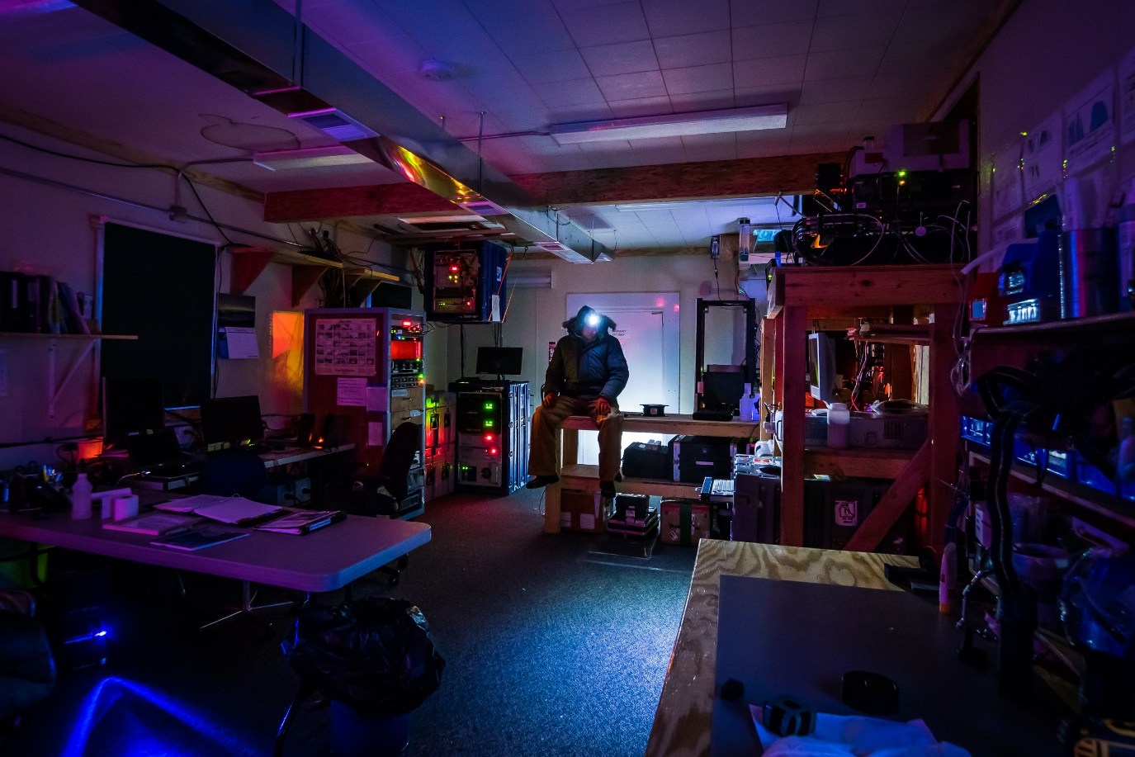

*The number of small light sources in the MSF is not insignificant.*

**General:** Wind and cold temperatures have not allowed much progress on excavating a couple of buried instrument cables around the MSF, so that project is ongoing.

**Significant Weather Observations:**

|  |  |  |  |  |  |  |  |
| --- | --- | --- | --- | --- | --- | --- | --- |
| **Date** | **Time (Z)** | **Wind** | **Weather** | **Visibility** | **Sky** | **Temp** | **Notes** |
| 12-31 | 12 | 11kt from 270 | BR | 0800 | FEW000 FEW100 | -40 |  |
| 1-1 | 12 | 12kt from 226 | BR | 0800 | FEW000 BKN030 | -35 | 4cm new rime |
| 1-2 | 12 | 25kt from 200 | BLSN | 0200 | BKN000 OVC020 | -25 |  |
| 1-3 | 12 | 23kt from 120 | FZFG BLSN | 0200 | VV006 | -26 |  |
| 1-4 | 12 | 25kt gusting to 30 from 140 | BLSN | 0200 | VV003 | -18 |  |
| 1-5 | 12 | 12kt from 170 | BR | 3200 | FEW000 SCT030 BKN090 | -32 |  |
| 1-6 | 12 | 07kt from 060 |  | 9999 | FEW100 | -46 | 2cm new rime |

**ICECAPS-ACE Data Management:**

* 12-31: Data transfer complete at 1231Z
* 1-1: Data transfer complete at 1309Z
* 1-2: Data transfer complete at 1231Z
* 1-3: Data transfer complete at 1345Z
* 1-4: Data transfer complete at 1248Z
* 1-5: Data transfer complete at 1201Z
* 1-6: Data transfer complete at 1331Z

**MWR:**

* Operating normally.

**SODAR:**

* Operating normally.

**POSS:**

* Operating normally.

**MMCR:**

* 1-2 15Z: Dessicant filters replaced.
* 1-4: Health log indicates that value “Temperature (outdoor)” is out of tolerance, at 24
* 1-5: Health log indicates that value “Temperature (outdoor)” continues out of tolerance, at 13
* Level is currently 0.11 pitch, 0.00 roll
* Operating normally.

**CAPABL:**

* Instrument currently operating normally using laser 2

**MPL:**

* Operating normally.

**VCEIL:**

* Operating normally.

**IceCAM:**

* Operating normally.

**PAERI:**

* 1-1: At approximately 14Z, I (apparently) knocked some snow on the scene mirror while clearing the roof. Red LWresponsivity and SWresponsivity flags occurred at this time. I cleaned the scene mirror at 1430Z.
* Operating normally.

**TSI:**

* Offline for winter season.

**IcePIC:**

* No images captured this week.

**Radiosonde:**

* Twice daily launches.

**MASC:**

* Instrument offsite for repair, will not return until summer 2019.

**OPC:**

* Located and connected the spare ACE laptop, but it requires configuration from Heather and/or Nealy which has not occurred yet. As a result the ACE quicklooks page is not available, and the ACE mount for DATAMAN is not present.
* OPC appears functional, but I cannot conclusively determine this.

**CLASP:**

* Instrument off site.

**CPC:**

* Instrument off site.