**ICECAPS-ACE Weekly Report**

April 1 – April 7, 2019

Nate Bowker

*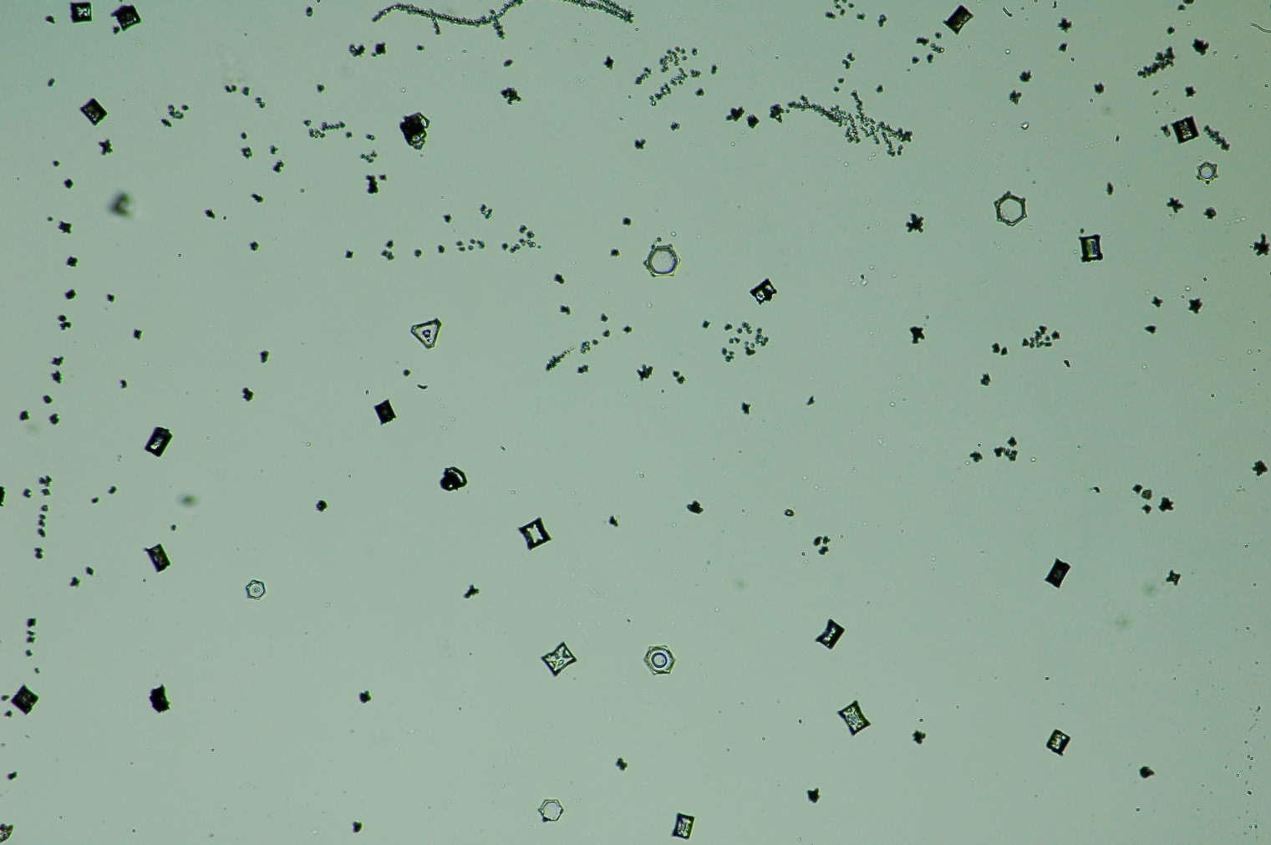  
Diamond dust and frost, photographed on 4-6.*

**General Notes:**  4-4 saw the arrival of 4 additional crew members to assist with preparations for the fast approaching summer season.

**General Weather Observations:**

|  |  |  |  |  |  |  |  |
| --- | --- | --- | --- | --- | --- | --- | --- |
| **Date** | **Time (Z)** | **Wind** | **Weather** | **Visibility** | **Sky** | **Temp** | **Notes** |
| 4-1 | 12 | 13kt from 120 | FZFG | 600 | FEW100 | -42 |  |
| 4-2 | 12 | 16kt from 170 | FZFG DRSN | 300 | BKN060 | -36 |  |
| 4-3 | 12 | 30kt from 180 | BLSN | 100 | VV003 | -19 |  |
| 4-4 | 12 | 9kt from 280 |  | 9999 | FEW100 | -38 |  |
| 4-5 | 12 | 16kt from 220 | FZFG DRSN | 800 | FEW016 FEW060 | -36 |  |
| 4-6 | 12 | 18kt from 180 | DRSN | 9999 | BKN070 | -26 |  |
| 4-7 | 12 | 10kt from 170 | BR | 1600 | SCT210 | -29 |  |

**Significant Weather Observations:**

* 4-3 2100Z: Lenticular clouds observed near station.
* 4-6 1700-2000Z: Diamond dust resulted in some of the first solar optics of the season, including a 22 degree halo and parhelia.

**ICECAPS-ACE Data Management:**

* 4-1: Data transfer completed at 1040Z.
* 4-2: Data transfer completed at 1019Z.
* 4-3: Data transfer completed at 1009Z.
* 4-4: Data transfer completed at 1007Z.
* 4-5: Data transfer completed at 1032Z.
* 4-6: Data transfer completed at 1008Z.
* 4-7: Data transfer completed at 1041Z.

**MWR:**

* Operating normally.

**SODAR:**

* 4-7 1011-1022Z: Removed snow from dishes.
* Operating normally.

**POSS:**

* 4-3: Errors “DC offset”, and “max noise limit” occurred.
* Operating normally

**MMCR:**

* 4-2: Cleared Labview error (Error 7) and resumed normal operation.
* 4-3 1415Z: Changed TWTA dry air desiccant.
* Temp (outside) value continues out of tolerance (at 30)
* Operating normally.

**CAPABL:**

* Instrument currently offline.

**MPL:**

* Operating normally.

**VCEIL:**

* Operating normally.

**IceCAM:**

* Operating normally

**PAERI:**

* 4-4 0908Z: Cleaned scene mirror.
* Operating normally.

**TSI:**

* Offline for winter season.

**IcePIC:**

* 4-6: Two sampling sessions photographed and uploaded.

**Radiosonde:**

* 4-4 1200Z: Balloon burst altitude just over 14km.
* 4-6 1200Z: Balloon burst altitude just under 15km.
* 4-7 0000Z: Flight terminated prematurely due to GPS week number rollover
* 4-7 1200Z: Two launches failed due to lack of GPS launch trigger associated with GPS week number rollover.
* Twice daily launches.

**MASC:**

* Instrument offsite for repair, will not return until summer 2019.

**OPC:**

* Operating normally.

**CLASP:**

* Instrument off site.

**CPC:**

* Operating normally