**ICECAPS-ACE Weekly Report**

April 15 – April 21, 2019

Nate Bowker

*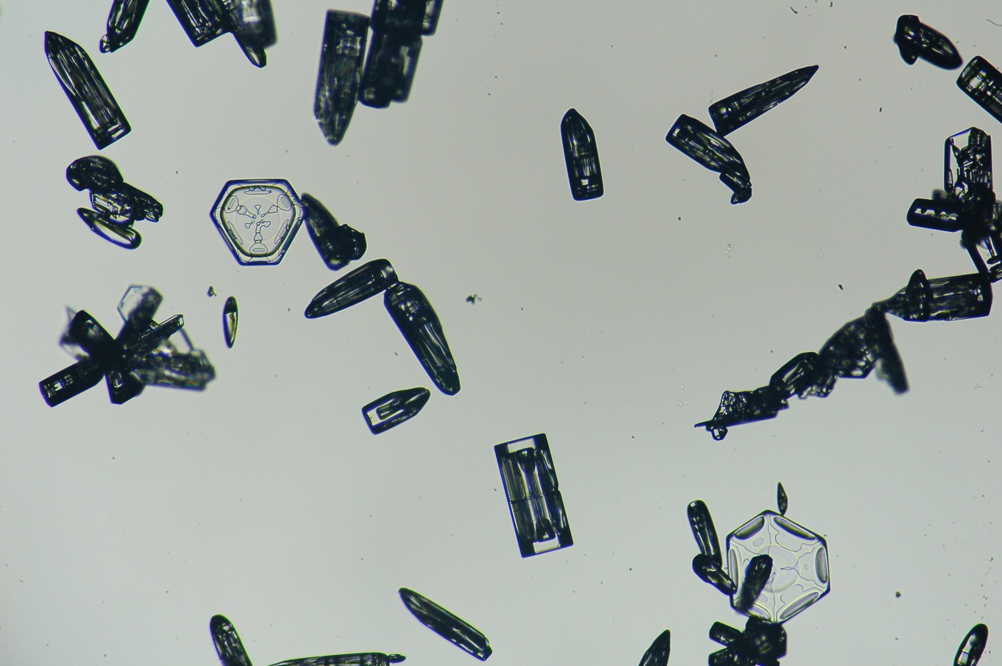  
Plates and bullets juxtaposed.*

**General Notes:**  Station opening activities are in full swing with the first LC-130 scheduled to arrive on Friday, 4-26. Heavy equipment operation is occurring around station on a daily basis.

**General Weather Observations:**

|  |  |  |  |  |  |  |  |
| --- | --- | --- | --- | --- | --- | --- | --- |
| **Date** | **Time (Z)** | **Wind** | **Weather** | **Visibility** | **Sky** | **Temp** | **Notes** |
| 4-15 | 12 | 21kt from 150 | DRSN FZFG | 800 | SCT100 | -19 |  |
| 4-16 | 12 | 18kt from 180 | DRSN FZFG | 800 | FEW030 | -23 |  |
| 4-17 | 12 | 30kt from 130 | BLSN | 100 | VV003 | -18 |  |
| 4-18 | 12 | 21kt from 180 | DRSN FZFG | 200 | VV006 | -23 |  |
| 4-19 | 12 | 20kt from 190 | FZFG | 600 | SCT100 | -23 |  |
| 4-20 | 12 | 12kt from 120 | BR | 1800 | BKN060 | -22 |  |
| 4-21 | 12 | 7kt from 197 |  | 9999 | FEW030 | -35 |  |

**Significant Weather Observations:**

* 4-16 ~0900 – 1330Z: 22-degree halo with infralateral arcs observed.
* 4-18 ~0700 – 1000Z: 22-degree halo observed.
* 4-18 ~1230 – 1400Z: 22-degree halo with infralateral arcs and a circumzenithal arc observed.
* 4-19 ~1600 – 1630Z: 22-degree halo observed.
* 4-20 ~1020 – 1200Z: 22-degree halo observed.

**ICECAPS-ACE Data Management:**

* 4-15: Data transfer completed at 0415Z.
* 4-16: Data transfer completed at 0415Z.
* 4-17: Data transfer completed at 0412Z.
* 4-18: Data transfer completed at 0415Z.
* 4-19: Data transfer completed at 0421Z.
* 4-20: Data transfer completed at 0415Z.
* 4-21: Data transfer completed at 0429Z.

**MWR:**

* Operating normally.

**SODAR:**

* 4-16 1000Z – 4-17 1300Z: No sodar JPGs due to my failure to leave software display maximized.
* 4-19 1640 – 1652Z: Powered down amp and cleaned sodar dishes.
* Operating normally.

**POSS:**

* Operating normally

**MMCR:**

* 4-19 and 4-20: Experienced radar calibration errors NetCDF_Mom and NetCDF_Spec.
* 4-21 1103 – 1321Z: Performed full system reboot. Required 5 attempts to achieve a successful startup.
* Temp (outside) value continues out of tolerance (at 30)
* Operating normally.

**CAPABL:**

* Instrument currently offline.

**MPL:**

* 4-15 1223-1246Z: Monthly afterpulse calibration performed.
* Operating normally.

**VCEIL:**

* Operating normally.

**IceCAM:**

* Operating normally

**PAERI:**

* Operating normally.

**TSI:**

* Offline for winter season.

**IcePIC:**

* 4-19: One sampling session photographed. Uploaded on 4-20.
* 4-20: One sampling session photographed and uploaded.
* 4-20: Microscope brought inside to thaw out. Cleaned the interior of the photo booth of frost and snow.
* 4-21: Fabricated a simple mount for the microscope light source allowing for consistent low oblique transmitted illumination with incremental adjustability.

**Radiosonde:**

* 4-16 1200Z: Sounding terminated prematurely (at ~12km) due to temperature sensor failure.
* 4-20 0000Z: Sounding burst altitude was just over 14km.
* 4-20 1200Z: Sonde damaged by snow removal activities when staged for launch outside of SMG. Second sonde prepped and launched at 1135Z.
* Twice daily launches.

**MASC:**

* Instrument offsite for repair, will not return until summer 2019.

**OPC:**

* Operating normally.

**CLASP:**

* Instrument off site.

**CPC:**

* 4-17 1229Z: Emptied condensate reservoir.
* 4-18 1232Z: Changed outlet filter per 21-day replacement interval.
* Operating normally

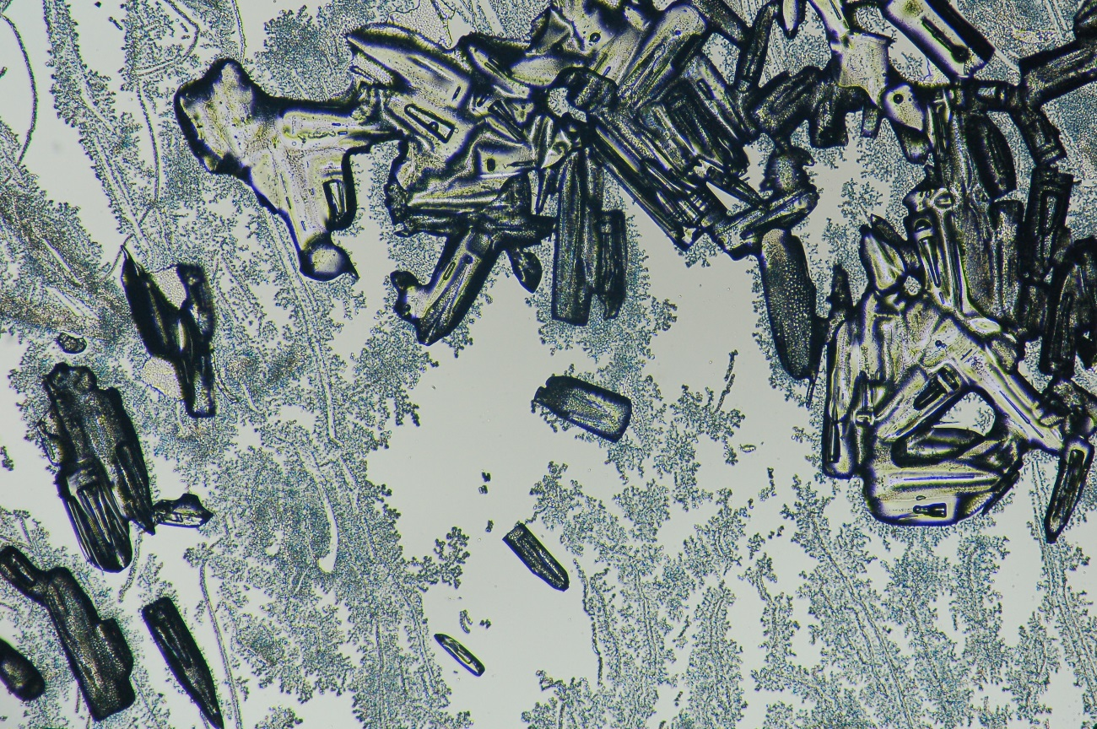

*Fractal frost and melting crystals.*