**ICECAPS-ACE Weekly Report**

April 22 – April 28, 2019

Nate Bowker

*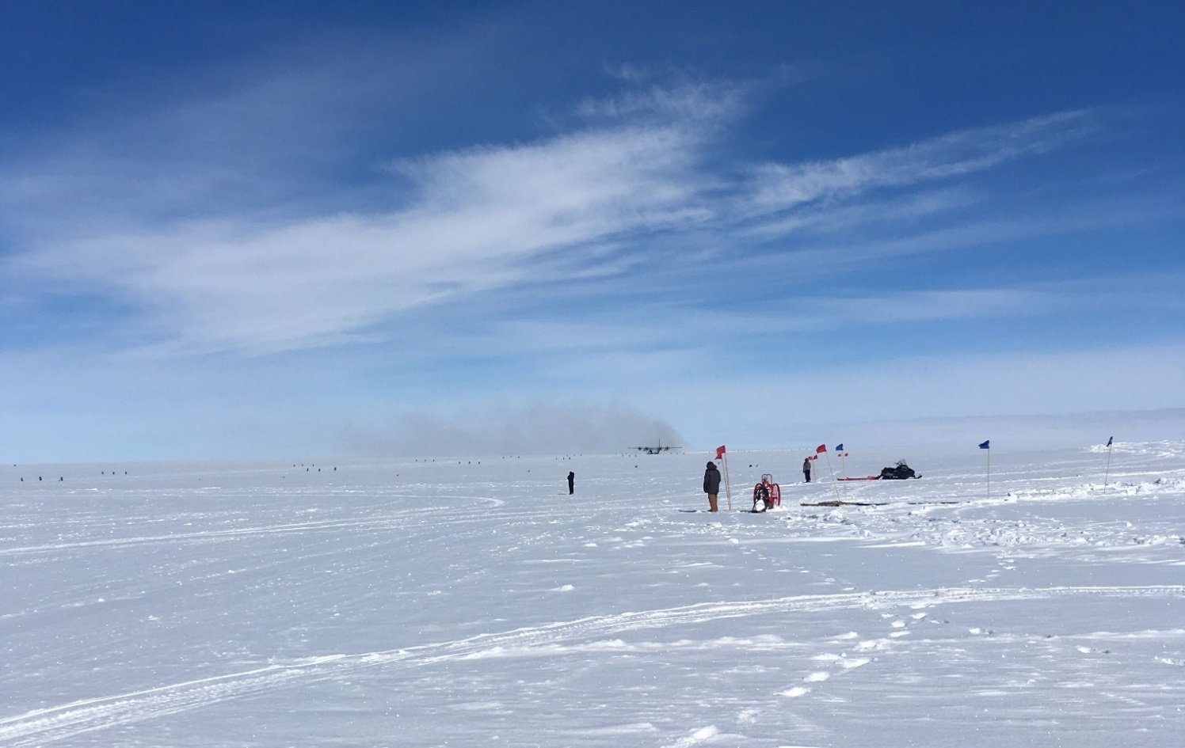  
This summer’s first LC-130 taxiing on the skiway.*

**General Notes:**  The first LC-130 of the 2019 summer season arrived on Sunday, 4-28, carrying the summer season science techs, Jonathon Miller, and Jenny Mowatt. Weather looks favorable for a busy fligh period, with ICECAPS-ACE cargo, CAPABL shipping materials, and LN2 for calibrating the MWR are expected to arrive early in the coming week.

**General Weather Observations:**

|  |  |  |  |  |  |  |  |
| --- | --- | --- | --- | --- | --- | --- | --- |
| **Date** | **Time (Z)** | **Wind** | **Weather** | **Visibility** | **Sky** | **Temp** | **Notes** |
| 4-22 | 12 | 11kt from 150 |  | 9999 | FEW130 | -33 |  |
| 4-23 | 12 | 13kt from 180 | IC BR | 1800 | SCT035 | -27 |  |
| 4-24 | 12 | 33kt from 120 | BLSN | 100 | VV003 | -22 |  |
| 4-25 | 12 | 25kt from 100 | IC BLSN | 300 | OVC010 | -16 |  |
| 4-26 | 12 | 17kt from 130 | FZFG | 800 | FEW100 | -19 |  |
| 4-27 | 12 | 11kt from 120 | BR | 1600 | SCT100 | -18 |  |
| 4-28 | 12 | 11kt from 120 |  | 9999 | FEW032 SCT190 | -16 |  |

**Significant Weather Observations:**

* 4-25 2030-2230Z: Partial 22-degree halo with particularly vibrant parhelia observed.
* 4-26 0830-1330Z: 22-degree halo observed during diamond dust precipitation. Coincident IcePICs taken.
* 4-28: Fresh deposition of large stellar dendrites overnight. Surface samples collected and photographed.

**ICECAPS-ACE Data Management:**

* 4-22: Data transfer completed at 0414Z.
* 4-23: Data transfer completed at 0412Z.
* 4-24: Data transfer completed at 0416Z.
* 4-25: Data transfer completed at 0446Z.
* 4-26: Data transfer completed at 0455Z.
* 4-27: Data transfer completed at 0456Z.
* 4-28: Data transfer completed at 0448Z.

**MWR:**

* Operating normally.

**SODAR:**

* Operating normally.

**POSS:**

* 4-27 1043Z: One instance of fault code “DC offset”.
* Operating normally

**MMCR:**

* Temp (outside) value continues out of tolerance (at 30)
* Operating normally.

**CAPABL:**

* Instrument currently offline.

**MPL:**

* Operating normally.

**VCEIL:**

* Operating normally.

**IceCAM:**

* Operating normally

**PAERI:**

* Operating normally.

**TSI:**

* Offline for winter season.

**IcePIC:**

* 4-22: One sampling session photographed. Uploaded 4-25.
* 4-26: One sampling session photographed and uploaded.

**Radiosonde:**

* 4-28 0000Z: Sounding burst altitude ~10km.
* Twice daily launches.

**MASC:**

* Instrument offsite for repair, will not return until summer 2019.

**OPC:**

* Operating normally.

**CLASP:**

* Instrument off site.

**CPC:**

* A small shelf was installed beneath the ACE bench to accommodate the CPC condensate reservoir.
* Operating normally