**ICECAPS-ACE Weekly Report**

April 29 – May 5, 2019

Nate Bowker / Jonathon Miller

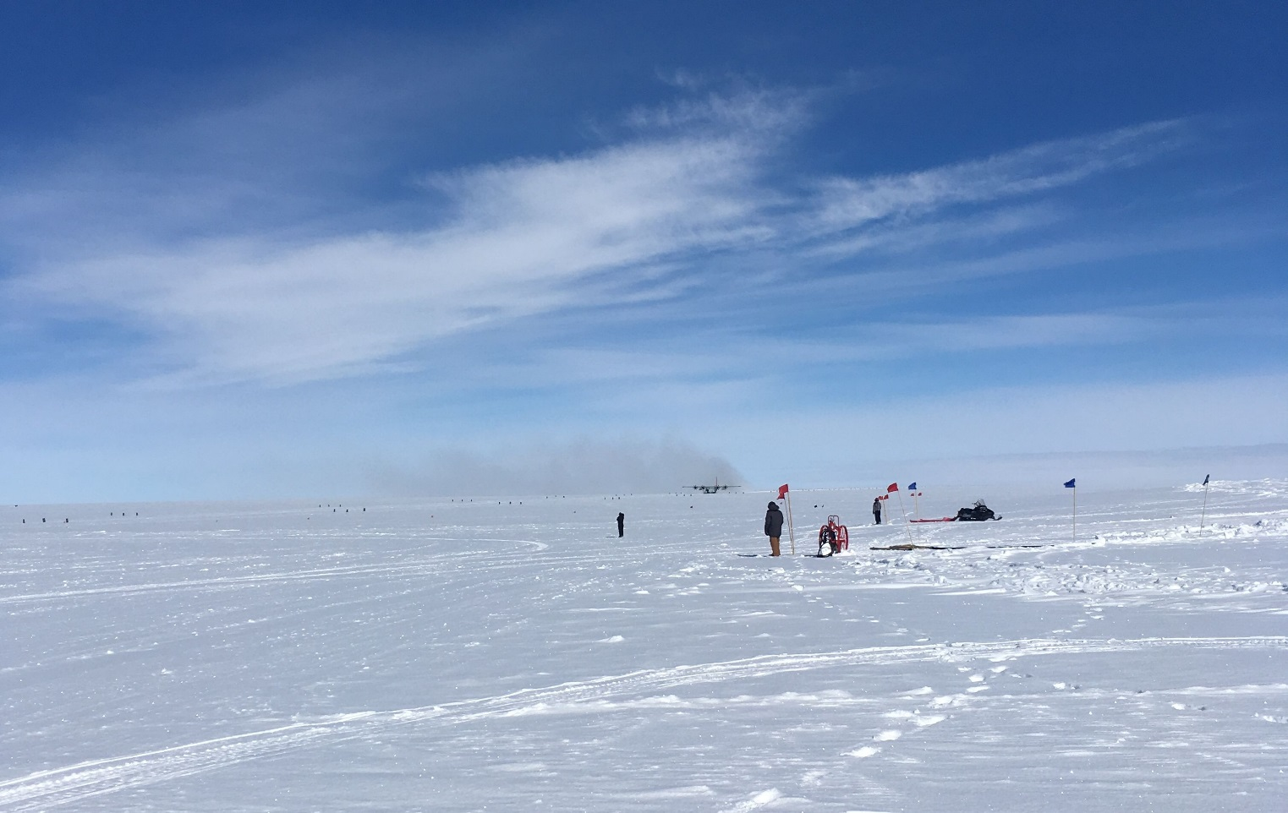 *This summer’s first LC-130 taxiing on the skiway.*

**General Notes:**

On 2019-04-30T12:15:00Z the main UPS experienced a failure that resulted in a ungraceful power shutdown of all Icecaps instruments. The PAERI, MMCR and ACE restarted automatically. The remaining instruments where restarted manually as described in the protocols.

**General Weather Observations:**

|  |  |  |  |  |  |  |  |
| --- | --- | --- | --- | --- | --- | --- | --- |
| **Date** | **Time (Z)** | **Wind** | **Weather** | **Visibility** | **Sky** | **Temp** | **Notes** |
| 4-29 | 12 | 8kt from 120 |  | 9999 | FEW100 | -20 | CLD HT EST |
| 4-30 | 12 | 4kt from 173 |  | 9999 | FEW032, FEW165 | -17 |  |
| 5-1 | 12 |  |  |  |  |  |  |
| 5-2 | 12 | 3kt from VRB | -SN | 9999 | OVC008 | -15 |  |
| 5-3 | 12 | 6kt from 305 | -SN | 5000 | OVC013 | -15 |  |
| 5-4 | 12 | 12kt from 265 | BLSN | 5000 | BKN016 | -18 |  |
| 5-5 | 12 | 17kt from 280 | BLSN | 800 | OVC 010 | -11 |  |

**Significant Weather Observations:** Normal

**ICECAPS-ACE Data Management:**

* 4-29: Data transfer completed at 04:56:00Z.
* 4-30: Data transfer completed at 05:01:59Z.
* 5-1: Data transfer completed at 04:36:51Z.
* 5-2: Data transfer completed at 04:53:16Z.
* 5-3: Data transfer completed at 04:59:08Z.
* 5-4: Data transfer completed at 04:45:37Z.
* 5-5: Data transfer completed at 05:02:48Z.

**MWR:**

* Performed LN2 calibration on HATPRO and 150/90 radiometers at 2019-05-01T11:13Z.
* Performed LN2 calibration on HATPRO at 2019-05-02T18:33Z.
* Performed LN2 calibration on HATPRO at 2019-05-03T17:18Z.
* Operating normally.

**SODAR:**

* Cleaned snow and leveled, 2019-05-02T17:26Z to 17:39Z
* Operating normally.

**POSS:**

* Operating normally

**MMCR:**

* Temp (outside) value continues out of tolerance (at 30)
* Operating normally.

**CAPABL:**

* Instrument disconnected and packed for servicing.

**MPL:**

* Operating normally.

**VCEIL:**

* Operating normally.

**IceCAM:**

* Operating normally

**PAERI:**

* Operating normally.

**TSI:**

* Offline for winter season.

**IcePIC:**

**Radiosonde:**

* Twice daily launches.

**MASC:**

* Instrument offsite for repair, will not return until summer 2019.

**OPC:**

* Operating normally.

**CLASP:**

* Instrument off site.

**CPC:**

* Operating normally