**ICECAPS-ACE Weekly Report**

April 8 – April 14, 2019

Nate Bowker

*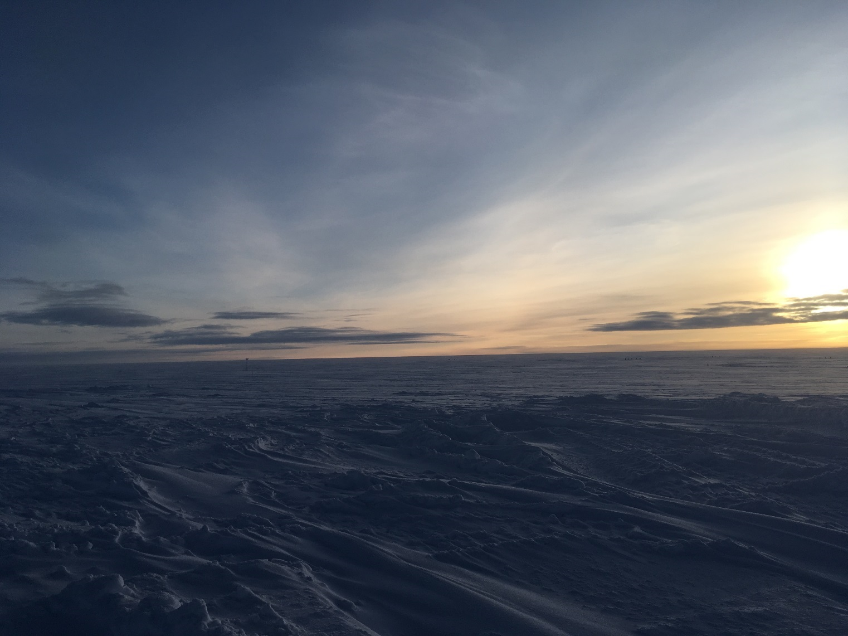  
Evening light highlights textures in snow and sky.*

**General Notes:**  Station opening activities are in full swing. Heavy equipment operation occurring around station on a daily basis.

**General Weather Observations:**

|  |  |  |  |  |  |  |  |
| --- | --- | --- | --- | --- | --- | --- | --- |
| **Date** | **Time (Z)** | **Wind** | **Weather** | **Visibility** | **Sky** | **Temp** | **Notes** |
| 4-8 | 12 | 16kt from 160 | IC FZFG | 800 | BKN130 | -24 |  |
| 4-9 | 12 | 11kt from 210 | IC BR | 1000 | OVC010 | -26 |  |
| 4-10 | 12 | 9kt from 180 |  | 9999 | BKN015 | -26 |  |
| 4-11 | 12 | 13kt from 200 | DRSN FZFG | 800 | BKN013 | -25 |  |
| 4-12 | 12 | 14kt from 170 | IC FZFG | 700 | BKN130 | -22 |  |
| 4-13 | 12 | 25kt from 160 | BLSN | 400 | VV013 | -12 |  |
| 4-14 | 12 | 20kt from 140 | BLSN FZFG | 400 | BKN013 | -14 |  |

**Significant Weather Observations:**

* NTR

**ICECAPS-ACE Data Management:**

* 4-8: Data transfer completed at 1012Z.
* 4-9: Data transfer completed at 1006Z.
* 4-10: Data transfer completed at 0414Z.
* 4-11: Data transfer completed at 0411Z.
* 4-12: Data transfer completed at 0422Z.
* 4-13: Data transfer completed at 0435Z.
* 4-14: Data transfer completed at 0416Z.

**MWR:**

* Operating normally.

**SODAR:**

* Operating normally.

**POSS:**

* 4-14 0520-0530Z: Experienced “max noise limit” fault code during high winds.
* Operating normally

**MMCR:**

* 4-11,12: Found DM computer with Labview error 7, but no radar errors on radar computer. Cleared error and resumed normal operation.
* Temp (outside) value continues out of tolerance (at 30)
* Operating normally.

**CAPABL:**

* Instrument currently offline.

**MPL:**

* Operating normally.

**VCEIL:**

* Operating normally.

**IceCAM:**

* Operating normally

**PAERI:**

* Operating normally.

**TSI:**

* Offline for winter season.

**IcePIC:**

* 4-11: One sampling session photographed and uploaded.
* 4-12: Two sampling sessions photographed and uploaded.

**Radiosonde:**

* 4-8: A software update for the MW41 sounding system was installed correcting the issues caused by the GPS week number rollover.
* 4-12 1200Z: Sonde burst altitude just under 14km.
* Twice daily launches.

**MASC:**

* Instrument offsite for repair, will not return until summer 2019.

**OPC:**

* Operating normally.

**CLASP:**

* Instrument off site.

**CPC:**

* 4-13: Found the CPC powered off. This appears attributable to a loose power connection to the ACE PDU. CPC power cord was stabilized and instrument restarted at 1225Z.
* Operating normally