**ICECAPS-ACE Weekly Report**

February 11 – February 17, 2019

Nate Bowker

*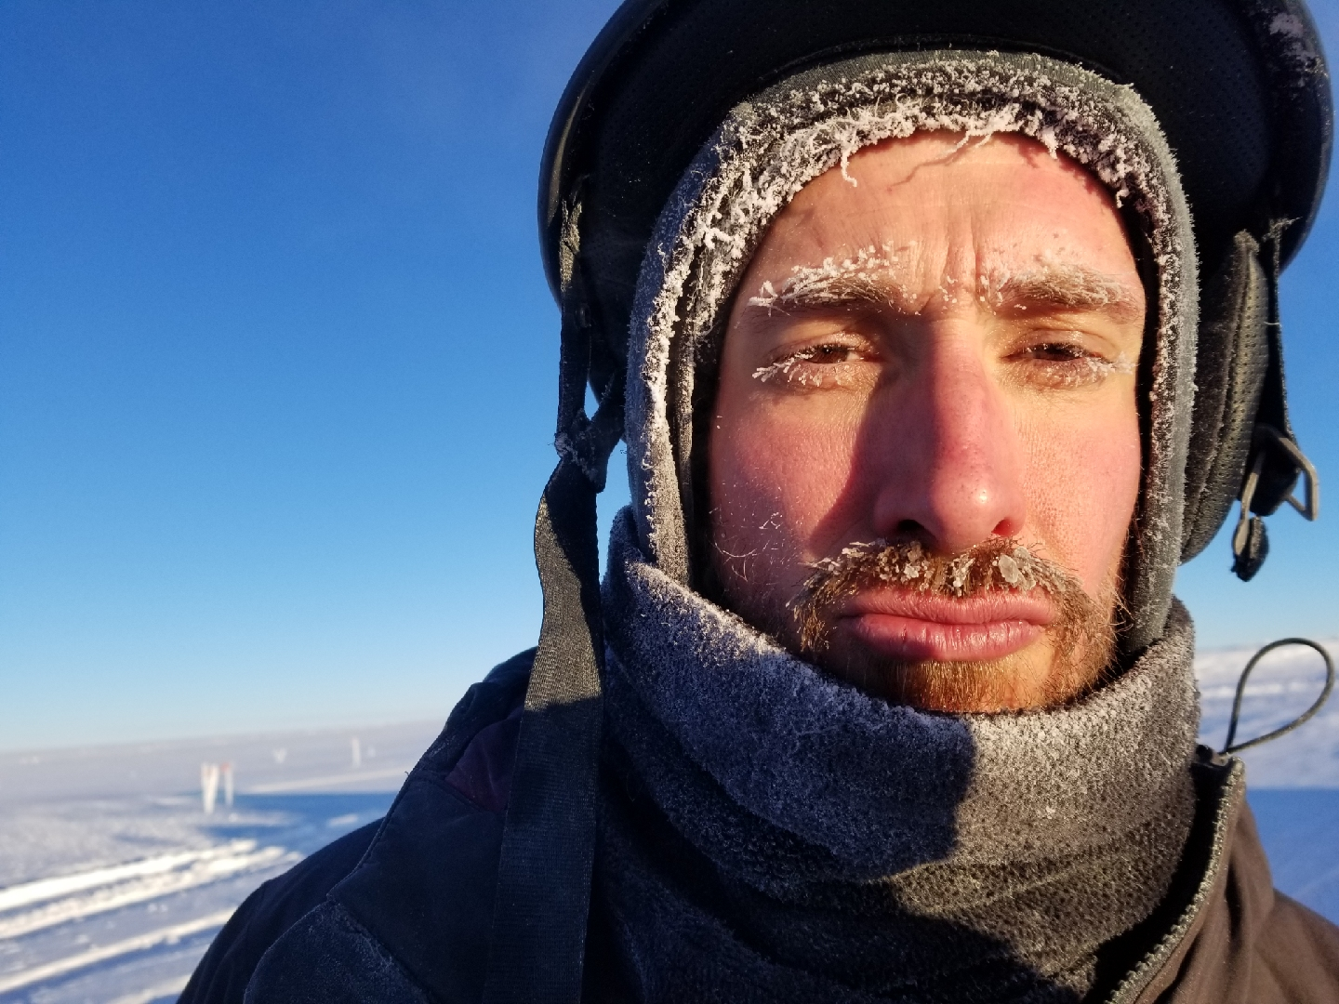  
In lieu of an in-person introduction, here is a frosty version of Nate Bowker.*

**General Notes:**  A busy turnover week concluded on Thursday, Feb 14 with the arrival of a twin otter and departure of the winter crew. Gus conducted an excellent turnover, and Nate is settling into his new routine without any difficulties to speak of. See below for details on CAPABL and CPC troubleshooting. Other notable events in Summit science this week include a successful ICESat traverse coordinated with an overpass of the new satellite.

**Significant Weather Observations:**

|  |  |  |  |  |  |  |  |
| --- | --- | --- | --- | --- | --- | --- | --- |
| **Date** | **Time (Z)** | **Wind** | **Weather** | **Visibility** | **Sky** | **Temp** | **Notes** |
| 2-11 | 12 | 12kt from 220 | FZFG | 0200 | SCT000 | -48 |  |
| 2-12 | 12 | 12kt from 230 |  | 9999 | FEW100 | -44 |  |
| 2-13 | 12 | 5kt from 160 | FZFG | 0600 | BKN000 | -42 |  |
| 2-14 | 12 | 9kt from 100 |  | 9999 | FEW100 | -53 |  |
| 2-15 | 12 | 1kt vrb |  | 9999 | SCT065 | -43 |  |
| 2-16 | 12 | 3kt from 220 |  | 9999 | FEW030 FEW090 | -42 |  |
| 2-17 | 12 | 12kt from 170 |  | 9999 | FEW130 | -52 |  |

**ICECAPS-ACE Data Management:**

* 2-11: Data transfer complete at 1702Z
* 2-12: Data transfer complete at 1704Z
* 2-13: Data transfer complete at 1812Z
* 2-14: Data transfer complete at 1751Z
* 2-15: Data transfer complete at 1356Z
* 2-16: Data transfer complete at 1607Z
* 2-17: Data transfer complete at 1455Z

**MWR:**

* Operating normally.

**SODAR:**

* 2-12 1446-1510z: Sodar amplifier turned off to clean and re-level dishes.
* Operating normally.

**POSS:**

* Operating normally.

**MMCR:**

* Temp (outside) value continues out of tolerance (at 30)
* Operating normally.

**CAPABL:**

* Further testing relating to potential problems with the laser 1 harmonic generator were put on hold to accommodate a thorough turnover, but will resume in the coming week.
* 2-13 ~1404-1500z: Attempted manual alignment for turnover training. Procedure was clearly conveyed; however, the altitude settings may have been off, creating unexpected results. Alignment screws were returned to their original positions and CAPABL was returned to normal operation.
* 2-16 ~1230z: Laser 2 was found not lasing. Further investigation on 2-17 revealed the presence of a lot of moisture in the laser 2 head. Laser 2 left to dry overnight. Concerns over further moisture infiltration will delay system restart pending further investigation.
* Instrument currently offline.

**MPL:**

* 2-12 1805-1825z: Afterpulse calibration performed.
* Operating normally.

**VCEIL:**

* Operating normally.

**IceCAM:**

* Operating normally.

**PAERI:**

* Operating normally.

**TSI:**

* Offline for winter season.

**IcePIC:**

* No images captured this week.

**Radiosonde:**

* 02-12 1100z – Balloon oven found off. Breaker tripped overnight due to 953 block heater being plugged into same outlet. Notified mechanic, unplugged block heater, and reset breaker. Launched the 12z flight with a room temp balloon, which made it to ~20km before burst. Made announcement at morning meeting explaining the issue and requested that folks avoid using that circuit for any devices that will be left unattended.
* Twice daily launches.

**MASC:**

* Instrument offsite for repair, will not return until summer 2019.

**OPC:**

* Operating normally.

**CLASP:**

* Instrument off site.

**CPC:**

* 2-11 ~1800z: Found instrument alarming and displaying the message “Check air inlet”. Inlet appears clear. Status light green. Alarm resolved overnight with no intervention.
* 2-12 ~1800z: Found instrument alarming and displaying the message “Check air inlet”. Inlet appears clear. Status light green. Alarm resolved overnight with no intervention and has not returned. Heather provided clear instruction for troubleshooting of this issue should it arise again.
* 2-15 1455z: Butanol refilled.
* Note: Windshield not installed
* Operating normally