**ICECAPS-ACE Weekly Report**

February 18 – February 24, 2019

Nate Bowker

*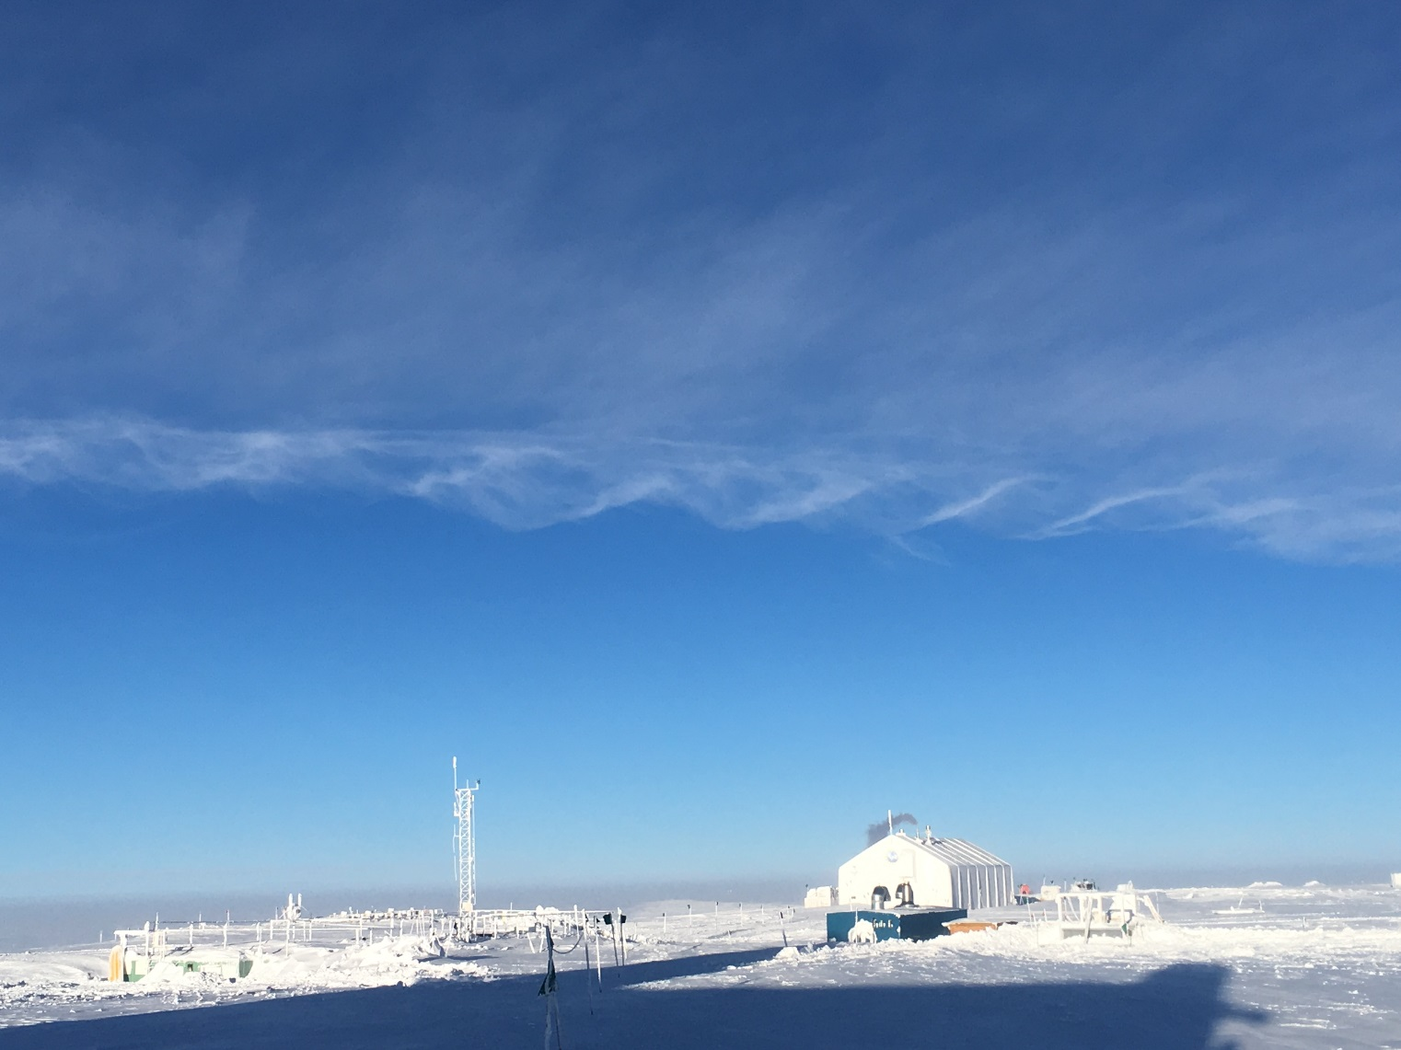  
Kelvin-Helmholtz instability evident over station on 2/24.*

**General Notes:**  The Dataman computer experienced a hard drive failure on 2/19. As a result, the regular data backup and transfer services normally provided by this system have been offline for much of this week. Significant effort has been put toward getting this system back up and running, and much progress has been made, although at the time this report the system was still offline. Meanwhile, data are still being collected normally and stored locally on the individual instrument computers.

**Significant Weather Observations:**

|  |  |  |  |  |  |  |  |
| --- | --- | --- | --- | --- | --- | --- | --- |
| **Date** | **Time (Z)** | **Wind** | **Weather** | **Visibility** | **Sky** | **Temp** | **Notes** |
| 2-18 | 12 | 12kt from 180 | FZFG | 0400 | FEW000 | -52 |  |
| 2-19 | 12 | 12kt from 180 | BR | 4800 | BKN130 | -39 |  |
| 2-20 | 12 | 13kt from 120 | BR | 3200 | BKN160 | -38 |  |
| 2-21 | 12 | 19kt from 140 | BLSN | 0300 | OVC030 | -24 |  |
| 2-22 | 12 | 20kt from 170 | BLSN | 0400 | OVC013 | -23 |  |
| 2-23 | 12 | 13kt from 110 | BR | 1600 | OVC016 | -32 |  |
| 2-24 | 12 | 14kt from 200 | DRSN FZFG | 0600 | SCT020 | -33 |  |

**ICECAPS-ACE Data Management:**

* 2-18: Data transfer complete at 1259Z
* 2-19: Data transfer complete at 1000Z
* 2-20: Dataman down – no transfer
* 2-21: Dataman down – no transfer
* 2-22: Dataman down – no transfer
* 2-23: Dataman down – no transfer
* 2-24: Dataman down – no transfer

**MWR:**

* Operating normally.

**SODAR:**

* 2-23 1356-1407z: Turned off amplifier and removed snow from dishes.
* Operating normally.

**POSS:**

* Offline since 2/19 due to Dataman computer failure.

**MMCR:**

* Temp (outside) value continues out of tolerance (at 30)
* Operating normally.

**CAPABL:**

* 2-18, 1730-2130z: Conducted 1064nm burn test on laser 1 @ 3” and 6”; used IR camera to document temps of both harmonic generators; opened harmonic generator on laser 1 path and confirmed and documented damage to crystal. Lasers powered down while awaiting further guidance from the manufacturer.
* 2/23: Ancillary systems powered down, while awaiting further guidance.
* Instrument currently offline.

**MPL:**

* Operating normally.

**VCEIL:**

* Operating normally.

**IceCAM:**

* Offline since 2/19 due to Dataman computer failure.

**PAERI:**

* Operating normally.

**TSI:**

* Offline for winter season.

**IcePIC:**

* 2/22: IcePIC equipment cleaned and serviced.
* No images captured this week.

**Radiosonde:**

* 2/24: Sonde computer restarted.
* Twice daily launches.

**MASC:**

* Instrument offsite for repair, will not return until summer 2019.

**OPC:**

* Operating normally.

**CLASP:**

* Instrument off site.

**CPC:**

* 2/20 1412z: Received error “Air pump problem, current too high”. Identified the cause as a plug of ice blocking flow through the sample outlet line. Pulled line inside, cleared blockage, and restarted data collection. Resulting data outage 1411-1427z.
* Operating normally
* Note: Wind shield not installed