**ICECAPS-ACE Weekly Report**

February 25 – March 3, 2019

Nate Bowker

*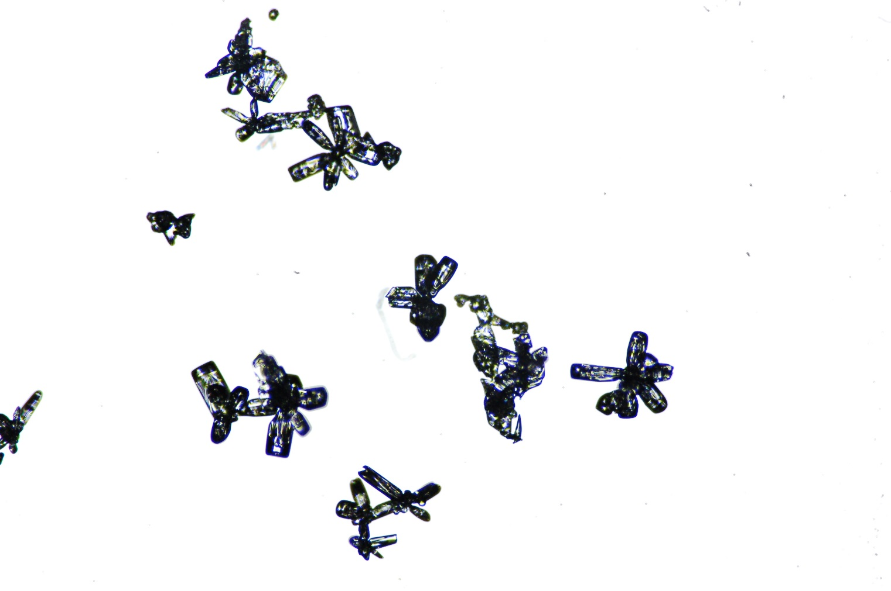  
Hollow Hex Bullet Rosettes, photographed on 3/3.*

**General Notes:**  This week included a positive resolution to last week’s hard drive failure on the dataman computer. The system is back online and working to catch up with the backlog of data that stacked up while the system was down.

**Significant Weather Observations:**

|  |  |  |  |  |  |  |  |
| --- | --- | --- | --- | --- | --- | --- | --- |
| **Date** | **Time (Z)** | **Wind** | **Weather** | **Visibility** | **Sky** | **Temp** | **Notes** |
| 2-25 | 12 | 17kt from 190 | DRSN FZFG | 0600 | BKN032 | -28 |  |
| 2-26 | 12 | 6kt from 100 | FZFG | 0800 | FEW100 | -39 |  |
| 2-27 | 12 | 13kt from 180 |  | 9999 | FEW100 | -43 |  |
| 2-28 | 12 | 15kt from 220 | DRSN BR | 1600 | FEW100 | -39 |  |
| 3-1 | 12 | 19kt from 250 | BLSN FZFG | 0200 | OVC020 | -19 |  |
| 3-2 | 12 | 13kt from 230 | DRSN FZFG | 0600 | FEW030 | -30 |  |
| 3-3 | 12 | 12kt from 170 | BLSN BR | 1600 | BKN013 | -30 |  |

**ICECAPS-ACE Data Management:**

* 2-25: Dataman down – no transfer
* 2-26: Dataman down – no transfer
* 2-27: Dataman computer is back online, with much of the data backlog queued for transfer.
* 2-28: Dataman catching up with data backlog: ~680MB transferred
* 3-1: Dataman catching up with data backlog: ~98MB transferred
* 3-2: Dataman catching up with data backlog: ~1429MB transferred
* 3-3: Dataman catching up with data backlog - ~344MB transferred

**MWR:**

* 3-1: Found with error “slave elevation mirror does not respond”. Restarted system and resumed data collection at ~1530z.
* Rebooting of instrument based on current protocols resulted in reversal of Master and Slave radiometers.

**SODAR:**

* Operating normally.

**POSS:**

* 3/2 0000z: POSS data acquisition software restarted.
* Operating normally

**MMCR:**

* LapXM NetCDF errors occurring since 2/27.
* Temp (outside) value continues out of tolerance (at 30)
* Operating normally.

**CAPABL:**

* Instrument currently offline.

**MPL:**

* Operating normally.

**VCEIL:**

* Operating normally.

**IceCAM:**

* Back online as of 3/1.
* Operating normally

**PAERI:**

* Some red flags for SW and LW Responsivity relating to BLSN on 2/28. These resolved without intervention.
* Operating normally.

**TSI:**

* Offline for winter season.

**IcePIC:**

* IcePICs taken: 2/25 and 3/3

**Radiosonde:**

* 3/2: 0000z sonde failed to transmit to DMI.
* Twice daily launches.

**MASC:**

* Instrument offsite for repair, will not return until summer 2019.

**OPC:**

* Operating normally.

**CLASP:**

* Instrument off site.

**CPC:**

* 2/27: Heather fixed the CPC quicklooks, and data is plotting to the Ncounts plot.
* Operating normally
* Note: Wind shield not installed