**ICECAPS-ACE Weekly Report**

February 4 – February 10, 2019

Gus Allen & Nate Bowker

*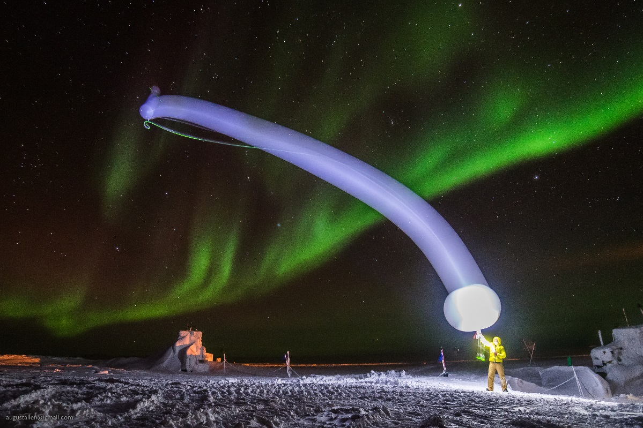  
My second-to-last radiosonde launch.*

**General Notes:**  The Feb 7 flight arrived on schedule, carrying my replacement Nate as well as the CPC, replacement OPC, and supplies for performing burn tests on the CAPABL lasers. I was able to install those instruments and Nate and I did the burn tests on Friday, the 8th.

**Significant Weather Observations:**

|  |  |  |  |  |  |  |  |
| --- | --- | --- | --- | --- | --- | --- | --- |
| **Date** | **Time (Z)** | **Wind** | **Weather** | **Visibility** | **Sky** | **Temp** | **Notes** |
| 2-4 | 12 | 07kts from 207 |  | 9999 | SKC | -49 |  |
| 2-5 | 12 | 09kt from 220 | BR | 1600 | FEW000 FEW100 | -48 |  |
| 2-6 | 12 | 13kt from 160 |  | 9999 | SCT060 | -40 |  |
| 2-7 | 12 | 05kt from 140 |  | 9999 | FEW180 | -45 | Flight arrived! |
| 2-8 | 12 | 02kts from 210 |  | 9999 | FEW100 | -42 |  |
| 2-9 | 12 | 10kts from 180 |  | 9999 | BKN100 | -45 |  |
| 2-10 | 12 | 11kts form 190 |  | 9999 | FEW100 | -51 |  |

**ICECAPS-ACE Data Management:**

* 2-4: Data transfer complete at 1353Z
* 2-5: Data transfer complete at 1406Z
* 2-6: Data transfer complete at 1318Z
* 2-7: Data transfer complete at 1405Z
* 2-8: Data transfer complete at 1324Z
* 2-9: Data transfer complete at 1435Z
* 2-10: Data transfer complete at 1357Z

**MWR:**

* Operating normally.

**SODAR:**

* Operating normally.

**POSS:**

* Operating normally.

**MMCR:**

* Temp (outside) value continues out of tolerance (at 30)
* 2-6 1230Z: Errors in log indicate calibration failure. These were cleared and have not repeated since.
* Operating normally.

**CAPABL:**

* 2-5: CAPABL found not lasing. Neely determined the flashlamp had failed. I performed a flashlamp change. On restart, the system did not lase initially. At Neelys direction I pulled the back panel off the laser head and allowed a small amount of moisture to dry out. After replacing it and restarting the system, the head lased and system appears to be functioning normally.
* 2-8: With the arrival of the first Feb flight, supplies and safety goggles arrived to perform laser burn tests to analyze the ongoing issues with laser 1. Following the procedure provided by Neely, we performed some tests on Friday.
  + The burns indicate the laser 1 head appears to be lasing appropriately.
  + It is very difficult to visualize, but the harmonic generator on the laser 1 path may be cracked or otherwise damaged.
  + Neely is determining next steps.
* Instrument currently operating normally using laser 2

**MPL:**

* Operating normally.

**VCEIL:**

* Operating normally.

**IceCAM:**

* Operating normally.

**PAERI:**

* Operating normally.

**TSI:**

* Offline for winter season.

**IcePIC:**

* No images captured this week.

**Radiosonde:**

* Von forwarded a message from the Danish Met Service regarding missing sonde data. Summit has some intermittent radio interference from an unknown source which interferes with the building-to-building wireless connection on occasion. We believe an interference event delayed the transmission of the 0 z sonde on 2019-02-08.
* Twice daily launches.

**MASC:**

* Instrument offsite for repair, will not return until summer 2019.

**OPC:**

* 2-7: OPC replaced with weather-proofed version. Windshield mounted.
* The ACE mount is not present for DATAMAN, so OPC data are not being transferred offsite. Neely is working on this issue.

**CLASP:**

* Instrument off site.

**CPC:**

* 2-7: CPC reconnected
* 2-8 1335Z: CPC powered up. Neely is working on back-end transfer functionality
* Note: Windshield not installed