**ICECAPS-ACE Weekly Report**

January 21 – January 27, 2019

Gus Allen

*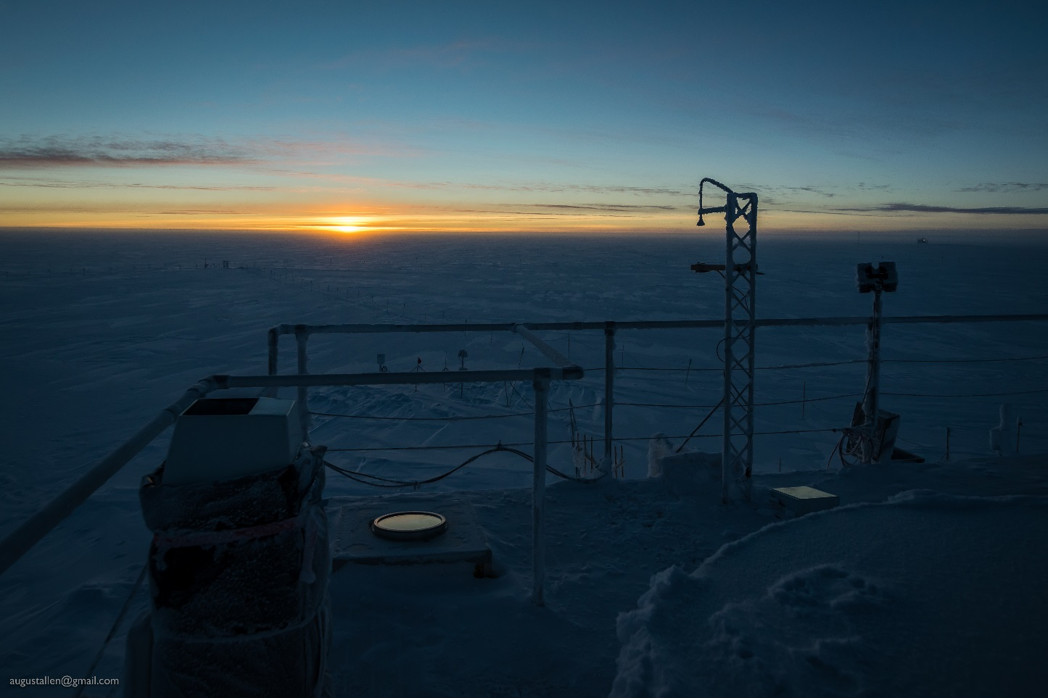  
Just a status shot of the MSF roof on 1-26 with absolutely nothing of note happening on the horizon, at least according*

*to the chart we have from the US Naval Observatory about sunrise and sunset times.*

**General Notes:** High winds on Tuesday and Wednesday caused minor issues with a couple of instruments, detailed below. Summit had a temperature spike on 1-27 which caused the MSF inside temp to get up to 63 briefly before I was able to bring it back down.

**Significant Weather Observations:**

|  |  |  |  |  |  |  |  |
| --- | --- | --- | --- | --- | --- | --- | --- |
| **Date** | **Time (Z)** | **Wind** | **Weather** | **Visibility** | **Sky** | **Temp** | **Notes** |
| 1-21 | 12 | 11kt from 170 |  | 9999 | FEW100 | -52 |  |
| 1-22 | 12 | 35G40kt from 100 | BLSN | 0000 | VV000 | -29 |  |
| 1-23 | 12 | 33kt from 122 | BLSN | 0100 | VV001 | -33 |  |
| 1-24 | 12 | 16kt from 150 |  | 9999 | FEW100 | -42 | Fog forming around 13Z |
| 1-25 | 12 | 09kt from 230 |  | 9999 | FEW100 | -52 | <1cm new rime |
| 1-26 | 12 | 14kt from 200 | FZFG | 0400 | SCT000 BKN012 | -41 |  |
| 1-27 | 12 | 5kt from 240 |  | 9999 | OVC009 | -29 | Winds dying |

**ICECAPS-ACE Data Management:**

* 1-21: Data transfer complete at 1310Z
* 1-22: Data transfer complete at 1556Z
* 1-23: Data transfer complete at 1406Z
* 1-24: Data transfer did not complete until 1-25 0130Z. The cause of this slowdown is unknown.
* 1-25: Data transfer complete at 1727Z
* 1-26: Data transfer complete at 1327Z
* 1-27: Data transfer complete at 1328Z

**MWR:**

* 1-24: R2CH software showing “Radiometer Communication Error” and is unresponsive. At Erik Olson’s direction I power-cycled the HATPRO and restarted the software, which allowed both radiometers to reconnect and resume normal operation.
* Operating normally.

**SODAR:**

* 1-22: JPG previews indicate dishes need cleaning.
* 1-24 1618 to 1819Z: Amp powered down to allow snow removal from dishes.
* Operating normally.

**POSS:**

* Operating normally.

**MMCR:**

* Temp (outside) value has been out of tolerance (at 30) all week.
* Operating normally.

**CAPABL:**

* 1-26: CAPABL terminal found showing “Disk Boot Error”. I rebooted it following the procedure provided by Robert Stillwell on 11/22.
* 1-27: CAPABL found not lasing. Robert Stillwell was able to resume normal operations remotely, but we were not able to definitively locate the root cause.
* Instrument currently operating normally using laser 2

**MPL:**

* Operating normally.

**VCEIL:**

* 1-23: Error: Optical Cross-talk Compensation Poor. I suspect this means there is snow in it.
* 1-24: Error: Window contaminated; Optical cross-talk compensation poor. Liquid water on window. I manually removed some snow, and the internal heater appears to be overcoming the remaining interfering snow and ice.
* Operating normally.

**IceCAM:**

* Operating normally.

**PAERI:**

* 1-22: PAERI showed red flags for LWresponsivity and SWresponsivity from approximately 03Z. Investigating, I found the outside power plug on the enclosure fan disconnected, probably from high wind. Plugging the fan back caused the flags to clear without any need to manually clean the scene mirror.
* Operating normally.

**TSI:**

* Offline for winter season.

**IcePIC:**

* No images captured this week.

**Radiosonde:**

* Launch on 1-22 12Z cancelled due to poor conditions.
* Twice daily launches.

**MASC:**

* Instrument offsite for repair, will not return until summer 2019.

**OPC:**

* OPC is operational and collecting data.
* The ACE mount is not present for DATAMAN, so OPC data are not being transferred offsite. Neely is working on this issue.

**CLASP:**

* Instrument off site.

**CPC:**

* Instrument off site.