**ICECAPS-ACE Weekly Report**

January 28 – February 3, 2019

Gus Allen

*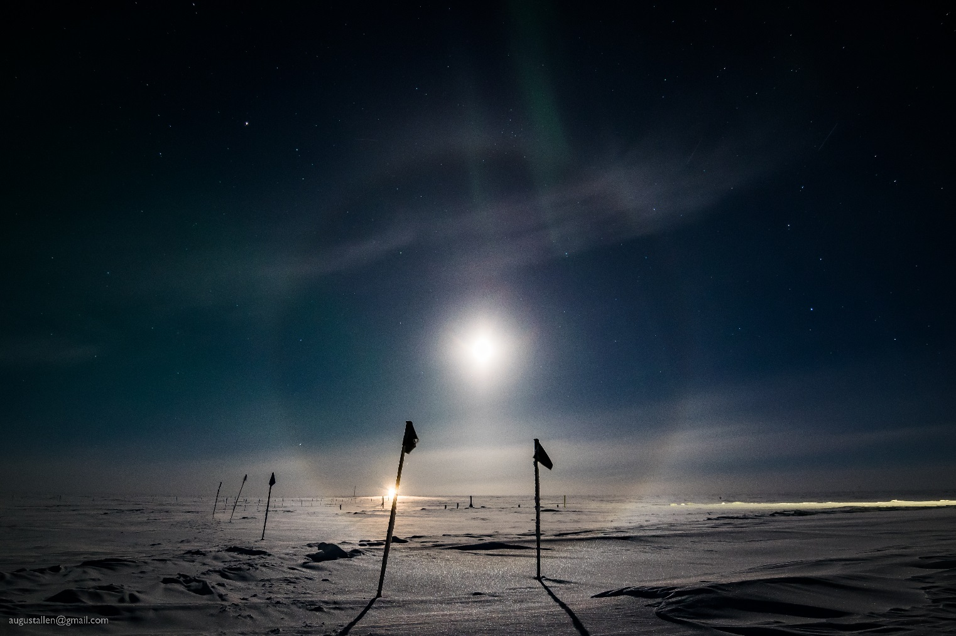  
A halo around the moon is made continuous by ice crystals on the surface of the snow.*

**General Notes:**  Nate Bowker, the replacement ICECAPS tech, is scheduled to arrive on Thursday. I have been preparing to turnover to him.

**Significant Weather Observations:**

|  |  |  |  |  |  |  |  |
| --- | --- | --- | --- | --- | --- | --- | --- |
| **Date** | **Time (Z)** | **Wind** | **Weather** | **Visibility** | **Sky** | **Temp** | **Notes** |
| 1-28 | 12 | 12kt from 080 | FZFG | 400 | BKN003 | -34 |  |
| 1-29 | 12 | 17kt from 090 |  | 9999 | FEW100 | -46 | brr |
| 1-30 | 12 | 10kt from 190 |  | 9999 | SCT100 | -45 |  |
| 1-31 | 12 | 16kt from 080 |  | 9999 | FEW100 | -50 |  |
| 2-1 | 12 | 17kt from 110 |  | 9999 | SKC | -49 |  |
| 2-2 | 12 | 07kt from 230 | FZFG | 0400 | VV003 | -41 | Rapidly warming |
| 2-3 | 12 | 18kt from 060 |  | 9999 | FEW100 | -48 | Nearly clear |

**ICECAPS-ACE Data Management:**

* 1-28: Data transfer complete at 1620Z
* 1-29: Data transfer complete at 1404Z
* 1-30: ICECAPS linux system found not responding at the desktop.
* 1-30 1900Z: ICECAPS linux server restarted; Matt restarted data transfer.
* 1-31: Data transfer complete at 1950Z.
* 2-1: Data transfer complete at 1331Z
* 2-2: Data transfer complete at 1330Z
* 2-3: Data transfer complete at 1430Z

**MWR:**

* Operating normally.

**SODAR:**

* Operating normally.

**POSS:**

* 2-3: POSS stand raised. Data acquisition stopped 1305Z, restarted 1441Z
* Operating normally.

**MMCR:**

* Temp (outside) value continues out of tolerance (at 30)
* Operating normally.

**CAPABL:**

* 1-31: CAPABL found not lasing – Robert logged on and restarted it.
* 2-1: Clear conditions allowed Neely and I to perform an alignment.
* Instrument currently operating normally using laser 2

**MPL:**

* Operating normally.

**VCEIL:**

* Operating normally.

**IceCAM:**

* Operating normally.

**PAERI:**

* Operating normally.

**TSI:**

* Offline for winter season.

**IcePIC:**

* No images captured this week.

**Radiosonde:**

* Twice daily launches.

**MASC:**

* Instrument offsite for repair, will not return until summer 2019.

**OPC:**

* OPC is operational and collecting data.
* The ACE mount is not present for DATAMAN, so OPC data are not being transferred offsite. Neely is working on this issue.

**CLASP:**

* Instrument off site.

**CPC:**

* Instrument off site.