**ICECAPS-ACE Weekly Report**

January 7 – January 13, 2019

Gus Allen

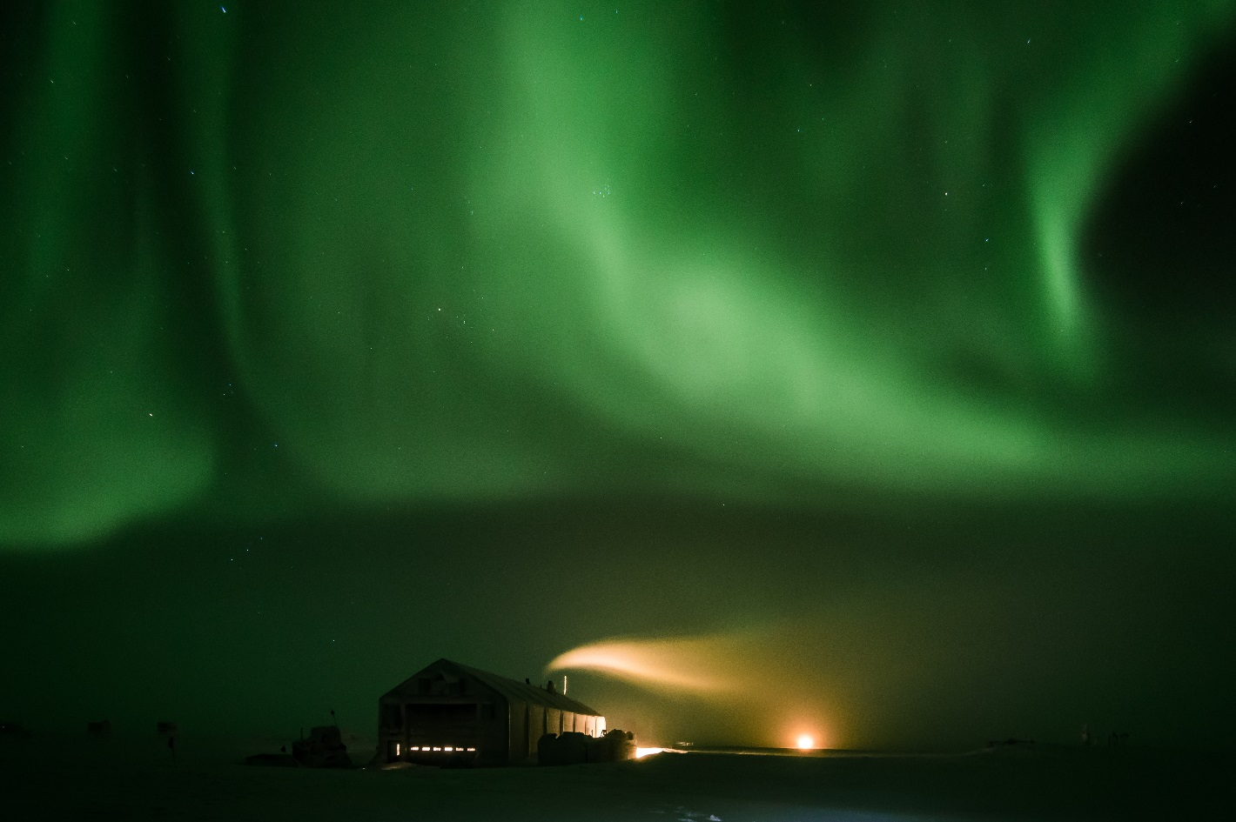

*Moderate fog partially obscures auroral activity on the evening of January 7*

**General:** This week saw the lowest temperatures at Summit so far this season. This has made balancing the inside MSF temperature slightly more challenging.

**Significant Weather Observations:**

|  |  |  |  |  |  |  |  |
| --- | --- | --- | --- | --- | --- | --- | --- |
| **Date** | **Time (Z)** | **Wind** | **Weather** | **Visibility** | **Sky** | **Temp** | **Notes** |
| 1-7 | 12 | 11kt from 220 |  | 9999 | FEW100 | -51 | 2cm rime overnight |
| 1-8 | 12 | 25kts from 210 | BLSN | 0200 | VV002 | -24 | Wind increasing to 30kts at 1500Z |
| 1-9 | 12 | 17kts from 270 | BLSN BR | 0800 | SCT000 OVC012 | -30 |  |
| 1-10 | 12 | 11kts from 320 |  | 9999 | SKC | -58(!!) | VERY cold; exhaust plume from SMG drifting right over MSF |
| 1-11 | 12 | 12kt from 230 |  | 9999 | FEW100 | -54 |  |
| 1-12 | 12 | 10kt from 220 | VCFG | 9999 | FEW100 | -54 |  |
| 1-13 | 12 | 13kt from 200 | VFCG IC | 8000 | FEW100 | -57 | <1cm rime |

**ICECAPS-ACE Data Management:**

* 1-7: Data transfer complete at 1250Z
* 1-8: Data transfer complete at 1257Z
* 1-9: Data transfer complete at 1055Z
* 1-10: Data transfer complete at 1610Z
* 1-11: Data transfer complete at 1831Z
* 1-12: Data transfer complete at 1232Z
* 1-13: Data transfer complete at 1151Z

**MWR:**

* Operating normally.

**SODAR:**

* Operating normally.

**POSS:**

* Operating normally.

**MMCR:**

* 1-8: Health log indicates Temperature (Outside) value is out of tolerance, at 1.
* 1-11: NetCDF error occurred at 0500Z. I cleared it and will continue to monitor.
* 1-12: More Net CDF errors
* Level is currently 0.11 pitch, 0.00 roll
* Operating normally.

**CAPABL:**

* 1-8 1308Z: Found CAPABL window blocked by snow. I was unable to clear immediately due to high wind conditions. Window cleared and laser restarted at 1605Z.
* Instrument currently operating normally using laser 2

**MPL:**

* Operating normally.

**VCEIL:**

* Data files were not logged from 1-1 until 1-10. I suspect user error.
* Operating normally.

**IceCAM:**

* Operating normally.

**PAERI:**

* 1-10: Red flag for Max Sample Std Dev. Flag is intermittently red and back to about 10Z. Associated with extremely cold temperature
* 1-12: Red flag for Max Sample Std Dev, continuous from 23Z onward.
* Operating normally.

**TSI:**

* Offline for winter season.

**IcePIC:**

* No images captured this week.

**Radiosonde:**

* Twice daily launches.

**MASC:**

* Instrument offsite for repair, will not return until summer 2019.

**OPC:**

* 1-7 1942Z: Pi powered down and OPC removed from roof to melt out.
* 1-9 1425Z: OPC re-mounted on roof tower and reconnected; Pi repowered
* 1-9 1600Z: Data collection restarted
* 1-10, 11,12: Heather has been working on restoring background services on the backup ACE laptop. As of this writing the ACE mount for Dataman has not been restored so OPC data is not being transmitted.

**CLASP:**

* Instrument off site.

**CPC:**

* Instrument off site.