**ICECAPS-ACE Weekly Report**

March 11 – March 17, 2019

Nate Bowker

*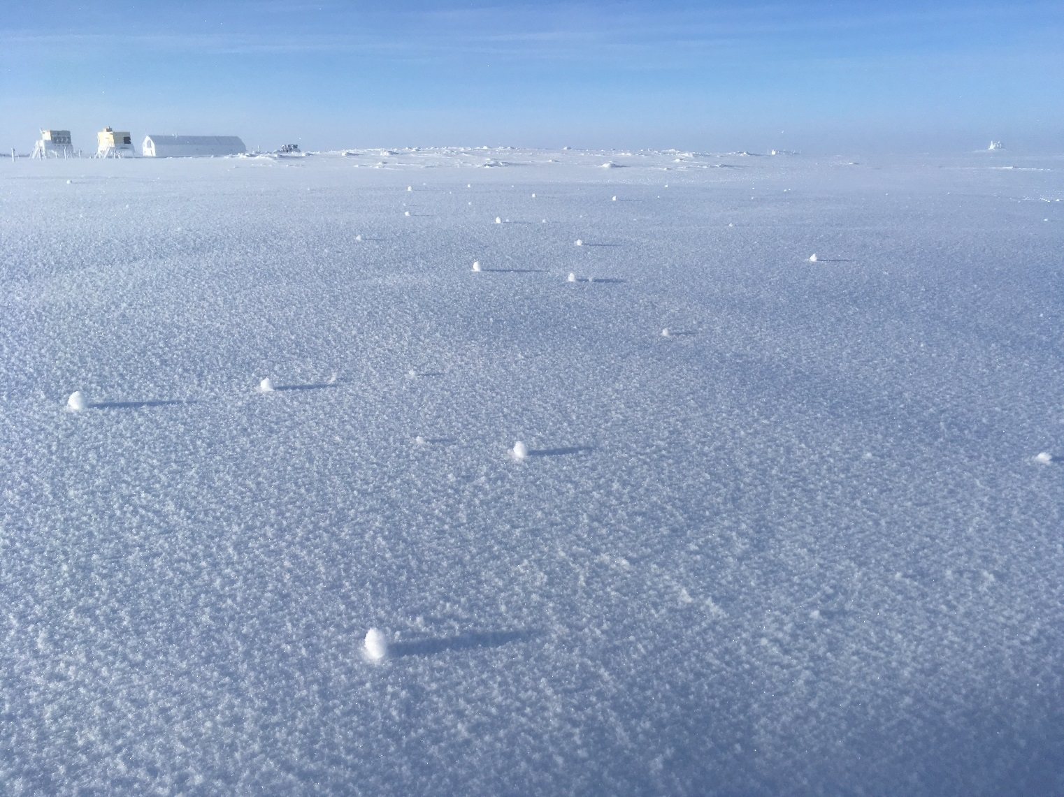  
Yukimarimo on 3-13.*

**General Notes:**  Tis the season for summer work planning! Please let me know if you have any questions about your tools, materials, or other supplies currently stored up at Summit.

**General Weather Observations:**

|  |  |  |  |  |  |  |  |
| --- | --- | --- | --- | --- | --- | --- | --- |
| **Date** | **Time (Z)** | **Wind** | **Weather** | **Visibility** | **Sky** | **Temp** | **Notes** |
| 3-11 | 12 | 14kt from 110 |  | 9999 | FEW100 | -50 |  |
| 3-12 | 12 | 10kt from 200 |  | 9999 | FEW013 SCT080 | -50 |  |
| 3-13 | 12 | 10kt from 180 | BR | 3200 | SCT065 | -46 |  |
| 3-14 | 12 | 2kt from 080 |  | 9999 | FEW100 | -45 |  |
| 3-15 | 12 | 10kt from 200 |  | 9999 | SCT046 | -52 |  |
| 3-16 | 12 | 9kt from 200 | FZFG | 0800 | BKN065 | -48 |  |
| 3-17 | 12 | 14kt from 190 | FZFG | 0800 | FEW030 | -49 |  |

**Significant Weather Observations:**

* 3-13: Yukimarimo formation observed from ~1530 – 2200z.
* 3-14: Particularly intense fata morgana observed from ~1130 – 1430z.

**ICECAPS-ACE Data Management:**

* 3-11: Data transfer completed at 1024z.
* 3-12: Data transfer completed at 1150z.
* 3-13: Data transfer completed at 1044z.
* 3-14: Data transfer completed at 1103z.
* 3-15: Data transfer completed at 1024z.
* 3-16: Data transfer completed at 1030z
* 3-17: Data transfer completed at 1112z.

**MWR:**

* Operating normally.

**SODAR:**

* 3-15 1838-1852Z: Cleaned and releveled dishes.
* Operating normally.

**POSS:**

* Operating normally

**MMCR:**

* Temp (outside) value continues out of tolerance (at 30)
* Operating normally.

**CAPABL:**

* Instrument currently offline.

**MPL:**

* 3-15: Afterpulse calibration performed.
* Operating normally.

**VCEIL:**

* Operating normally.

**IceCAM:**

* 3-14 1045z: No image captured.
* Operating normally

**PAERI:**

* Operating normally.

**TSI:**

* Offline for winter season.

**IcePIC:**

* 3-13: Two sampling sessions photographed and uploaded.
* 3-16: One sampling session photographed and uploaded.

**Radiosonde:**

* 3-17: 0000Z sonde data collected but did not transmit to DMI.
* Twice daily launches.

**MASC:**

* Instrument offsite for repair, will not return until summer 2019.

**OPC:**

* Operating normally.

**CLASP:**

* Instrument off site.

**CPC:**

* 3-12: Changed carbon filter on outlet line
* 3-13: Found with “Air pump problem” alarm. Cleared small blockage at the end of the outlet tube and restarted at 1247z.
* 3-14: Installed wind shield on sample inlet.
* Operating normally