**ICECAPS-ACE Weekly Report**

March 18 – March 24, 2019

Nate Bowker

*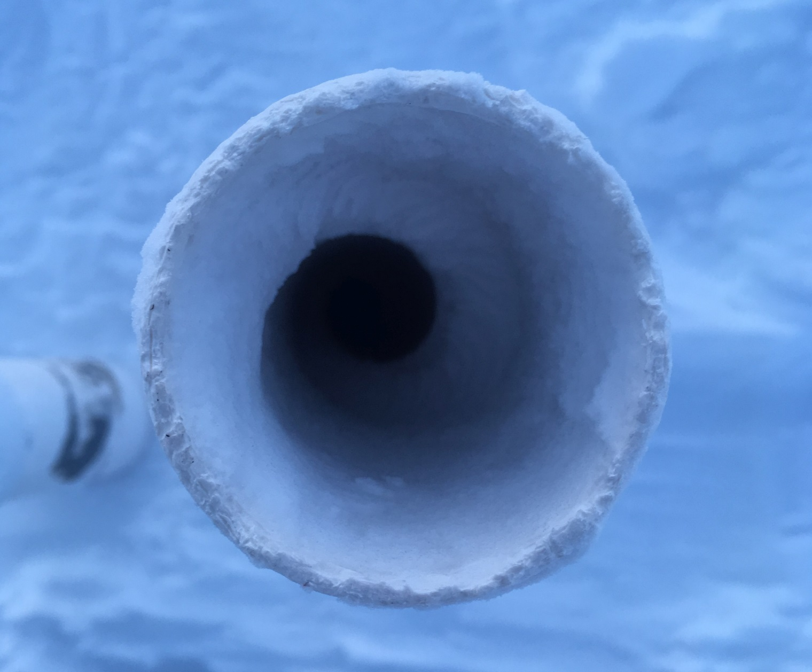  
The fluid properties of air captured in ice, courtesy of the RN filter intake.*

**General Notes:**  Tis the season for summer work planning! Please let me know if you have any questions about your tools, materials, or other supplies currently stored up at Summit.

“Spring cleaning” has begun and will be ongoing in the coming weeks. This includes flag line maintenance, manual snow removal and cleanup around buildings, cleaning and organization of interior physical and digital spaces, routine maintenance and repair of tools and equipment, conducting inventories of consumable items for resupply, identifying and staging materials for impending summer work, and any other activities that you can think of to help prepare our work spaces for maximum productivity during the busy summer field season. Please feel free to add to my list if you have any specific items that could benefit from my attention in advance of summer flight period 1.

**General Weather Observations:**

|  |  |  |  |  |  |  |  |
| --- | --- | --- | --- | --- | --- | --- | --- |
| **Date** | **Time (Z)** | **Wind** | **Weather** | **Visibility** | **Sky** | **Temp** | **Notes** |
| 3-18 | 12 | 28kt from 200 | BLSN | 0000 | VV001 | -31 |  |
| 3-19 | 12 | 11kt from 140 | BR | 1200 | SCT060 | -42 |  |
| 3-20 | 12 | 15kt from 100 |  | 9999 | BKN070 | -48 |  |
| 3-21 | 12 | 10kt from 230 | BR | 1600 | FEW030 | -55 |  |
| 3-22 | 12 | 22kt from 116 | BLSN | 200 | OVC030 | -40 |  |
| 3-23 | 12 | 14kt from 170 | DRSN BR | 1400 | SCT030 | -46 |  |
| 3-24 | 12 | 12kt from 200 | BR | 1200 | FEW120 | -48 |  |

**Significant Weather Observations:**

* 3-20 1632Z: Atmospheric pressure of 625.1 mbar observed.

**ICECAPS-ACE Data Management:**

* 3-18: Data transfer completed at 1042Z.
* 3-19: Data transfer completed at 1059Z.
* 3-20: Data transfer completed at 1024Z.
* 3-21: Data transfer completed at 1051Z.
* 3-22: Data transfer completed at 1108Z.
* 3-23: Data transfer completed at 1102Z.
* 3-24: Data transfer completed at 1025Z.

**MWR:**

* Operating normally.

**SODAR:**

* 3-19 1815-1840Z: Raised flag line.
* 3-24 1252-1303Z: Removed snow from dishes.
* Operating normally.

**POSS:**

* 3-19 1840-1900: Raised flag line.
* Operating normally

**MMCR:**

* Temp (outside) value continues out of tolerance (at 30)
* Operating normally.

**CAPABL:**

* Instrument currently offline.

**MPL:**

* Operating normally.

**VCEIL:**

* Operating normally.

**IceCAM:**

* Operating normally

**PAERI:**

* Operating normally.

**TSI:**

* Offline for winter season.

**IcePIC:**

* 3-21: One sampling session photographed and uploaded.
* 3-24: One sampling session photographed and uploaded.

**Radiosonde:**

* Twice daily launches.

**MASC:**

* Instrument offsite for repair, will not return until summer 2019.

**OPC:**

* 3-18 ~1820Z: Data collection was interrupted during a high wind event. Instrument was restarted at 1535Z on 3-19 and resumed collection of minute data in Konsole, however the daily data text file is not getting written and the plot is not updating. Awaiting further guidance on this.
* Operating normally.

**CLASP:**

* Instrument off site.

**CPC:**

* Operating normally