**ICECAPS-ACE Weekly Report**

March 25 – March 31, 2019

Nate Bowker

*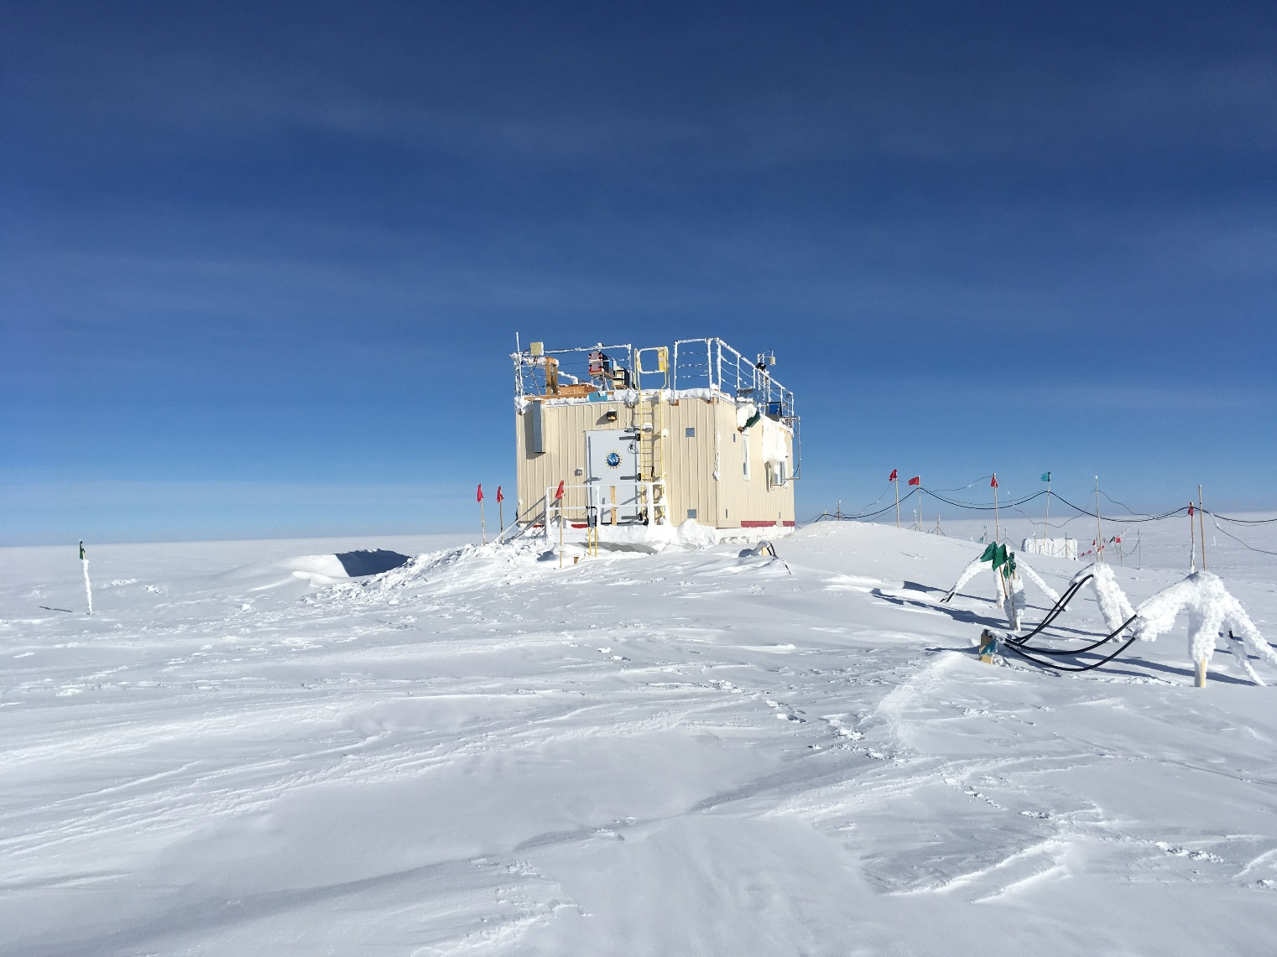  
Snow accumulation around the MSF this winter seems less substantial than in some previous years.*

**General Notes:**  Tis the season for summer work planning! Please let me know if you have any questions about your tools, materials, or consumable supplies currently stored up at Summit, or if you would like any items to be staged or serviced in preparation for the summer season.

**General Weather Observations:**

|  |  |  |  |  |  |  |  |
| --- | --- | --- | --- | --- | --- | --- | --- |
| **Date** | **Time (Z)** | **Wind** | **Weather** | **Visibility** | **Sky** | **Temp** | **Notes** |
| 3-25 | 12 | 24kt from 190 | BLSN FZFG | 200 | VV060 | -22 |  |
| 3-26 | 12 | 6kt from 180 | IC | 9999 | SCT030 | -36 |  |
| 3-27 | 12 | 13kt from 050 | BR | 1600 | BKN070 | -41 |  |
| 3-28 | 12 | 10kt from 350 | FZFG | 800 | SCT100 | -42 |  |
| 3-29 | 12 | 8kt from 330 |  | 9999 | FEW090 | -40 |  |
| 3-30 | 12 | 14kt from 220 | FSFG DRSN | 300 | BKN030 | -38 |  |
| 3-31 | 12 | 10kt from 180 |  | 9999 | FEW100 | -41 |  |

**Significant Weather Observations:**

* NTR

**ICECAPS-ACE Data Management:**

* 3-25: Data transfer completed at 1114Z.
* 3-26: Data transfer completed at 1026Z.
* 3-27: Data transfer completed at 1117Z.
* 3-28: Data transfer completed at 1059Z.
* 3-29: Data transfer completed at 1059Z.
* 3-30: Data transfer completed at 1016Z.
* 3-31: Data transfer completed at 1051Z.

**MWR:**

* Operating normally.

**SODAR:**

* Operating normally.

**POSS:**

* “Heater current” fault code started showing up this week.
* Operating normally

**MMCR:**

* Temp (outside) value continues out of tolerance (at 30)
* Operating normally.

**CAPABL:**

* Instrument currently offline.

**MPL:**

* Operating normally.

**VCEIL:**

* Operating normally.

**IceCAM:**

* Operating normally

**PAERI:**

* Operating normally.

**TSI:**

* Offline for winter season.

**IcePIC:**

* 3-26: One sampling session photographed and uploaded.

**Radiosonde:**

* 3-30 1200Z: Balloon burst at just over 13km.
* 3-31 1200Z: Sonde data not processed in time to send to DMI due to an error in entering surface observations.
* Twice daily launches.

**MASC:**

* Instrument offsite for repair, will not return until summer 2019.

**OPC:**

* 3-26 1309Z: Restarted instrument.
* Operating normally.

**CLASP:**

* Instrument off site.

**CPC:**

* 3-26 1422Z: Refilled butanol reservoir.
* 3-28 1400Z: Changed outlet filter due to condensate in the outlet tubing.
* Operating normally