**ICECAPS-ACE Weekly Report**

March 4 – March 10, 2019

Nate Bowker

*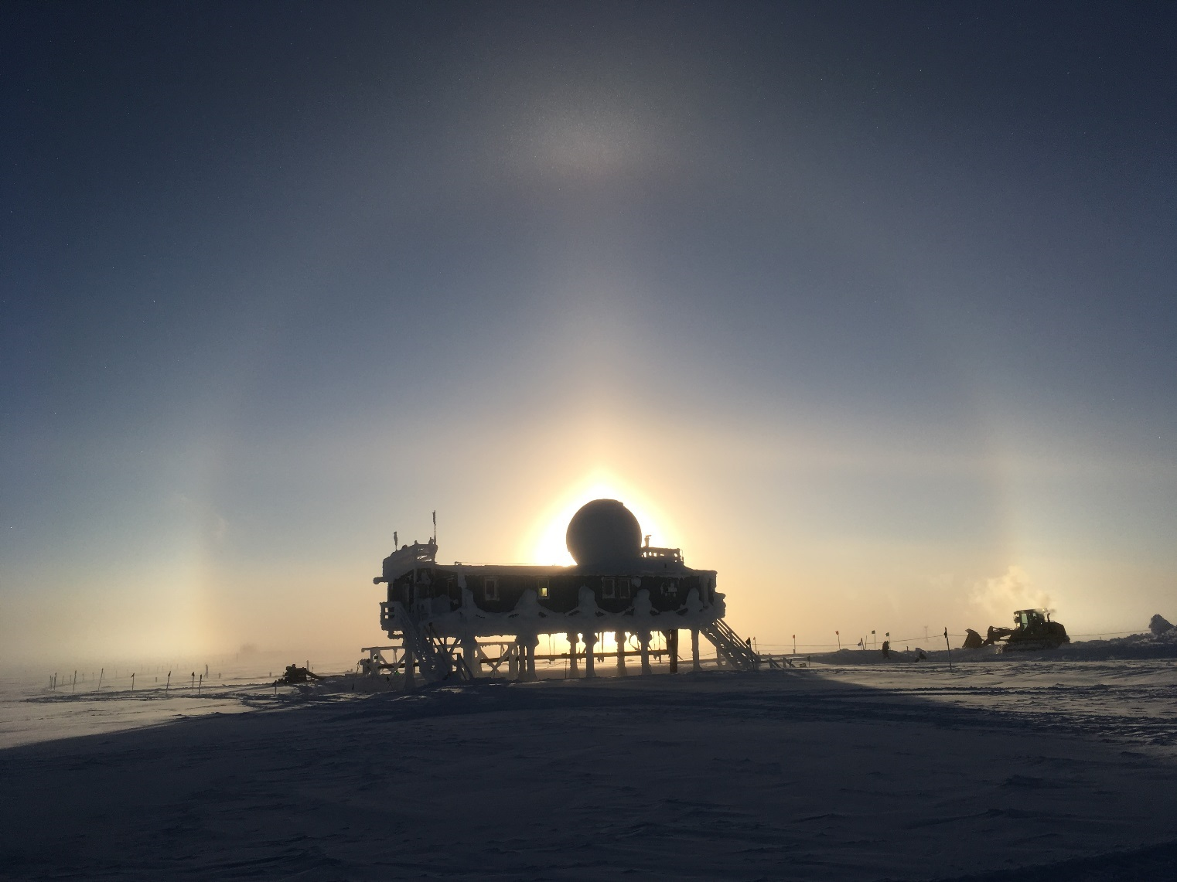  
Faint solar optics on 3-4 provide a nice backdrop for digging out the freezer trench and thawing the BH sewer outfall.*

**General Notes:**  The backlog of data that amassed while the dataman computer was down is fully caught up as of Friday, March 8th. Nightly data transfers are once again occurring normally.

Daylight savings time for 2019 began in the United States on Sunday, March 10th. Greenland and the UK will begin “saving” daylight on Sunday, March 31st. In the interim, our time difference will be one hour less than normal.

**Significant Weather Observations:**

|  |  |  |  |  |  |  |  |
| --- | --- | --- | --- | --- | --- | --- | --- |
| **Date** | **Time (Z)** | **Wind** | **Weather** | **Visibility** | **Sky** | **Temp** | **Notes** |
| 3-4 | 12 | 11kt from 300 |  | 9999 | SCT060 | -38 |  |
| 3-5 | 12 | 8kt from 40 |  | 9999 | FEW100 | -48 |  |
| 3-6 | 12 | 13kt from 160 |  | 9999 | SKC | -46 |  |
| 3-7 | 12 | 12kt from 230 | FZFG | 0800 | BKN026 | -33 |  |
| 3-8 | 12 | 12kt from 50 | FZFG | 0600 | FEW100 | -40 |  |
| 3-9 | 12 | 9kt from 220 |  | 9999 | SKC | -45 |  |
| 3-10 | 12 | 5kt from 230 | BR | 3200 | FEW100 | -48 |  |

**ICECAPS-ACE Data Management:**

* 3-4: Dataman catching up with data backlog: ~1.9GB transferred
* 3-5: Dataman catching up with data backlog: ~2.1GB transferred
* 3-6: Dataman catching up with data backlog: ~1.8GB transferred
* 3-7: Dataman catching up with data backlog: ~1.7GB transferred
* 3-8: Dataman is caught up with data backlog! ~1.3GB transferred, completed at 1021z
* 3-9: Data transfer completed at 1009Z.
* 3-10: Data transfer completed at 1004Z

**MWR:**

* 3-4: Restarted system to correct Master/Slave COM port reversal.
* Operating normally.

**SODAR:**

* Operating normally.

**POSS:**

* Operating normally

**MMCR:**

* 3-7 1617z: Reboot performed to correct LabVIEW error relating to the synchronization of the dm and radar PCs.
* Temp (outside) value continues out of tolerance (at 30)
* Operating normally.

**CAPABL:**

* Instrument currently offline.

**MPL:**

* Operating normally.

**VCEIL:**

* Operating normally.

**IceCAM:**

* Operating normally

**PAERI:**

* Operating normally.

**TSI:**

* Offline for winter season.

**IcePIC:**

* Backlog of IcePICs staged to be transferred on 3/11
* No pictures taken this week.

**Radiosonde:**

* 3-5: Replaced plastic on balloon table.
* Twice daily launches.

**MASC:**

* Instrument offsite for repair, will not return until summer 2019.

**OPC:**

* Operating normally.

**CLASP:**

* Instrument off site.

**CPC:**

* 3-5 1410z: Refilled butanol reservoir.
* 3-6 1245z: Received “Liquid Level” error which cleared upon venting the butanol reservoir. Received “Check Air Inlet” alarm for ~15min immediately after the “Liquid Level” alarm cleared, perhaps relating to the ingestion of snow during inlet cleaning.
* Operating normally
* Note: Wind shield not installed