**ICECAPS-ACE Weekly Report**

September 23 – September 29, 2019

Heather Guy

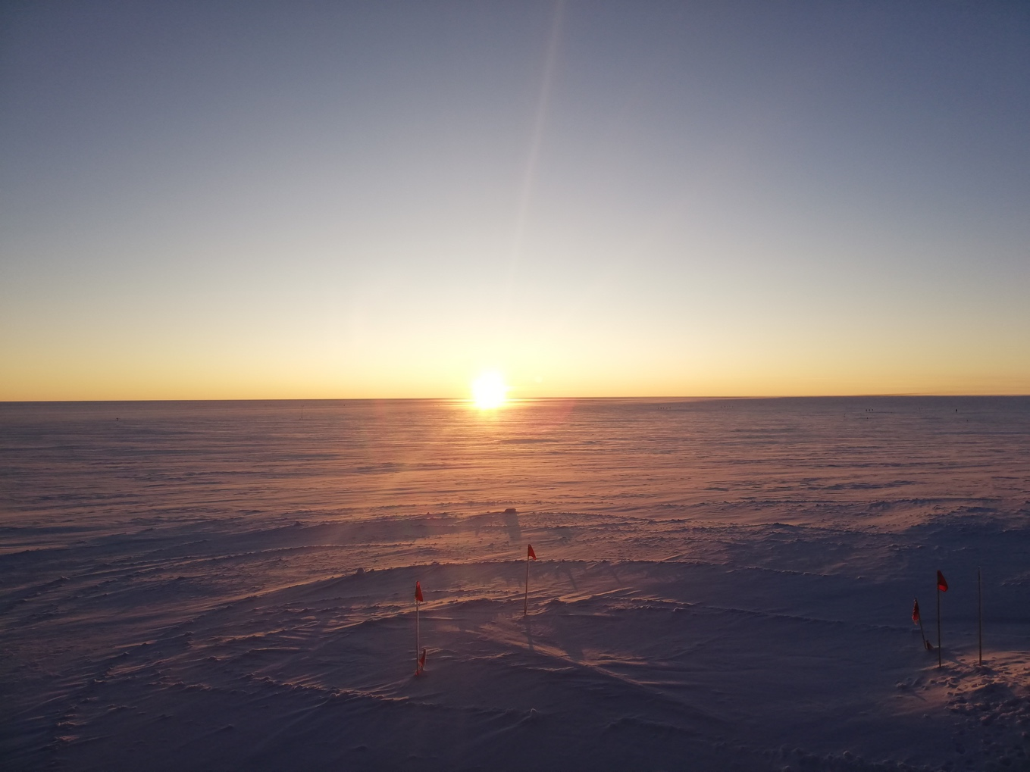

*Lots of clear skies later in the week made way for some beautiful sunsets and auroral displays. 09-26.*

**General Notes:**

A quieter week focused on organising workspaces and documentation in preparation for the rapidly approaching turnover. The first half of the week we saw some warm temperatures coinciding with extensive cloud and some snow. The second half of the week brought clear skies, but temperatures remained unusually high resulting some low relative humidity values.

**General Weather Observations:**

|  |  |  |  |  |  |  |  |
| --- | --- | --- | --- | --- | --- | --- | --- |
| **Date** | **Time (Z)** | **Wind** | **Weather** | **Visibility** | **Sky** | **Temp** | **Notes** |
| 9-23 | 12 | 164°, 12 kn | BLSN SN | 2000 | VV008 | -12 |  |
| 9-24 | 12 | 176°, 20 kn | DSN | 4800 | BKN018 | -11 |  |
| 9-25 | 12 | 273°, 9 kn | -SN | 9999 | BKN044 | -17 |  |
| 9-26 | 12 | 82°, 12 kn |  | 9999 | SKC | -37 | FZFG in distance. |
| 9-27 | 12 | 320°, 7 kn |  | 9999 | FEW262 | -18 | Very low RH <40% |
| 9-28 | 12 | 130°, 12 kn |  | 9999 | FEW196 | -20 |  |
| 9-29 | 12 | 136°, 12 kn | FZFG | 1600 | SKC | -24 |  |

**Significant Weather Observations:**

* 9-23 1330-1400z: Sundogs.
* 9-26 1230-1700z: Clear skies for checking CAPABL.

**MSF**

* Operating normally.

**ICECAPS-ACE Data Management:**

* 9-23: Data transfer completed at 0537z.
* 9-24: Data transfer completed at 0526z.
* 9-25: Data transfer completed at 0538z.
* 9-26: Data transfer completed at 1357z. Cause of slow transfer today not identified. Possible early switch to winter bandwidth?
* 9-27: Data transfer completed at 1036z.
* 9-28: Data transfer completed at 0918z.
* 9-29: Data transfer completed at 0725z.

**MWR:**

* 9-23: 150/90 small fan only turning intermittently. Possibly near failure?
* Operating normally.

**SODAR:**

* 9-27 1251-1317z: Sodar cleaned and levelled.
* Operating normally.

**POSS:**

* Peter Rodriguez from EC is happy to be the primary POC for the POSS while Matt Shupe is away.
* Operating normally.

**MMCR:**

* Operating normally.

**CAPABL:**

* 9-27 2108z: Stopped collecting data due to TCP/IP error.
* 9-28 1600z: Data collection restarted after multiple reboot attempts. Iris aperture adjusted to 3mm. New configuration file in operation.
* Operating normally.

**MPL:**

* Operating normally

**VCEIL:**

* 9-26: Ceilometer time was 1 minute behind server. Corrected.
* Spare laser stored under Ceilometer computer.
* Operating normally.

**IceCAM:**

* Operating normally

**PAERI:**

* 9-23 PAERI fan found not operational. Fan housing brought inside to defrost. Fuse is blown.
* 9-24 1332z: PAERI fan replaced with fan #1. Fan operating normally.
* 9-25: Bearings replaced in failed fan #8. Tests OK.
* Operating normally

**TSI:**

* Offline for winter season,

**IcePIC:**

* 9-24 1150-1210z: Stellar plates and stellar dendrites, 20 photos uploaded.

**Radiosonde:**

* Twice daily launches.
* 9-23: Face-mask filter changed.
* See plot below for temperature inside the enclosure over the last week.



**MASC:**

* Operating normally.

**MSF - OPC:**

* Operating normally.

**TAWO – OPC:**

* Operating normally.

**SKYOPC:**

* Operating normally.

**CLASP:**

* Operating normally.

**CPC:**

* Operating normally.

**Fluxtower instrument suite:**

* 9-24: Water ice formed in front of the KT15 lens resulting in incorrect readings. Difficult for techs to remove without a step ladder (there isn’t currently a step ladder at TAWO). Cleared after ~ 24 hours.
* 9-26 1500-1700z: Wireless data link down due to lose connection.
* Operating normally.

**INP Freezing assay:**

* 9-24: An adaptation was installed to the INP work bench to add strain relief to the push-fit connectors and to make it easier for technicians to identify and turn the correct valves. See photo below.
* 9-24: Three filter samples collected.
* 9-25 1530-1900z: Weekly sample assay run; data transferred.

