**ICECAPS-ACE Weekly Report**

October 7 – October 13, 2019

Heather Guy and Jess Ackerman

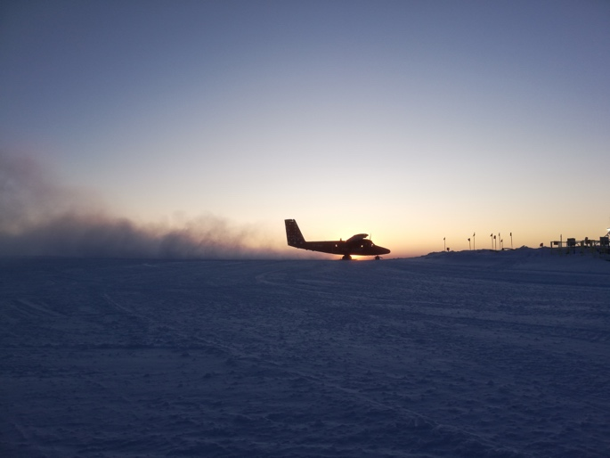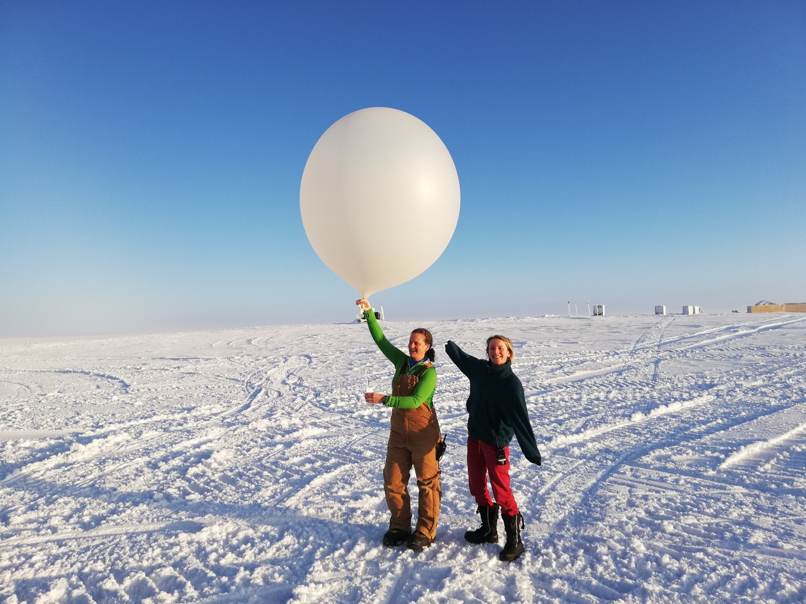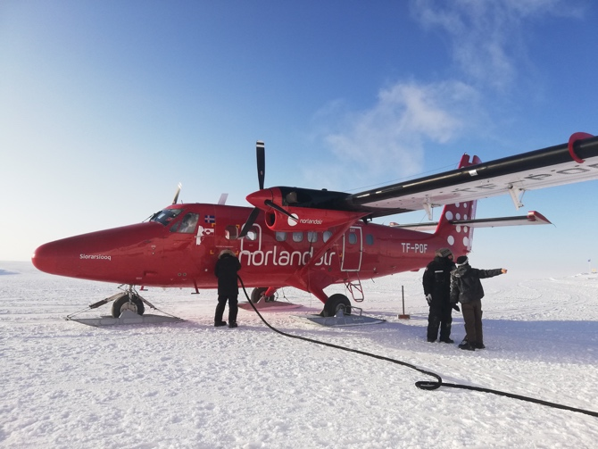

*Top: The twin otter arriving at Summit with the winter crew, 10-10.*

*Bottom: New Icecaps technician Jess Ackerman launching her first ICECAPS weather balloon. 10-12.*

**General Notes:**

On October 10th two Twin Otter planes arrived at Summit bringing the replacement winter crew, including new ICECAPS science technician Jess Ackerman. Jess is enthusiastically getting familiar with everything ICECAPS related during a very busy turnover week.

On October 13th we changed the CAPABL flash lamp, aside from that, there have been no major events this week.

**General Weather Observations:**

|  |  |  |  |  |  |  |  |
| --- | --- | --- | --- | --- | --- | --- | --- |
| **Date** | **Time (Z)** | **Wind** | **Weather** | **Visibility** | **Sky** | **Temp** | **Notes** |
| 10-7 | 12 | 169°, 14 kn | DRSN | 1600 | BKN030 | -21 |  |
| 10-8 | 12 | 121°, 18 kn | FZFG | 1600 | FEW | -33 |  |
| 10-9 | 12 | 186°, 7 kn | BR | 3200 | OVC003 | -23 | FZFG and low vis all day. |
| 10-10 | 12 | 48°, 16 kn | FZFG | 1600 | SKC | -41 |  |
| 10-11 | 12 | 97°, 13 kn | FZFG | 1600 | VV001 | -33 |  |
| 10-12 | 12 | 345°, 14 kn |  | 3200 | SKC | -41 | FZFG in distance. |
| 10-13 | 12 | 127°, 17 kn | FZFG | 1600 | VV001 | -35 |  |

**Flight operations:**

* 10-10 1230-1400z: Twin otter at Summit.
* 10-10 1830-1930z: Twin otter at Summit.

**Significant Weather Observations:**

* 10-11 1100-1600z: Fog bow
* 10-12 1222-1600z: Fog bow
* 10-13 1200-1345z: Fog bow

**MSF**

* Operating normally.

**ICECAPS-ACE Data Management:**

* 10-7: Data transfer completed at 0524z.
* 10-8: Data transfer completed at 0525z.
* 10-9: Data transfer completed OK, time not recorded.
* 10-10: Data transfer completed at 0543z.
* 10-11: Data transfer completed at 0524z.
* 10-12: Data transfer completed at 0520z.
* 10-13: Data transfer completed at 0524z.

**MWR:**

* Operating normally.

**SODAR:**

* 10-8 1304-1330z: Cleaned and levelled.
* Operating normally.

**POSS:**

* Operating normally.

**MMCR:**

* Operating normally.

**CAPABL:**

* 10-13 1853-2025z: Laser two flashlamp changed successfully.
* Operating normally.

**MPL:**

* Operating normally

**VCEIL:**

* Operating normally.

**IceCAM:**

* Operating normally

**PAERI:**

* 10-11 1245z: Fan found disconnected. The plug on the outside of the building had somehow come out of the socket. Fan brought inside to defrost then reconnected – operating normally.
* Operating normally

**TSI:**

* Offline for winter season,

**IcePIC:**

* No IcePics this week.

**Radiosonde:**

* Twice daily launches.
* 10-11 1630z: New high-volume filter installed on the outside of the enclosure (see photo below). Inside of enclosure and ground check station cleaned.

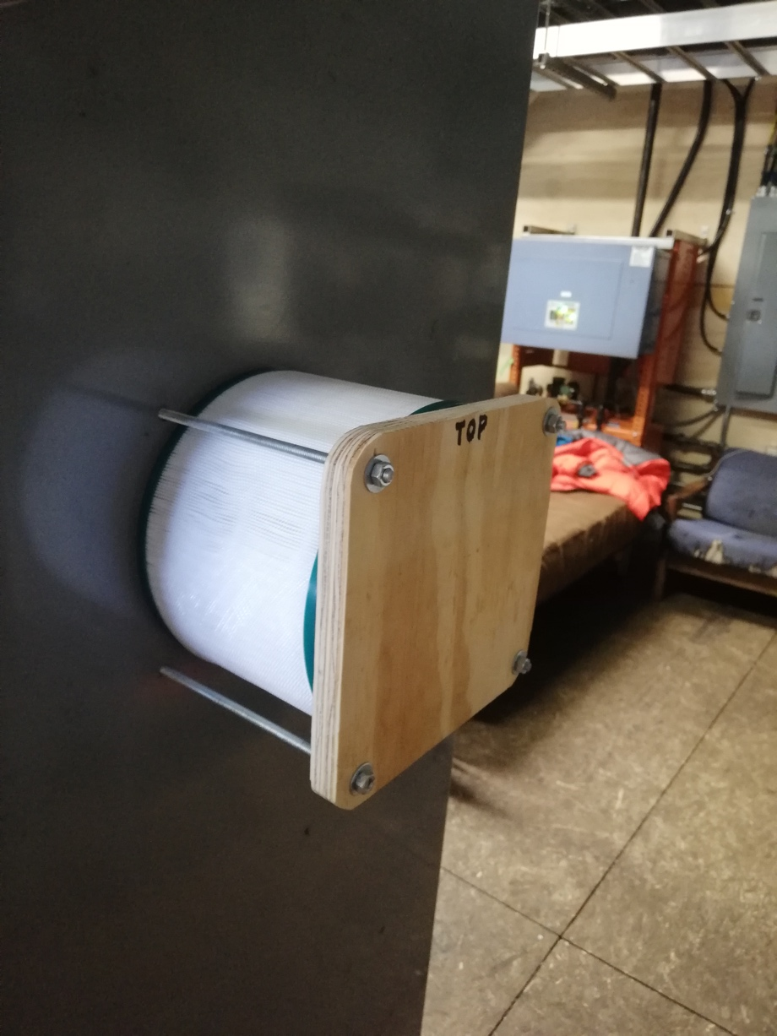

* See plot below for temperature inside the enclosure over the last week.



**MASC:**

* Operating normally.

**MSF - OPC:**

* Operating normally.

**TAWO – OPC:**

* Operating normally.

**SKYOPC:**

* Operating normally.

**CLASP:**

* Operating normally.

**CPC:**

* 10-8 1257z: Emptied butanol condensate.
* Operating normally.

**Fluxtower instrument suite:**

* 10-9: Enclosure temperatures over the last two weeks ranged between -7 to 25C, outside temperatures reached a low of -41C. I am happy that the enclosure does not need heating. Enclosure temperatures will henceforth be checked every 75 days or on instruction from the PI.
* Operating normally.

**INP Freezing assay:**

* 10-8: Three filter samples collected from TAWO.
* 10-9 1700-2000z: Weekly sample assay run; data transferred.