**ICECAPS-ACE Weekly Report**

October 14 – October 20, 2019

Jess Ackerman

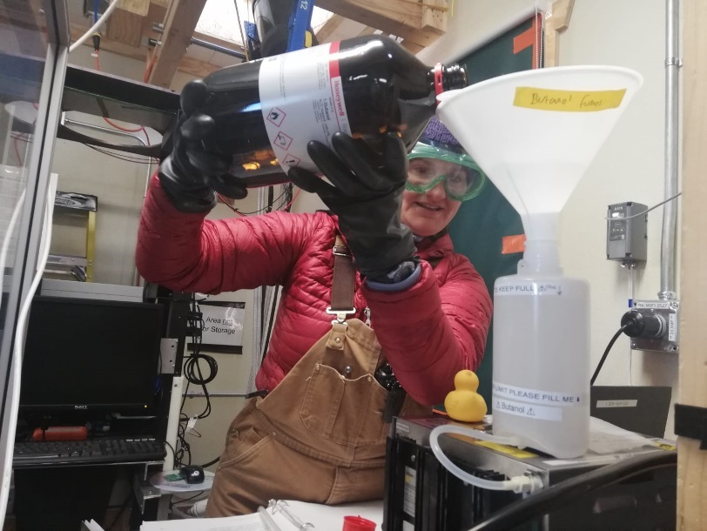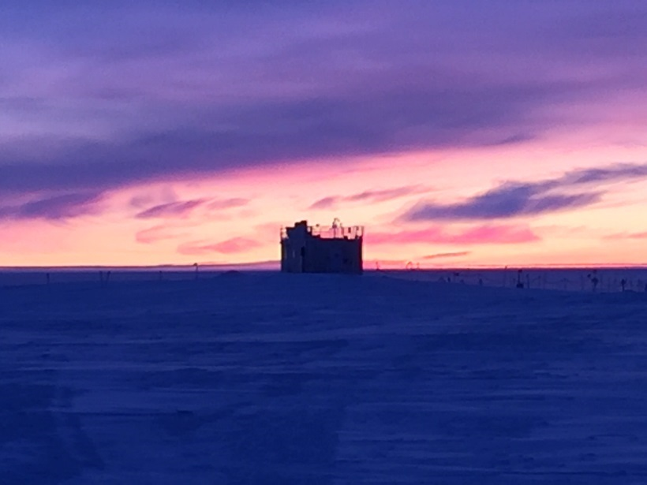

*Left: ICECAPS Technician Jess Ackerman refilling the butanol on the CPC for the ACE experiment. 10-14.*

*Right: MSF sunrise 0734. 10-18.*

**General Notes:**

On October 17th the Twin Otter departed with 6 PFS staff, leaving the final 4 staff for the winter. Since then, the pace has not slowed and the learning curve has been exponential for all. There were 2 brief minute-long planned power outages on 2019-10-15 at 1310 and 1318. Notable ICECAPS events this week included troubleshooting the Data Management transfers to Boulder and a “third time is the charm” successful reboot for the MMCR.

**General Weather Observations:**

|  |  |  |  |  |  |  |  |
| --- | --- | --- | --- | --- | --- | --- | --- |
| **Date** | **Time (Z)** | **Wind** | **Weather** | **Visibility** | **Sky** | **Temp** | **Notes** |
| 10-14 | 12 | 150°, 12 kn |  | 3200 | FEW | -38 |  |
| 10-15 | 12 | 181°, 7 kn |  | 3200 | FEW098 | -38 | FZFG distant. |
| 10-16 | 12 | 211°, 10 kn |  | 800 | FEW131 | -42 | Cirrus. |
| 10-17 | 12 | 232°, 13 kn | FZFG -SN | 800 | OVC005 | -24 | Stratus. |
| 10-18 | 12 | 215°, 11 kn |  | 4800 | FEW098 | -32 | Cirrostratus. |
| 10-19 | 12 | 245°, 11 kn |  | 1600 | FEW | -33 | Stratus distant. |
| 10-20 | 12 | 269°, 3 kn |  | 4800 | SCT025 | -38 | Stratus. BR distant. |

**Flight operations:**

* 10-17 1530-1607z: Twin otter at Summit.

**Significant Weather Observations:**

* 10-14 2045z: Rave Ice
* 10-16 1103z: Fog bow
* 10-19 1045-1145z: Fog bow
* 10-20 1343-1350z: Fog bow

**MSF**

* Operating normally.

**ICECAPS-ACE Data Management:**

* 10-14: Data transfer completed at 0554z.
* 10-15: Data transfer completed at 0525z.
* 10-16: Data transfer completed at 0523z.
* 10-17: Data transfer completed at 0420z.
* 10-18: Data transfer completed at 0630z.
* 10-19: Data transfer completed at 0844z.
* 10-20: Data transfer completed at 1048z.

Several errors on DataMan after 10-16, causing the abnormal times above. Apparently, ICECAPS data transfers to Boulder were not taking place because the mount name for the USB backup drive was incorrect after a routine swap of these drives during turnover. Collaborative troubleshooting occurred. Standing by to see if things improve on 10/22 daily checks.

**MWR:**

* 10-16 1205z: Light frost cleared from 150-90 window. Photo taken and logged. Also, an exposed wire on the GPS component was re-wrapped and secured with rubber mastic tape.
* Operating normally.

**SODAR:**

* 10-15 1632-1654z: Cleaned and levelled.
* Operating normally.

**POSS:**

* Operating normally.

**MMCR:**

* 10-18 1723-1900z: After continuous NetCDF errors (starting 10-16 1242z) would not stay cleared, rebooted the system 3x.

**CAPABL:**

* 10-17 1351-1405z: Turned off laser to clear window.
* Operating normally.

**MPL:**

* 10-15 1825-1854z: Monthly calibration completed.
* Operating normally

**VCEIL:**

* Operating normally.

**IceCAM:**

* Operating normally

**PAERI:**

* 10-14 1235z: Fan unplugged briefly for training.
* 10-17 1333 and 1344z: Scene mirror cleaned for training.
* Operating normally

**TSI:**

* Offline for winter season,

**IcePIC:**

* 10-15: Used equipment for training.
* No IcePics this week.

**Radiosonde:**

* Twice daily launches.
* See charts below for temperatures inside and outside the enclosure over the last week.

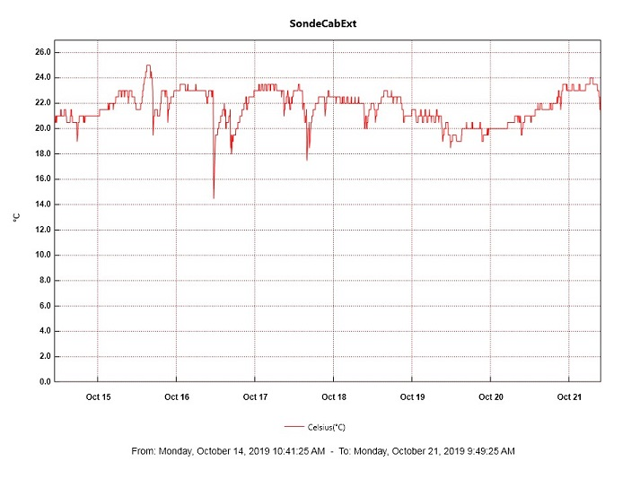 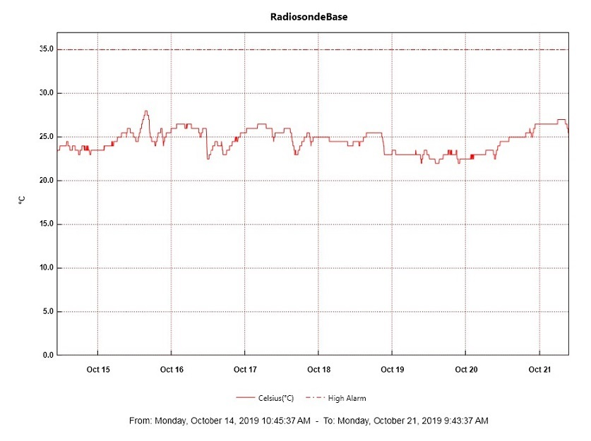

**MASC:**

* 10-15 1337z: Computer rebooted due to unresponsive trackpad.
* Operating normally.

**MSF - OPC:**

* Operating normally.

**TAWO – OPC:**

* Operating normally.

**SKYOPC:**

* Operating normally.

**CLASP:**

* Operating normally.

**CPC:**

* 10-14 1415z: Butanol refilled and condensate emptied.
* Operating normally.

**Fluxtower instrument suite:**

* 10-17 0800-1530z: Fluxtower data interrupted due to TAWO network outage.

**INP Freezing Assay:**

* 10-15 1816z: Coldstage calibrations performed.
* 10-16 1308z: Three filter samples collected from TAWO and weekly sample assays run.