**ICECAPS-ACE Weekly Report**

October 21 – October 27, 2019

Jess Ackerman

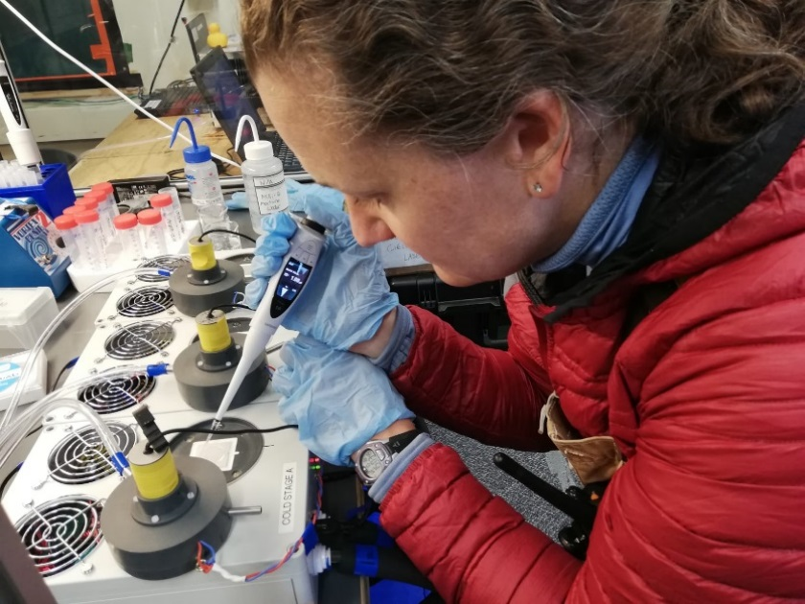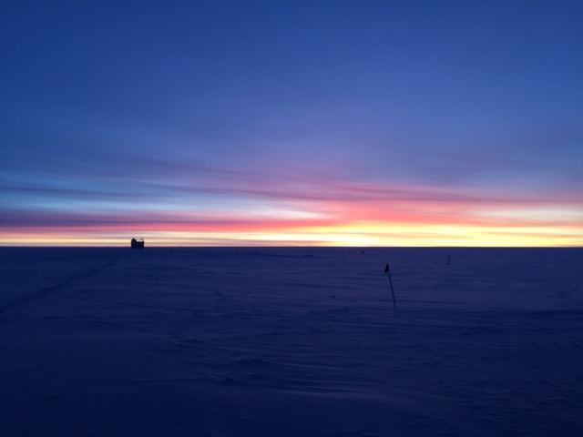

*Left: ICECAPS Technician Jess Ackerman using a digital pipette during the INP experiment. 10-23.*

*Right: MSF sunrise 0818L. Yes, another sunrise pic, later and later each day – must enjoy them while we can! 10-25.*

**General Notes:**

The 4 of us continue to adjust to Summit Camp life and find our balance in routines. ICECAPS Data Management continues to be watched carefully as data transfers catch up this week. Heavy frost mornings on Oct 26th and 27th required extra cleaning attention to the instruments on the MSF rooftop. We had several days of Northwinds that postpone our first ICESAT Traverse of the season until Oct 25th. It is a huge relief and a rewarding success to have that behind us now.

**General Weather Observations:**

|  |  |  |  |  |  |  |  |
| --- | --- | --- | --- | --- | --- | --- | --- |
| **Date** | **Time (Z)** | **Wind** | **Weather** | **Visibility** | **Sky** | **Temp** | **Notes** |
| 10-21 | 12 | 48°, 5 kn |  | 4800 | BKN016 | -46 | Stratus. |
| 10-22 | 12 | 348°, 13 kn |  | 1600 | FEW | -44 | BR distant. Stratus distant. |
| 10-23 | 12 | 341°, 15 kn |  | 4800 | SKC | -43 |  |
| 10-24 | 12 | 46°, 10 kn | FZFG | 800 | FEW | -46 | Cirrus |
| 10-25 | 12 | 220°, 11 kn |  | 4800 | SCT100 | -32 | Cirrocumulus. |
| 10-26 | 12 | 165°, 7 kn | FZFG | 800 | BKN033 BKN065 | -31 | Stratus. Cirrus. Heavy frost morning. |
| 10-27 | 12 | 181°, 10 kn | FZFG | 100 | SCT000 | -33 | Cirrus. |

**Significant Weather Observations:**

* No significant weather observed this week. We did have auroras several nights!

**MSF**

* Operating normally.

**ICECAPS-ACE Data Management:**

* 10-21: Data transfer completed at 1259z.
* 10-22: Data transfer finish time unknown. Slow.
* 10-23: Data transfer completed at 0522z.
* 10-24: Data transfer completed at 0544z.
* 10-25: Data transfer completed at 0507z. ‘No Such File or Directory’ errors present.
* 10-26: Data transfer finish time unknown. Slow.
* 10-27: Data transfer finish time unknown. Slow.

DataMan troubleshooting continues for slow transfers. Will send email update with completed times when obtained 2019.10.29 before ICECAPS conference call.

**TSI:**

* Offline for winter season.

**Radiosonde:**

* Twice daily launches.
* *Left: As requested per PIs, a picture of the filter outside the enclosure will be included monthly.*
* *Right: A picture of inside the enclosure - it is staying clean!*

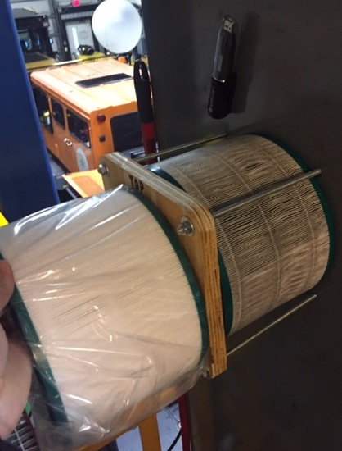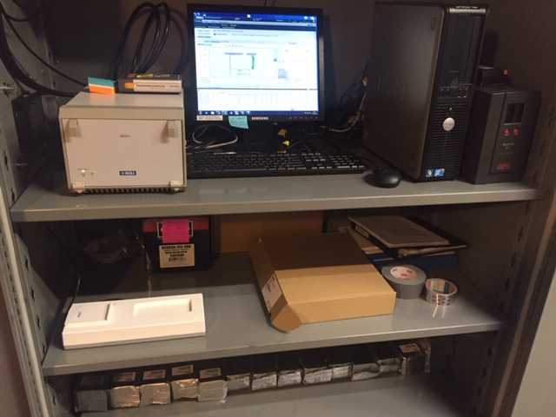

* See charts below for temperatures outside and inside the Radiosonde cabinet over the last week.

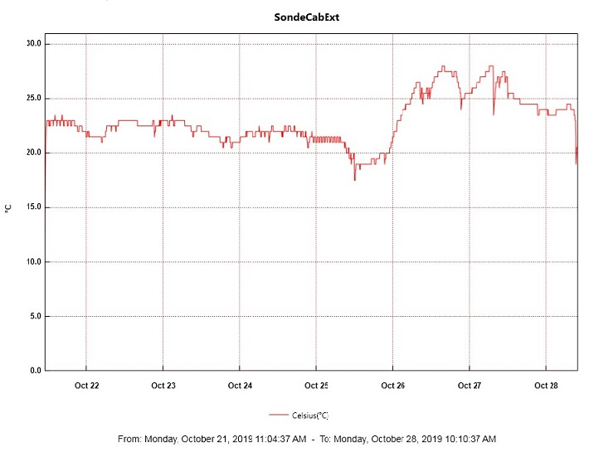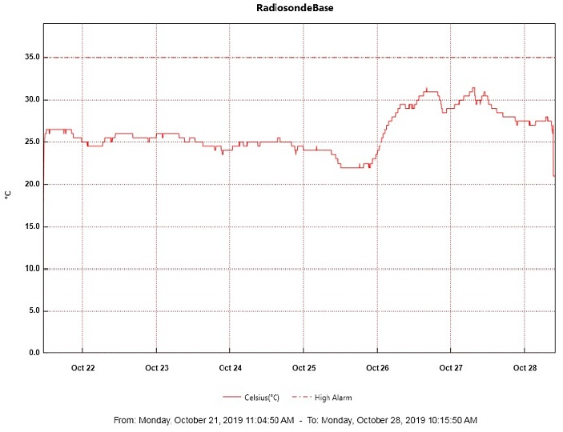

**MWR:**

* 2019-10-26 1130z and 10-27 1428z: Light frost removed from windows of both 150-90 and HatPro due to heavy frost covering the heater intake. Pictures sent to PI.
* Operating normally.

**SODAR:**

* 2019-10-26 1216-1259z: Powered off for cleaning and leveling. Adjusted cable heights and performed bamboo pole maintenance.
* Operating normally.

**POSS:**

* Operating normally.

**MASC:**

* 2019-10-21 1330z: Informed PI of “MASC waiting for status” message.
* 2019-10-25: Computer reboot due to unresponsive trackpad.

**MMCR:**

* 2019-10-22 1259z: In communication with PI on system specifics.
* Operating normally.

**CAPABL:**

* 2019-10-21 1515z: Rebooted system with direction from PI due to TCPIP errors. At 1620z laser was turned off for window clearing.
* 2019-10-26 1139-1147z: Laser turned off for window clearing.
* 2019-10-27 1442-1456z: Laser turned off for window clearing.

**MPL:**

* Operating normally

**VCEIL:**

* Operating normally.

**PAERI:**

* 2019-10-21 1433z: Clarification obtained from PI on severity of yellow warning flags.
* 2019-10-27 1433z: Covered roof hatch for cleaning. Obtained clarification from PI on cleaning preferences. 1522-1524z: Outside fan unplugged briefly to inspect loud vibration and assessed future fan hood securing needs.
* Operating normally

**IceCAM:**

* Operating normally

**IcePIC:**

* No IcePics this week.

**CLASP:**

* Operating normally.

**CPC:**

* Operating normally.

**MSF - OPC:**

* 2019-10-22 1340z: Computer not updating. Brought instrument inside to defrost and replaced filter cover.
* 2019-10-24 1455z: Instrument re-installed on roof and data collection resumed.

**TAWO - OPC:**

* Operating normally.

**SKYOPC:**

* Operating normally.

**INP Freezing Assay:**

* 2019-10-23 1321z: Filter samples collected from TAWO, weekly INP sample assays run, and data sent.

**Fluxtower instrument suite:**

* 2019-10-21: Shield cover for HMP2 (4m) fell off tower while gently brushing snow off during routine maintenance. PI notified.