**ICECAPS-ACE Weekly Report**

October 28 – November 3, 2019

Jess Ackerman

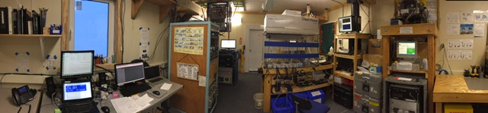

*Above: 2019-10-28 – Panoramic photo of inside the MSF. Lots going on in here!*

**General Notes:**

Still plugging along here at Summit Station. Work load for the ICECAPS tech is starting to stabilize as I learn more and more about my job. Very helpful conference calls during the week with boss Sam totaling over 3 hours helped clarify detailed tasking and responsibilities. Getting to know my workspace through explorative snooping. Still so much to learn.

**General Weather Observations:**

|  |  |  |  |  |  |  |  |
| --- | --- | --- | --- | --- | --- | --- | --- |
| **Date** | **Time (Z)** | **Wind** | **Weather** | **Visibility** | **Sky** | **Temp** | **Notes** |
| 10-28 | 12 | 247°, 10 kn |  | 9999 | OVC050 | -30 | Altostratus. |
| 10-29 | 12 | 125°, 8 kn | FZFG | 800 | FEW | -44 |  |
| 10-30 | 12 | 239°, 9 kn | FZFG | 300 | OVC003 | -32 |  |
| 10-31 | 12 | 174°, 10 kn | BR | 1600 | SCT098 | -42 | Cirrostratus. |
| 11-01 | 12 | 253°, 10 kn | BR | 1600 | OVC003 OVC016 | -27 | Stratus. |
| 11-02 | 12 | 235°, 9 kn | -SN | 1600 | OVC016 | -30 | Stratus. |
| 11-03 | 12 | 182°, 11 kn |  | 4800 | OVC030 | -36 | Stratus. |

**Significant Weather Observations:**

* 2019-10-31 1400-1429z: Fog Bow
* 2019-11-01 1844z: Rave Ice
* 2019-11-03 1240-1255z: Sundog

**MSF**

* 2019-10-29 1312z: Increased Solo Controller by 2° F due to cooler temperatures per Sam.
* Operating normally.

**ICECAPS-ACE Data Management:**

* 10-28: Stop ArchieveToBoulder at 1442z.
* 10-29: Stop ArchieveToBoulder at 1430z.
* 10-30: Stop ArchieveToBoulder at 1430z.
* 10-31: Stop ArchieveToBoulder at 1634z.
* 11-01: Stop ArchieveToBoulder at 1406z.
* 11-02: Stop ArchieveToBoulder at 1457z.
* 11-03: Stop ArchieveToBoulder at 1355z.

**TSI:**

* Offline for winter season.

**Radiosonde:**

* Twice daily launches.
* 2019-10-27 1121z: RH values >100% outside SMG. Initial sonde launched.
* 2019-10-30 2357z: RH not measuring. Launched 2nd sonde successfully.
* See charts below for temperatures outside and inside the Radiosonde cabinet over the last week.

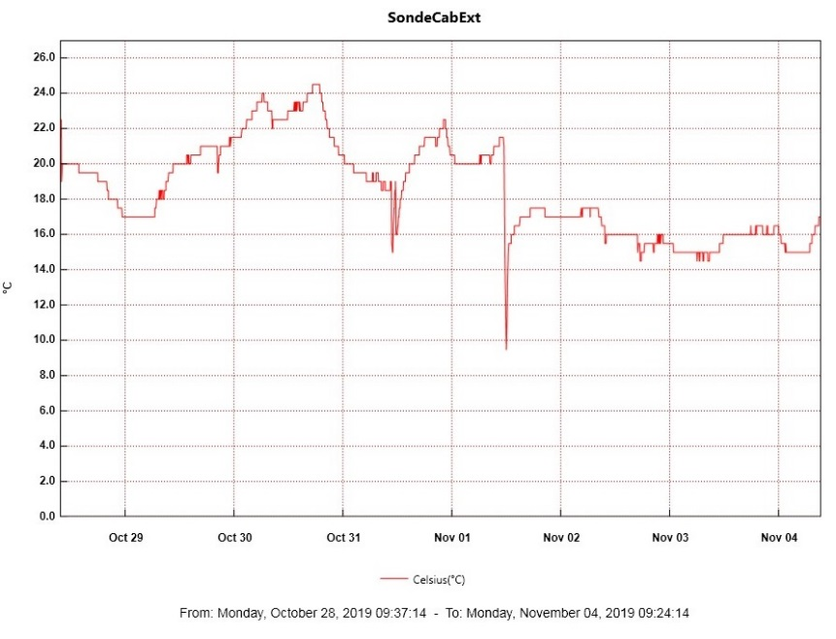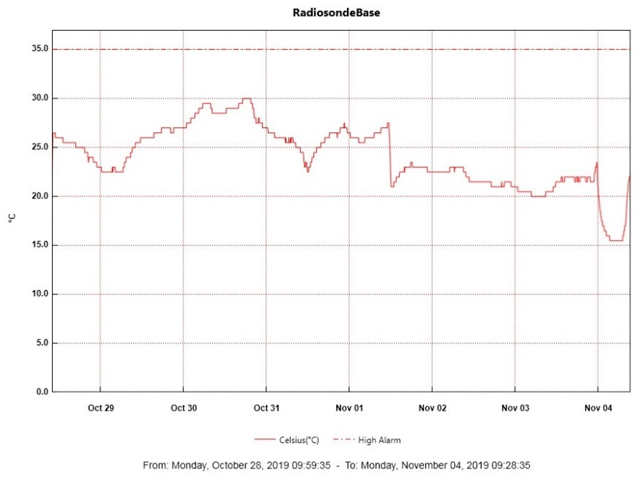

**MWR:**

* 2019-10-30 1225z: Frosty window pics taken and cleaned.
* Operating normally.

**SODAR:**

* 2019-11-01 1412-1442z: Powered off for routine cleaning. Adjusted more cable heights.
* Operating normally.

**POSS:**

* 2019-10-31 1351z: Minor “DC Offset” error. No action needed.
* Operating normally.

**MASC:**

* 2019-10-29: 1252-1313z Computer shut down. 1257-1258z Unplugged at instrument to reset. YES “MASC waiting for status” message cleared. PI notified.
* 2019-10-30 1315z: Informed PI “MASC waiting for status” YES message has returned.

**MMCR:**

* Operating normally.

**CAPABL:**

* 2019-10-30 1232-1241z: Laser turned off for window clearing.
* 2019-11-02 1235-1247z: Laser turned off for window clearing.
* Operating normally

**MPL:**

* Operating normally

**VCEIL:**

* Operating normally.

**PAERI:**

* 2019-10-30 1245z: Outside fan unplugged briefly to clear snow.
* 2019-10-31 1349z: Outside fan unplugged briefly to clear snow. 1405z Red Flags for LW and SW Responsivity. 1443z Flags turned Yellow and eventually cleared themselves.

**IceCAM:**

* Operating normally.

**IcePIC:**

* No IcePics this week.

**CLASP:**

* Operating normally.

**CPC:**

* 2019-10-30 1505z: Butanol refilled and condensate emptied. 1600z carbon filter changed.
* Operating normally.

**MSF - OPC:**

* Operating normally.

**TAWO - OPC:**

* Operating normally.

**SKYOPC:**

* Operating normally.

**INP Freezing Assay:**

* 2019-10-30 1344z: Filter samples collected from TAWO, weekly INP sample assays run, and data sent.

**Fluxtower instrument suite:**

* Shield repair for the HMP2 will commence when weather and tasking supports a tower climb.
* Operating normally.