**ICECAPS-ACE Weekly Report**

November 4 – 10, 2019

Jess Ackerman

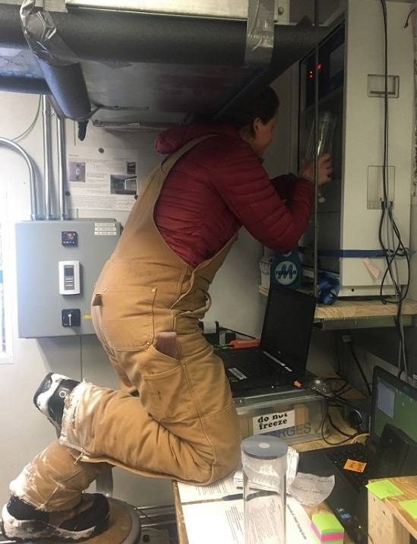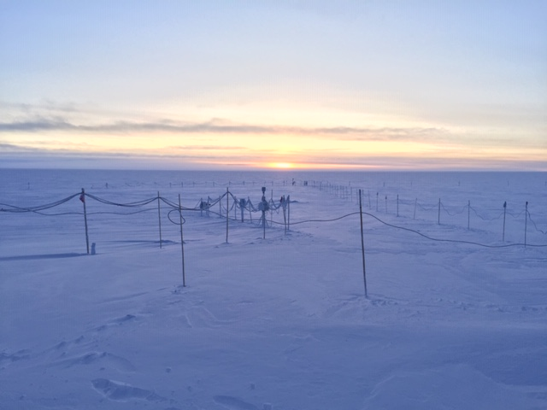

*Left: 2019-11-06 1344Z: ICECAPS Tech Jess changing out INP Experiment filters at TAWO.*

*Right: 2019-11-09 1300Z: MSF backyard sunrise. Last sunrise scheduled for Nov 14.*

**General Notes:**

“Sticky” snow was the motto this week while cleaning the instruments. Not wet, not icy, but dense frost that cakes on and is challenging to remove with a soft-bristled paintbrush. The ICECAPS Tech Jess has been working diligently at improving the bamboo flag lines little by little that hold the instrument cables above ground. With the higher winds and drifting snow, items are slowly starting to disappear into the winter abyss. A conscious effort has been made to make sure everything is clearly marked and can be found again when needed.

**General Weather Observations:**

|  |  |  |  |  |  |  |  |
| --- | --- | --- | --- | --- | --- | --- | --- |
| **Date** | **Time (Z)** | **Wind** | **Weather** | **Visibility** | **Sky** | **Temp** | **Notes** |
| 11-04 | 12 | 63°, 6 kn | BR | 3200 | FEW | -41 |  |
| 11-05 | 12 | 190°, 12 kn |  | 1600 | BKN033 | -36 |  |
| 11-06 | 12 | 212°, 10 kn |  | 800 | OVC003 | -26 | Stratus. |
| 11-07 | 12 | 163°, 14 kn | DRSN | 800 | BKN033 | -34 |  |
| 11-08 | 12 | 184°, 13 kn | FZFG, DRSN | 500 | BKN033 | -33 |  |
| 11-09 | 12 | 179°, 11 kn |  | 9999 | FEW016 | -38 | Stratus distant. |
| 11-10 | 12 | 130°, 13 kn | BR | 1600 | OVC003 | -32 |  |

**Significant Weather Observations:**

* No significant weather this week.

**MSF**

* Operating normally.

**ICECAPS-ACE Data Management:**

* 11-04: Stop ArchieveToBoulder at 1353Z.
* 11-05: Stop ArchieveToBoulder at 1316Z.
* 11-06: Stop ArchieveToBoulder at 1528Z.
* 11-07: Stop ArchieveToBoulder at 1643Z.
* 11-08: Stop ArchieveToBoulder at 1339Z.
* 11-09: Stop ArchieveToBoulder at 1416Z.
* 11-10: Stop ArchieveToBoulder at 1350Z.
* 2019-11-08 1411Z: Started backing up MMCR spectra data (381GB) to external hard drive to free up space on the data management archive, per previous Shupe email.

**TSI:**

* Offline for winter season.

**Radiosonde:**

* 2019-11-04 1100Z: Computer was found shutdown unexpectedly before burst pressure could be obtained.
* 2019-11-05: Tested Radiosonde UPS. All is well.
* Twice daily launches.
* Still hoping to get Easy Log USB program installed on Radiosonde computer for ease.
* See charts below for temperatures outside and inside the Radiosonde cabinet over the last week.

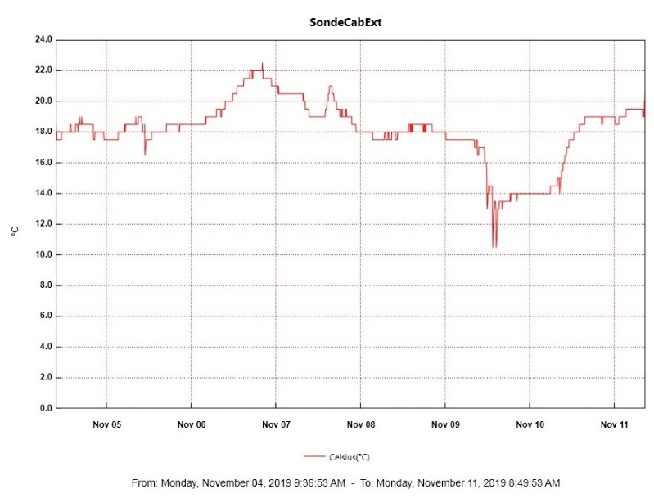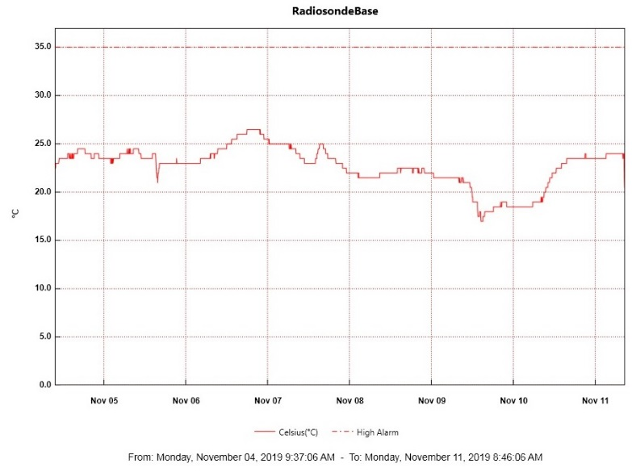

**MWR:**

* Operating normally.

**SODAR:**

* 2019-11-09 1404-1431Z: Powered off for routine cleaning.
* Operating normally.

**POSS:**

* Operating normally.

**MASC:**

* 2019-11-05 1240-1300Z: Computer shut down and unplugged at instrument to reset.

YES “MASC waiting for status” message cleared. PI notified. All is well.

**MMCR:**

* 2019-11-08 1238Z: GPIB bus interrupted the daily calibration. Errors cleared. PI notified.
* Operating normally.

**CAPABL:**

* Operating normally

**MPL:**

* Operating normally

**VCEIL:**

* Operating normally.

**PAERI:**

* 2019-11-04 1345Z: Powered off fan briefly to clear snow and take measurements for minor repairs.
* 2019-11-08 1300Z: Powered off fan briefly to clear snow.
* Operating normally.

**IceCAM:**

* Operating normally.

**IcePIC:**

* No IcePics this week.

**CLASP:**

* Data this week has been “a bit dodgy.” Heather is aware and looking into it.

**CPC:**

* Operating normally.

**MSF - OPC:**

* Operating normally.

**TAWO - OPC:**

* 2019-11-04: TAWO OPC data gaps first noticed.
* 2019-11-08 1547Z: Instrument brought inside to thaw out, disassemble, and inspect.
* 2019-11-09 1340Z: Instrument returned to TAWO rooftop and restored to proper function.

**SKYOPC:**

* Operating normally.

**INP Freezing Assay:**

* 2019-11-06 1344z: Filter samples collected from TAWO, weekly INP sample assays run, and data sent. HEPA filter changed. New Mille-Q water and Isopropanol squirt bottles.

**Fluxtower instrument suite:**

* 2019-11-04 1530Z: Successful tower climb to retrieve the HMP2 instrument for future shield repair.