**ICECAPS-ACE Weekly Report**

November 18 - 24, 2019

Jess Ackerman

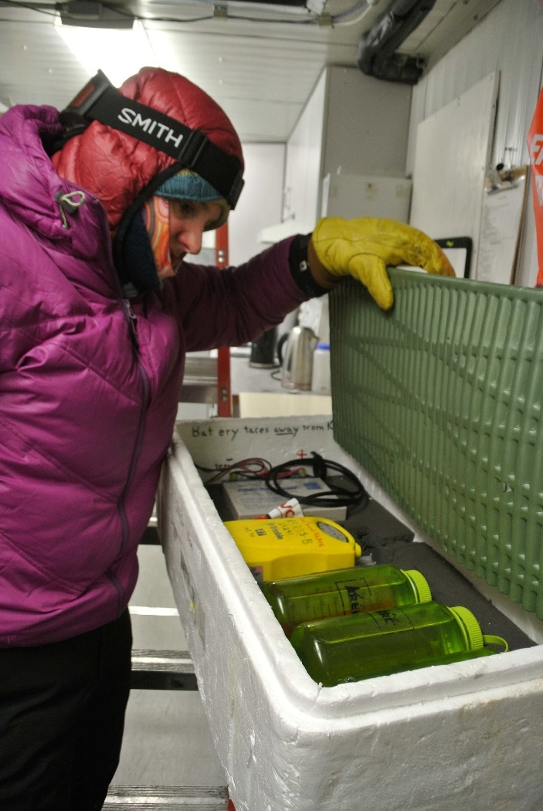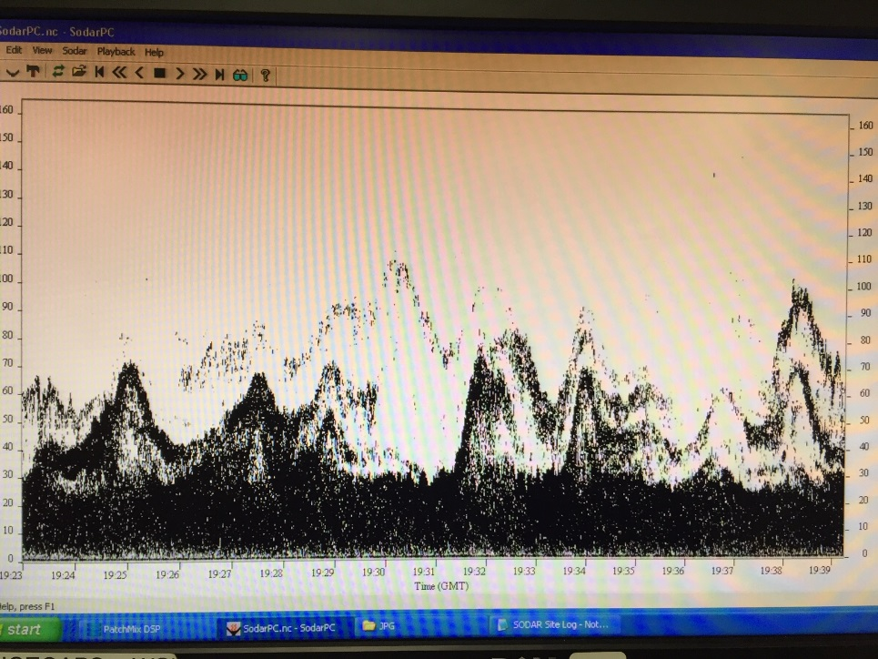

*Left:2019-11-22: ICECAPS Tech Jess checking on the ICESAT instrumentation before traverse departure.*

*Right: 2019-11-21: SODAR “Mountain Scene”.*

**General Notes:**

Our ICESAT Traverse was the hot topic this week. We were able to complete the accumulation survey section (about 80%) on 11/20 but had to turn back after is was impossible to navigate in the dark when we reached the extension portion. It was a safe, smart, and well-executed decision. With the satellite passover scheduled for 11/23, we decided to rally again on 11/22 and completed the remaining extension section of the traverse. Wonderful efforts by all. Woohoo!

**General Weather Observations:**

|  |  |  |  |  |  |  |  |
| --- | --- | --- | --- | --- | --- | --- | --- |
| **Date** | **Time (Z)** | **Wind** | **Weather** | **Visibility** | **Sky** | **Temp** | **Notes** |
| 11-18 | 12 | 192°, 19 kn | BLSN | 500 | OVC066 | -26 |  |
| 11-19 | 12 | 175°, 18 kn | BLSN | 800 | OVC033 | -22 |  |
| 11-20 | 12 | 191°, 11 kn |  | 800 | FEW000 SCT140 | -30 |  |
| 11-21 | 12 | 154°, 12 kn |  | 1600 | SCT049 | -39 |  |
| 11-22 | 12 | 180°, 13 kn | BR | 1600 | FEW030 | -49 |  |
| 11-23 | 12 | 185°, 13 kn |  | 800 | SCT008 | -40 | Stratus distant |
| 11-24 | 12 | 224°, 16 kn | -SN | 600 | OVC016 | -25 |  |

**Significant Weather Observations:**

* 2019-11-20 1221Z: Rave Ice
* 2019-11-24 1724Z: Rave Ice

**MSF**

* Operating normally.

**ICECAPS-ACE Data Management:**

* 11-11: Stop ArchieveToBoulder at 1056Z.
* 11-12: Stop ArchieveToBoulder at 1111Z.
* 11-13: Stop ArchieveToBoulder at 1453Z.
* 11-14: Stop ArchieveToBoulder at 1311Z.
* 11-15: Stop ArchieveToBoulder at 1525Z.
* 11-16: Stop ArchieveToBoulder at 1110Z.
* 11-17: Stop ArchieveToBoulder at 1122Z.

**TSI:**

* Offline for winter season.

**Radiosonde:**

* Twice daily launches.
* Thank you Erik for the Easy Log USB program installation on Radiosonde computer! Soon will be able to download temperature logger data right there on site in the SMG vs. trekking to another building to use computer with specific program. Just need the appropriate USB drivers now.
* See picture below for monthly filter condition update. Next filter change scheduled Dec. 1.

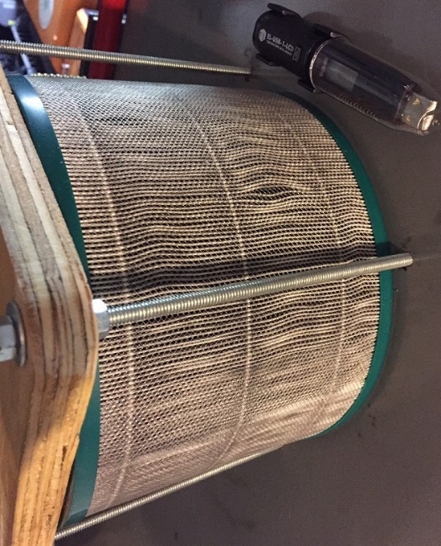

* See charts below for temperatures outside and inside the Radiosonde cabinet over the last week.

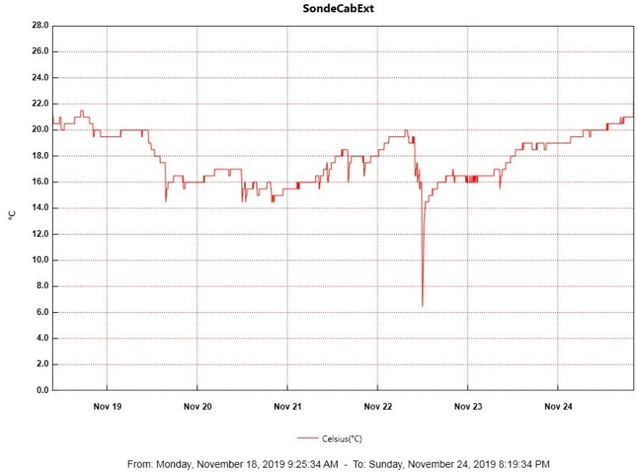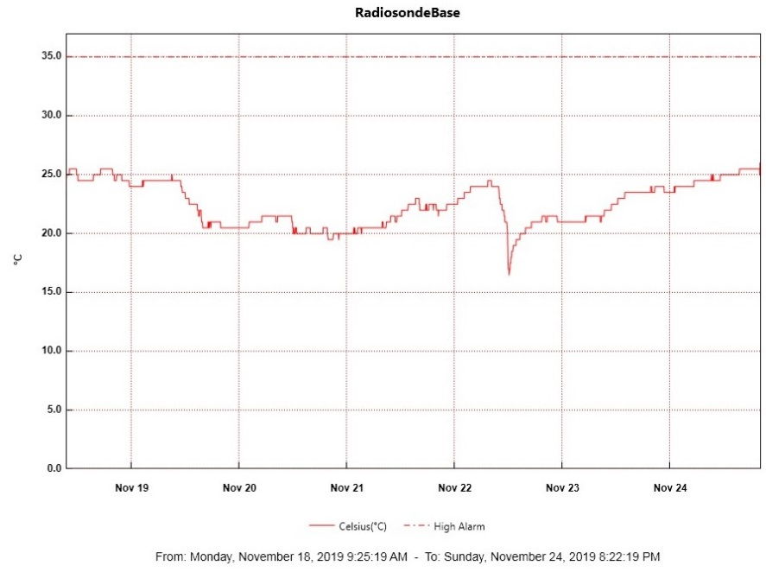

**MWR:**

* Operating normally.

**SODAR:**

* 2019-11-19 1242-1304Z: SODAR cleaned and levelled.
* Operating normally.

**POSS:**

* 2019-11-21 1300Z: Accidentally closed POSS computer window which stopped data collection briefly. Followed system start-up protocol. All is well.
* Operating normally.

**MASC:**

* 2019-11-18 1600Z: Per ICECAPS weekly conference call, awaiting instructions to shut down MASC for the winter due to temperature related issues. Data collection will resume in warmer temperatures this spring.

**MMCR:**

* 2019-11-22 1659Z: GPIB interrupted the daily calibration. Errors cleared. PI notified.
* Operating normally.

**CAPABL:**

* 2019-11-18 1234-1444Z: Found CAPABL computer with “black screen of death”. LabVIEW software kept crashing. Rebooted several times. Then LICEL not triggering (no DAQ cycles, no shots). Clicking the “Start Discriminator Scan” button in the Licel Tab finally woke it up. Troubleshot with PI all along.

**MPL:**

* Operating normally

**VCEIL:**

* Operating normally.

**PAERI:**

* Outside Air Temp Sensor not functioning, currently troubleshooting with PI.
* Operating normally.

**IceCAM:**

* Operating normally.

**IcePIC:**

* No IcePics this week.

**CLASP:**

* 2019-11-18 1259Z: Unplugged CLASP for 10 sec to reset data collection. P2 light now flashes.
* 2019-11-21 1218Z: CLASP had odd high-pitched sound during cleaning. Sent PI video. Resolved itself shortly after.
* Operating normally.

**CPC:**

* Operating normally.

**MSF - OPC:**

* Operating normally.

**TAWO - OPC:**

* 2019-11-19: Connectivity restored when swapping out failed network switch in TAWO. Unable to resolve gaps in data present by reseating communications cable connection on TAWO rooftop on 2019-11-23. Troubleshooting ongoing.

**SKYOPC:**

* Operating normally.

**INP Freezing Assay:**

* 2019-11-20 1339Z: Filter samples collected from TAWO.
* 2019-11-21: Weekly INP sample assays run and data sent.

**Fluxtower instrument suite:**

* 2019-11-18: Fluxtower instruments KT15, HMP3 (9m temperature sensor), HMP4 (15m temperature sensor), Ventus2 (9m 2D sonic), Metek2 (15m 2D sonic) lost power on 2019-11-09 at 1815Z. Failed power supply suspected; plans to swap out the power supply in progress.
* 2019-11-19: Swapped out failed network switch in TAWO and restored connectivity to Fluxtower instruments.